Microsoft Applications as of 2025
Icon | Name | Used For
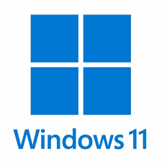 | Microsoft Windows 11 | Computer Operating System
 | Microsoft 365 Copilot | Microsoft Office Suite / O365
 | Microsoft Word | Word Processing
 | Microsoft Excel | Spreadsheet
 | Microsoft PowerPoint | Presentations, Slide Shows
 | Microsoft Outlook | Email, Contacts, Calendar
 | Microsoft Exchange | Email Server
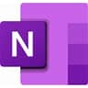 | Microsoft OneNote | Note Taking, To-Do Lists
 | Microsoft Visio | Diagramming, Flowcharts
 | Microsoft Access | Relational Database
 | Microsoft Project | Scheduling
 | Microsoft Publisher | Desktop Publishing
 | Microsoft SharePoint | Internal Web Pages, HTML
 | Microsoft Teams | Collaboration
 | Microsoft Forms | Data Collection Tool
 | Microsoft Edge | Browser w/CoPilot AI
 | Microsoft Copilot | AI Chatbot
 | Microsoft OneDrive | Cloud File Storage
 | Microsoft Designer | Stickers, Greeting Cards, Invitations, Collages
 | Microsoft Whiteboard | Whiteboard, Digital Canvas
 | Microsoft Clipchamp | Video Editor
 | Microsoft Paint | Image Editor
 | Microsoft Visual Basic | Macros, VBA Scripting, Keystroke Logging
 | Microsoft Visual Studio | Programming Environment
 | Microsoft Defender | Security, Antivirus, Malware
 | Microsoft Power BI | Business Analytics Tool

