AI Chatbots as of 2025
Icon | Name & Vendor | Strength / Typically Used For
 | ChatGPT (OpenAI) | Best overall. Generates natural language text, solves math problems, coding assistance, STEM tasks, resumes, lists, conversational, and brainstorming. No sources.
 | Copilot (Microsoft) | Search engine with up-to-date information on current events, links back to sources, and easy to use (integrated into Bing). Free.
 | Gemini (Google) | Productivity. Advanced AI integration and writing assistance. Human-like voice assistant. Beautiful visualizations, images, and text. Formerly Bard. Free.
 | Socratic (Google) | Kids and students can type in any question, and it will generate a conversational, human-like response with fun unique graphics (not text). Double-check homework. Free.
 | Perplexity.ai | Combines the best of AI chatbots and search engines to offer users an optimized hybrid experience. Enjoyable UI, and current events. Internet deep dive. Provides sources. Free.
 | Claude (Anthropic) | Conversational depth, PDF summaries, coding, math, writing, research, and links to sources. Strong privacy policy. Nuanced dialog, long-form content generation.
 | Grok (xAI) | Social entertainment with internet access. Known for its humorous and engaging responses. Optimized for informal conversations. Integrated with X (Twitter).
 | Meta AI (Meta) | Complex reasoning, following instructions, visualizing ideas, and solving nuanced problems. Social media integration. Formerly LLaMA2.
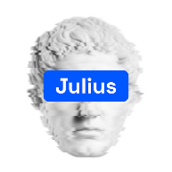 | Julius AI (Caesar Labs) | Advanced data analysis and visualization. Research insights, math equations, tutoring students, and complex analytical tasks.
 | Jasper Chat (Jasper AI) | Business workflow and marketing. Summarize texts and generate paragraphs and product descriptions. 50+ helpful writing templates. Plagiarism checker.
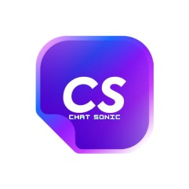 | Chatsonic (Writesonic) | Marketing, voice dictation, story generation, image generation. Write articles for you with its ability to offer up-to-date news stories about current events. Plagiarism checker. Free trial.
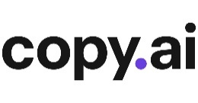 | Copy.AI | Marketing. Useful for social media content, email copy, and ad generation. Optimized for businesses needing quick, compelling copy.
 | You.com | LLM experimentation and testing. Real-time knowledge search engine, math, coding, translating, and writing prompts. Lists sources. Formerly YouChat.
 | HuggingChat (Hugging Face) | Build your very own customizable chatbot and make it available to others. Leverages open models (Open source). Free.
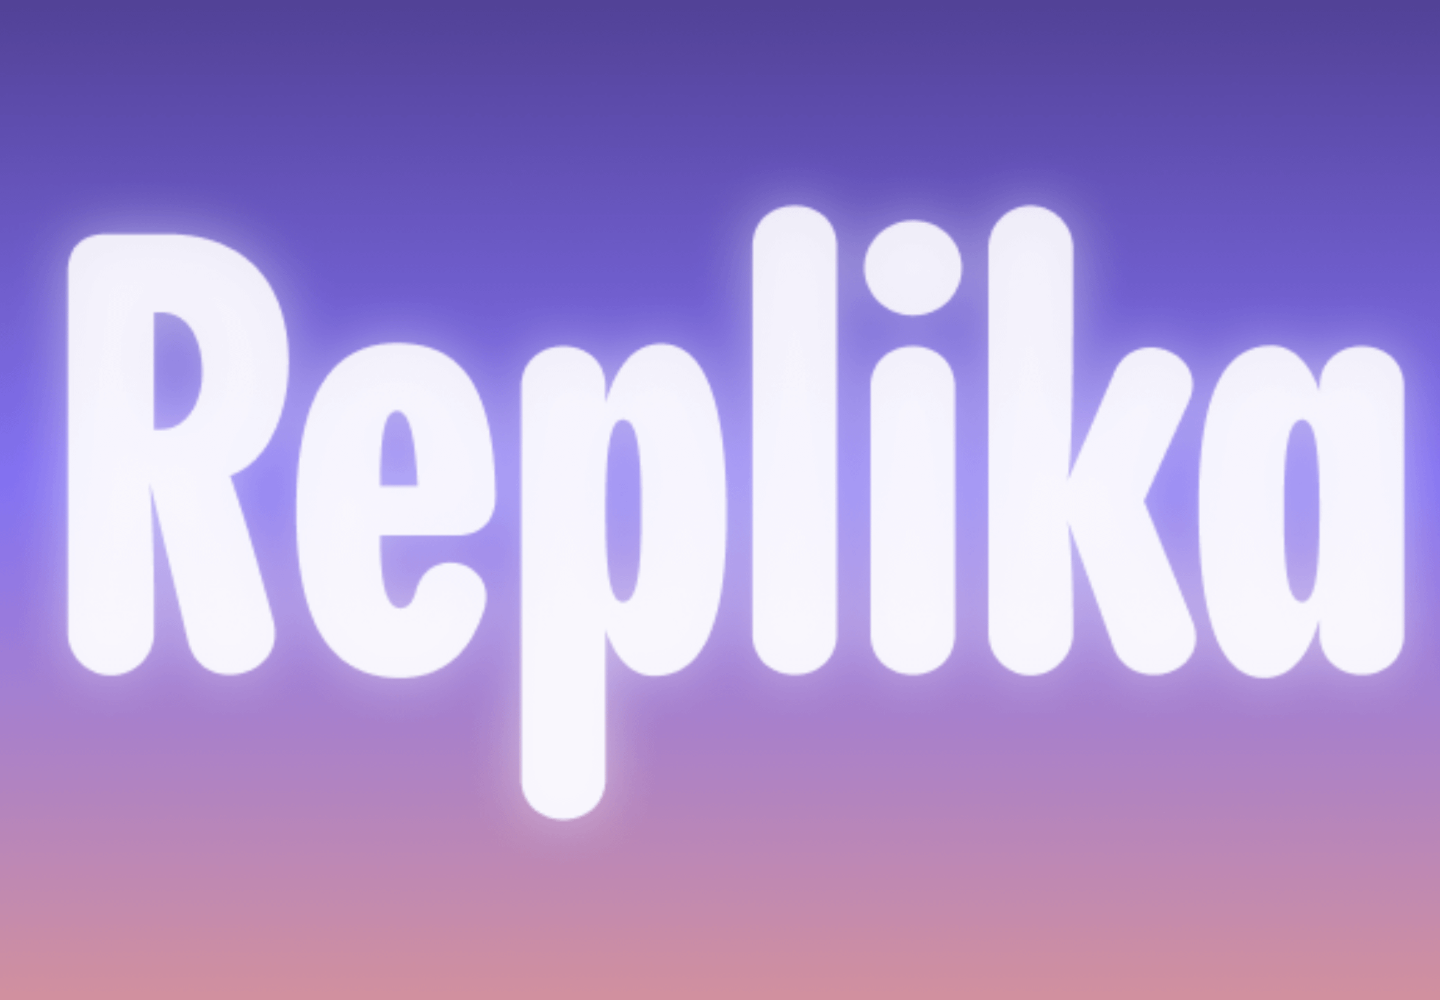 | Replika (Luka) | Mimics human conversation.
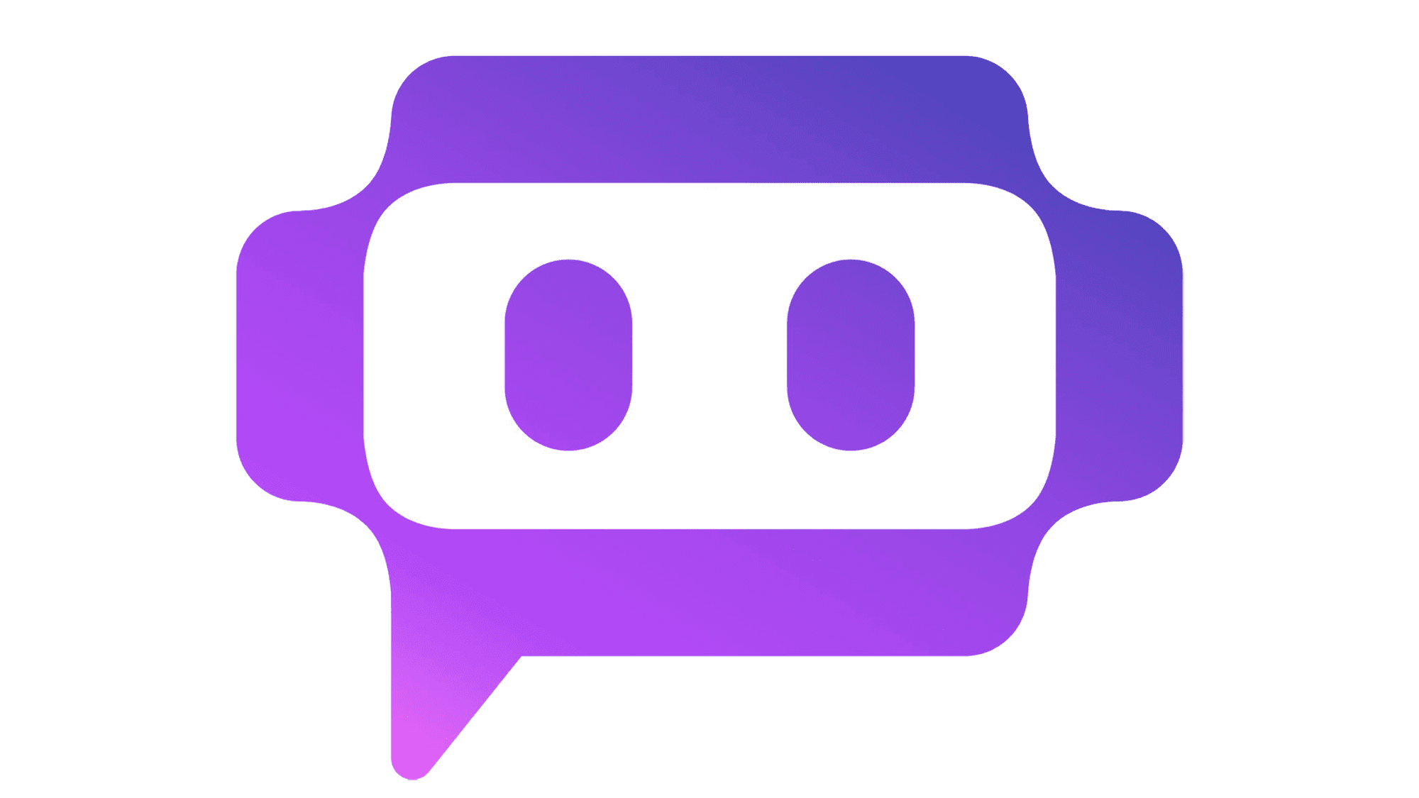 | Poe (Quora) | Poe’s chatbot ‘assistant’ is great at answering all kinds of questions with real-time internet access. Poe, the platform allows users to use other chatbots and even create their own.
 | Character AI (Character.ai) | Create "characters", craft their "personalities", set specific parameters, and then publish them to the community for others to chat with. Generate human-like text responses and participate in contextual conversation. Free, no ads.
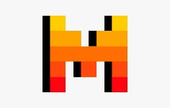 | Mistral Large Chat (Minstrel AI) | Simple experience. Aka Mistral Le Chat.
 | Personal AI (Human AI Labs) | Training AI personas for business and personal use.
 | Pi (Inflection AI) | The first emotionally intelligent AI. Personal use.
 | Merlin AI (Foyer Tech) | Using an AI chatbot through a browser extension. Images, essays, emails, answers, posts, plans, charts.
 | ZenoChat (TextCortex) | ChatGPT alternative. Personal productivity. 10 Free creations daily.
 | Khanmigo AI (Khan Academy) | Education. For teachers and homework.
 | DeepSeek | Open source reasoning model. Chinese owned.

Sources:
- https://originality.ai/blog/ai-chatbot-list
- https://zapier.com/blog/best-ai-chatbot/

