Harold’s Undirected Graphs and Trees
Cheat Sheet
22 October 2022

Definitions

Term | Definition | Example
Vertices  (Nodes) | An individual element of V is called a vertex.  A graph is finite if the vertex set is finite. | Set $V=\{a, b, c, d, e\}$  ① or ●
Edges  (Arcs) | An edge (u, v) ∈ E, is pictured as an arrow going from one vertex to another. | Set E ⊆ V x V  $$E=\{\{a, b\}, \{a, c\}, ..., \{d, e\}\}$$  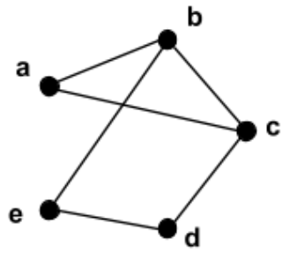
Self-Loop (Loop) | An edge that connects a vertex to itself. | 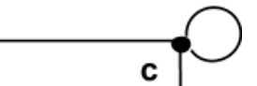
Undirected Graph | A graph whose edges are unordered pairs of vertices. | G = (V, E)  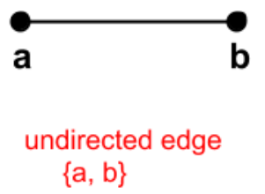
Simple Graph | A graph with no parallel edges or self-loops. | |Cycle| ≥ 3
Adjacent | There is an edge between two vertices. | Two vertices are connected.
Endpoints | Vertices b and e are the endpoints of edge {b, e} | The two vertices of an edge.
Incident | The edge {b, e} is incident to vertices b and e. | The edge of two vertices.
Neighbor | A vertex c is a neighbor of vertex b if and only if {b, c} is an edge. | Has an edge to it.
Degree | The degree of a vertex is the number of neighbors it has. | $$deg(v)$$
Total Degree | The sum of the degrees of all of the vertices. | $$\sum_{v∈V}{deg(v)}=2·|E|$$
Regular Graph | All the vertices have the same degree. | $$deg(a)=deg(b)=deg(c) ...$$
d-Regular Graph | All the vertices have degree d. | 3-Regular Graph:  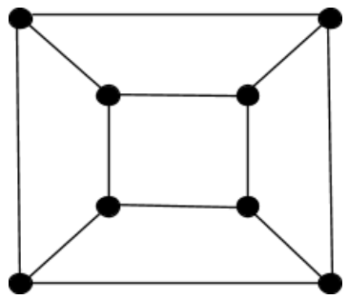
Subgraph | A graph H = (V_{H}, E_{H}) is a subgraph of a graph G = (V_{G}, E_{G}) if V_{H} ⊆ V_{G} and E_{H} ⊆ E_{G}.  Any graph G is a subgraph of itself. | 2-Regular Graph:  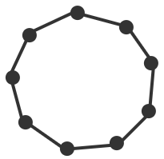
Common Graphs | K₆: Complete Graph (Clique)  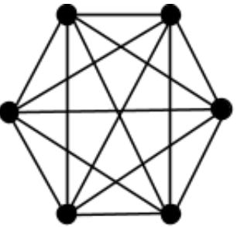  Has an edge between every pair of vertices. | C₇: Cycle  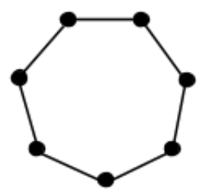
 | Q₃: 3-Dimentional Hypercube  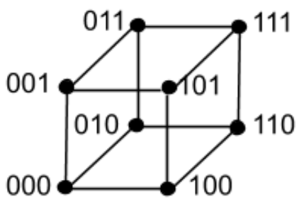  Has 2^{n} vertices. | K_{3,4}:  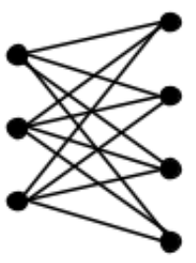  No edges between vertices in the same set.
 | P₅: A path | S₅: Star  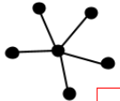
Graph Representation

Term | Description
Adjacency List | Each vertex has a list of all its neighbors.  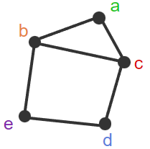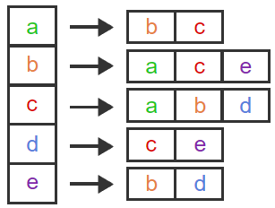
Matrix | A ‘1’ means an edge is present. Is symmetrical about the diagonal (M_{i,j} = M_{j,i}).  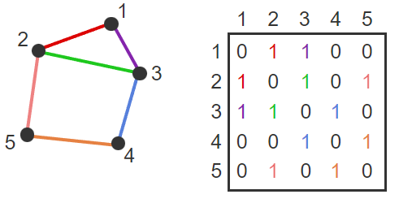
Isomorphic | There is a one-to-one correspondence between each of the edges of two graphs (bijection).
"Efficient" Algorithm | An algorithm that runs in worst-case polynomial time.
Theorem: Vertex degree preserved under isomorphism | Consider two graphs, G and G'. Let f be an isomorphism from G to G'. For each vertex v in G, the degree of vertex v in G is equal to the degree of vertex f(v) in G'.  If one graph has a vertex of degree 1 and the other graph does not, then not isomorphic.
Degree Sequence | A list of the degrees of all of the vertices in non-increasing order.
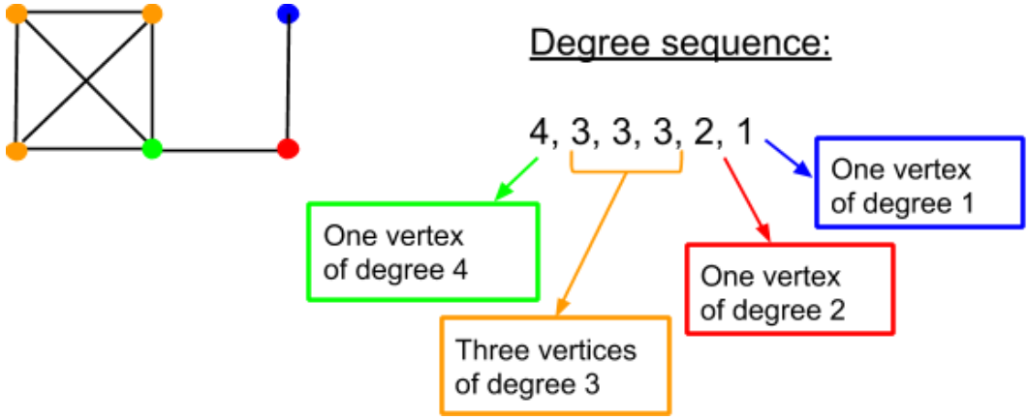
Theorem: Degree sequence preserved under isomorphism | Degree sequence is preserved under isomorphism.  If two graphs are isomorphic, they have the same degree sequence.
Graph Theory | Concerned with properties of graphs that are preserved under isomorphism.  Preserved:  - Number of vertices (|V|)  - Number of edges (|E|)  - Degree sequence (degrees listed high to low)  - Total degree (2·|E|)  Not Preserved:  - The lowest numbered vertex has degree 3  - Every even numbered vertex has odd degree

Graph Types

Term | Description | Example
Walk | A sequence of alternating vertices and edges that starts and ends with a vertex. | $$〈v_{0}, (v_{0}, v_{1}), v_{1}, (v_{1}, v_{2})v_{2}, ..., v_{l}〉$$  $$〈v_{0}, v_{1}, v_{2}, ..., v_{l}〉$$  $$| 〈v_{0}〉 | = 0$$
Open Walk | A walk in which the first and last vertices are not the same. | $$〈a, ... , z〉$$
Closed Walk | A walk in which the first and last vertices are the same. | $$〈a, ... , a〉$$
Length | l, the number of edges in the walk, path, or cycle. | $$l=\left|E\right|$$  $l =|V|-1$ if sequence
Trail | An open walk in which no edge occurs more than once. | $$〈a, b, c, d, c, b, a〉$$
Circuit | A closed walk in which no edge occurs more than once. | $$〈a, b, a, c, a〉$$
Path | A trail in which no vertex occurs more than once. | $$〈a, b, c, d〉$$
Cycle | A circuit of length at least 1 in which no vertex occurs more than once, except the first and last vertices which are the same. | $$〈a, b, c, a〉$$
Walk | No repeated …
 | Edge | Vertex or Edge
Open | Trail | Path
Closed | Circuit | Cycle

Connectivity

Term | Description | Example
Connected | If there is a path from vertex v to vertex w, then there is also a path from w to v. The two vertices, v and w, are said to be connected. | 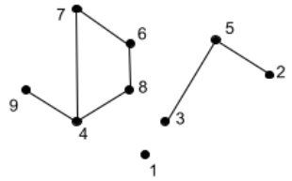
Disconnected | A graph is said to be connected if every pair of vertices in the graph is connected, and is disconnected otherwise.
Connected Component | A maximal set of vertices that is connected. | See graph above for examples.
Isolated Vertex | A vertex that is not connected with any other vertex is called an isolated vertex and is therefore a connected component with only one vertex. | ●
k-Vertex-Connected | The graph contains at least k + 1 vertices and remains connected after any k - 1 vertices are removed from the graph. (mesh network) | 2-vertex-connected:  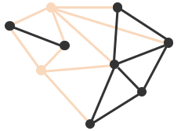
Vertex Connectivity | The largest k such that the graph is k-vertex-connected. | κ(G)  $$κ(K_{n})=n-1$$
k-Edge-Connected | The graph remains connected after any k - 1 edges are removed from the graph. | 3-edge-conncted:  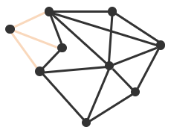
Edge Connectivity | The largest k such that the graph is k-edge-connected. | λ(G)  $$λ(K_{n})=n-1$$
Theorem: Upper bound for vertex and edge connectivity | Let G be an undirected graph. Denote the minimum degree of any vertex in G by δ(G). Then κ(G) ≤ δ(G) and λ(G) ≤ δ(G). | The minimum degree of any vertex is at least an upper bound for both the edge and vertex connectivity of a graph.
Complete Graph | There is no set of vertices whose removal disconnects the graph. | Full mesh network.

Euler Circuits and Trails

Term | Description | Example
Euler Circuit | An undirected graph circuit that contains every edge and every vertex.  Every vertex reached.  Every edge occurs exactly once. | 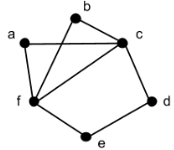
Theorem: Required conditions for an Euler circuit in a graph | If an undirected graph G has an Euler circuit, then G is 1) connected and 2) every vertex in G has an even degree. | $$deg\left(v\right)=2k$$  where $k∈Z^{+}$
Theorem: Sufficient conditions for an Euler circuit in a graph | If an undirected graph G is connected and every vertex in G has an even degree, then G has an Euler circuit.
Theorem: Characterization of graphs that have an Euler circuit | An undirected graph G has an Euler circuit if and only if G is connected and every vertex in G has even degree.
Procedure | Find circuit C in G.  Repeat until C is an Euler circuit:  Create new graph G' :  Remove edges in C from G  Remove isolated vertices  Find vertex w in G' and C (select any)  Find circuit C' in G' starting at w  Combine C and C'  Follow edges in C to w  Follow edges in C' back to w  Follow remaining edges in C  Rename new circuit to be C
Euler Trail | An undirected graph open trail that includes each edge exactly once. | 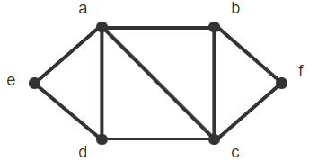
Theorem: Characterizations of graphs that have an Euler trail | An undirected graph G has an Euler trail if and only if G is 1) connected and 2) has exactly two vertices with odd degree. | Euler trail begins and ends with vertices of odd degree.

Tree Terms

Term | Description | Example
Tree | An undirected graph that is connected and has no cycles. | Computer file system
Free Tree | There is no particular organization of the vertices and edges | 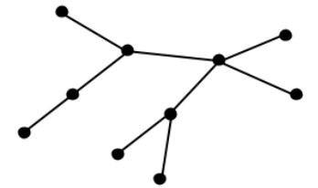
Rooted Tree | The vertex at the top is designated as the root of the tree. | 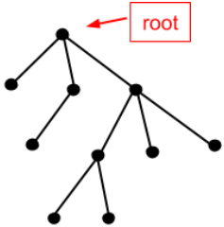
Level | The level of a vertex is its distance (number of edges in the shortest path between the two vertices) from the root. | The root is the only level 0 vertex.
Height | The height of a tree is the highest level of any vertex. | Most hops to bottom.
Parent | The first vertex after v encountered along the path from v to the root. (One vertex above v.) | The parent of vertex g is h.
Child | The vertex below the parent. | Vertices c and g are the children of vertex h.
Ancestor | All vertices up in path. | The ancestors of vertex g are h, d, and b.
Descendant | All vertices down in path. | The descendants of vertex h are c, g, and k.
Leaf | Rooted: A vertex which has no children.  Free: A vertex of degree 1. | The leaves are a, f, c, k, i, and j.  $$deg(v)=1$$
Sibling | Vertices with the same parent. | Vertices h, i, and j are siblings of parent d.
Subtree | A tree consisting of new root v and all v's descendants. | The subtree rooted at h includes h, c, g, and k and the edges between them.
Game Tree | Shows all possible playing strategies of both players in a game.  Games can be deterministic (tic-tac-toe) or chance (dice). | v_{i} = game configuration
Variable Length Codes | The number of bits for each character can vary. | ‘a’ = 1, ‘e’ = 01, etc.
Prefix Code | The code for one character cannot be a prefix of the code for another character. | Leaf nodes guarantee the prefix property.
ASCII | 8-Bit characters (256 max.) | UTF-8
Unicode | 16-Bit characters (64K max.) | UTF-16
Internal Vertex | Free: The vertex has degree at least two. | $$deg(v)≥2$$
Forest | A graph that has no cycles and that is not necessarily connected.  |E|= |V| – |C| (connected components) | 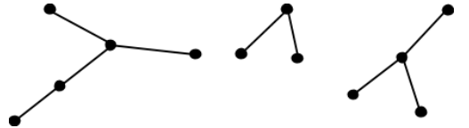

Tree Theorems

Term | Description | Example
Theorem: Unique paths in trees | Let T be a tree and let u and v be two vertices in T. There is exactly one path between u and v.  There is a unique path between every pair of vertices in a tree. | 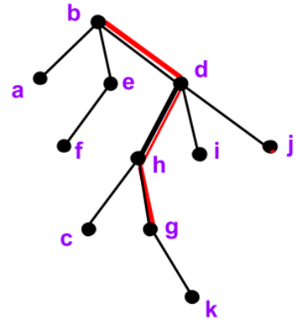
Theorem: Number of edges in a tree | Let T be a tree with n vertices and m edges, then m = n - 1. | $$m=n-1$$
Theorem: Number of leaves in a tree | Any free tree with at least two vertices has at least two leaves. | Lower bound  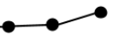
Theorem: Prim's Algorithm | Prim's algorithm finds a minimum spanning tree of the input weighted graph. | See Spanning Trees below

Tree Traversals

Term | Description | Example
Traversal | Systematically visiting each vertex. | Hit a node.
Pre-Order Traversal | A vertex is visited before its descendants. | First hit (left side) of tree vertex
In-Order Traversal | A vertex is visited after its first descendant. | 2nd hit of tree vertex
Post-Order Traversal | A vertex is visited after its descendants. | Last hit (right side) of tree vertex

Spanning Trees

Term | Description | Example
Spanning Tree | For a connected graph G. a subgraph of G which contains all the vertices in G and is a tree. | Fewest edges possible to visit all vertices
Depth-First Search (DFS) | Favors going deep into the graph.  Produces trees with longer paths. | Explorer ventures far away from home
Breadth-First Search (BFS) | Explores the graph by distance from the initial vertex, starting with its neighbors and expanding the tree to neighbors of neighbors.  Produces trees with shorter paths. | Explorer ventures close to home
Weighted Graph | A graph G = (V ,E), along with a function w: E → ℝ. | The function w assigns a real number to every edge.
Weight w(G) | 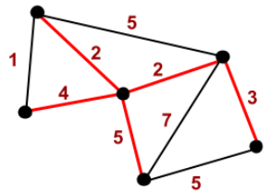 | w(G) is the sum of the weights of the edges in G.
Minimum Spanning Tree (MST) | A spanning tree T of G whose weight is no larger than any other spanning tree of G. | Goal: Min. weight
Prim's Algorithm | A classic algorithm for finding minimum spanning trees developed by mathematician Robert Prim in 1957. | Always choose min. edge in queue.
Input: An undirected, connected, weighted graph G.
Output: T, a minimum spanning tree for G.

T := ∅.
Pick any vertex in G and add it to T.

For j = 1 to n-1
Let C be the set of edges with one endpoint inside T and one endpoint outside T.
Let e be a minimum weight edge in C.
Add e to T.
Add the endpoint of e not already in T to T.
End-for

Sources:
- SNHU MAT 230 - Discrete Mathematics, zyBooks.
- See also “Harold’s Directed Graphs Cheat Sheet”.

