Harold’s Trigonometry
“Cheat Sheet”
18 January 2023

Unit Circle |  |  | Trig Chart
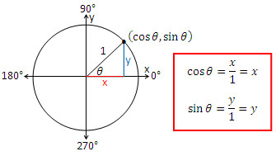 |  |  | (Quadrant I only)  Degrees 0° 30° 45° 60° 90°  Radians 0 $π$/6 $π$/4 $π$/3 $π$/2  $\text{Sin (θ)}$ $$0$$ $$\frac{1}{2}$$ $$\frac{\sqrt{2}}{2}$$ $$\frac{\sqrt{3}}{2}$$ $$1$$  $\text{Cos (θ)}$ $$1$$ $$\frac{\sqrt{3}}{2}$$ $$\frac{\sqrt{2}}{2}$$ $$\frac{1}{2}$$ $$0$$  $\text{Sin (θ)}$ Pattern $$\frac{\sqrt{0}}{2}$$ $$\frac{\sqrt{1}}{2}$$ $$\frac{\sqrt{2}}{2}$$ $$\frac{\sqrt{3}}{2}$$ $$\frac{\sqrt{4}}{2}$$  Tan$\text{ (θ)}$ Pattern $$0$$ $$\frac{{(\sqrt{3})}^{1}}{3}$$ $$\frac{{(\sqrt{3)}}^{2}}{3}$$ $$\frac{{(\sqrt{3})}^{3}}{3}$$ Und
Graphical Representation Of The Six Trig Functions
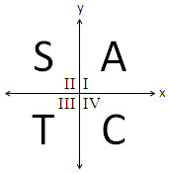
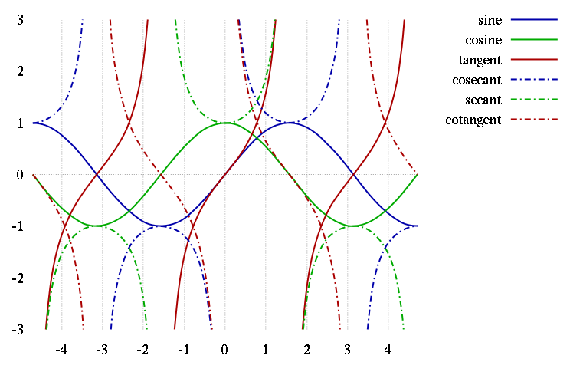
π
$-$π
$$\frac{3π}{2}$$
$$\frac{-3π}{2}$$
$$\frac{-π}{2}$$
$$\frac{π}{2}$$
$$\frac{π}{2}$$
“All Students Take Calculus”

The Six Trig “Levers” | y = a sin (b (x - h)) + k | Graphing Tips |  | Notes
- Move up/down ↕ | k (Vertical translation) | $$k= \frac{(max + min)}{2}$$ |  | If k = f(x) then x-axis is replaced by f(x)-axis
- Move left/right ↔ | h (Phase shift) | ‘+‘ shifts right |  | $$\sin{(x)}=\cos{(x-π/2)}$$
- Stretch up/down ↕ | a (Amplitude) | $$a= \frac{(max – min)}{2}$$ |  | a is NOT peak-to-peak on the y-axis
- Stretch left/right ↔ | b (Frequency $⦁$ 2$π$) | $$T=\frac{2π}{\left|b\right|}= \frac{1}{ƒ}$$ |  | T = peak-to-peak on the $θ$-axis  $T=\frac{π}{|b|}$ for $tan (bx)$ and $cot (bx)$
- Flip about y-axis | b → –b | f(x) → f(-x) |  | Even Function: $\cos{(x)}=\cos{(-x)}$
- Flip about x-axis | a → –a | f(x) → –f(x) |  | Odd Function: $\sin{(x)}=-sin{(-x)}$

Unit Circle
$$(x, y) = (cos θ, sin θ)$$ | $$π rad={180}^{⁰}$$

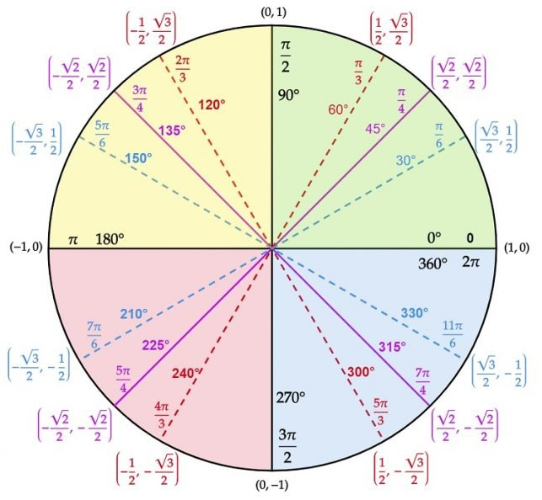

Source: Unit Circle Quick Lesson - Matter of Math
https://matterofmath.com/trigonometry/unit-circle/

