Harold’s Statistics
Hypothesis Testing
Cheat Sheet
23 June 2022

Hypothesis Terms | Definitions
Significance Level ($α$) | Defines the strength of evidence in probabilistic terms. Specifically, alpha represents the probability that tests will produce statistically significant results when the null hypothesis is correct. In most fields, α = 0.05 is used most often.
Confidence Level (c) | The percentage of all possible samples that can be expected to include the true population parameter. α + c = 1
Confidence Interval | A range of values within which you are fairly confident that the true value for the population lies. (e.g., 69% ± 3.8%)
Critical Value (z*) | z* is the critical value of a standard normal distribution under H₀.  Critical values divide the rejection and non-rejection regions.  Set using p-values or to a threshold value of 0.05 (5%) or 0.01 (1%), but always ≤ 0.10 (10%).
Test Statistic (z_{data}) | A value calculated from sample data during hypothesis testing that measures the degree of agreement between the sample data and the null hypothesis.  If z_{data} is inside the rejection region, demarked by z*, then we can reject the null hypothesis, H₀.
p-value | Probability of obtaining a sample “more extreme” than the ones observed in your data, assuming H₀ is true.
Hypothesis | A premise or claim that we want to test.
Null Hypothesis: H₀ | Currently accepted value for a parameter (middle of the distribution).  Is assumed true for the purpose of carrying out the hypothesis test.  - Always contains an “=“ {=, ≤, ≥}  - The null value implies a specific sampling distribution for the test statistic  - H₀ is the middle of the normal distribution curve at $z=0$.  - Can be rejected, or not rejected, but NEVER supported
Alternative Hypotheses: H_{a} | Also called Research Hypothesis or H₁. Is the opposite of H₀ and involves the claim to be tested. Is supported only by carrying out the test if the null hypothesis can be rejected.  - Always contains “>“ (right-tailed), “<” (left-tailed), or “≠” (two-tailed) [tail selection is important]  - Can be supported (by rejecting the null), or not supported (by failing or rejecting the null), but NEVER rejected

Hypothesis Testing | Steps
Hypothesis Testing  (for one population) | - Claim: Formulate the null (H₀) and the alternative (H_{a}) hypothesis  - Graph: Sketch and label critical value (left-tailed, right-tailed, two-tailed)  - Decision Rule: Use significance level (α), confidence level (c), confidence Interval, or critical value z*. e.g., We will reject H₀ if z_{data} > 1.645.  - Critical Value: Determine critical values (z*) to mark the rejection regions  - Test Statistic: Calculate the test statistic (z_{data} or t_{data}) from the sample data  - p-Value: Use the test statistic to find the p-value  - Conclusion: Reject the null hypothesis (supporting the alternative hypothesis) otherwise fail to reject the null hypothesis, then state claim

1) Claim: Formulate Hypothesis
If claim consists of … | then the hypothesis test is | and is represented by…
“is equal to”, “is exactly”, “is the same as”, “is between”  “is at least”  “is at most” | Two-tailed =  Left-tailed ≤  Right-tailed ≥ | H₀
“is not equal to”, “is different from”, “has changed from”  “is less than”, “is below”, “is lower or smaller than”, “reducing”  “is greater than”, “is above”, “is longer or bigger than” | Two-tailed ≠  Left-tailed <  Right-tailed > | H_{a}
Make sure H₀ + H_{a} = all possible outcomes.
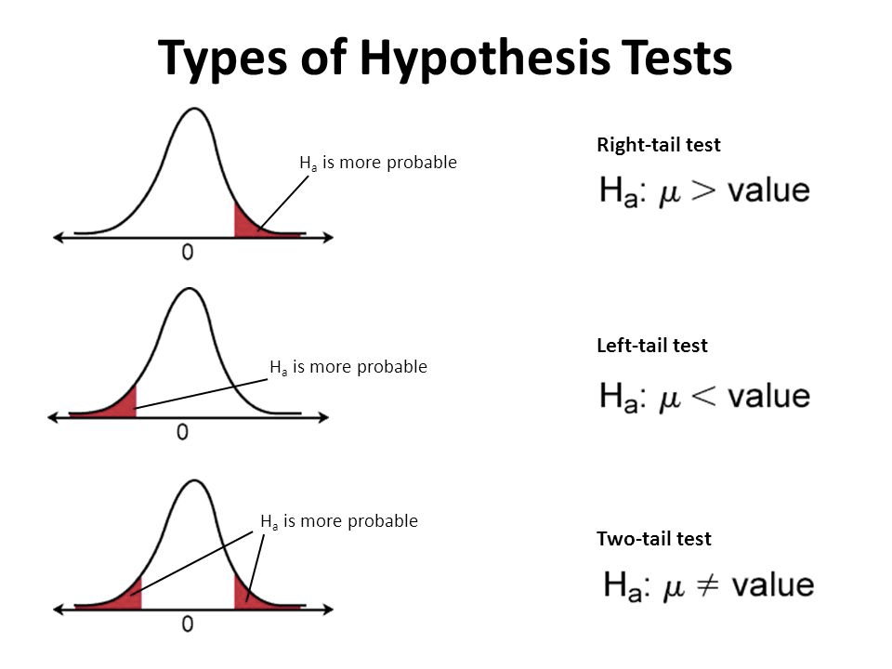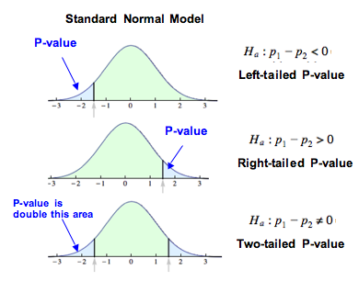

2) Graph: Sketch and Label
Sketch and label critical value (z* or z_{c}). |  | Look at the direction of the inequality symbol in H_{a} to determine where to shade.
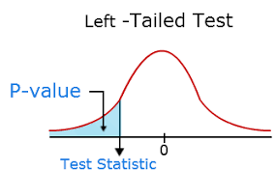 |  | 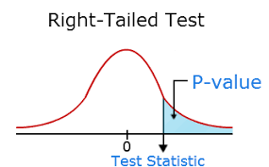
Two-Tailed Test  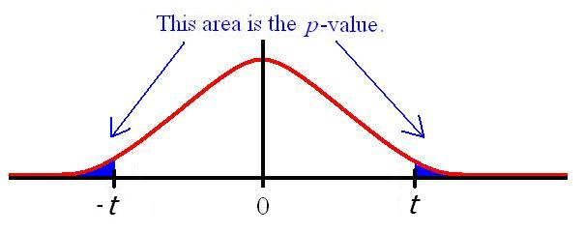 |  | Right-Tailed Test  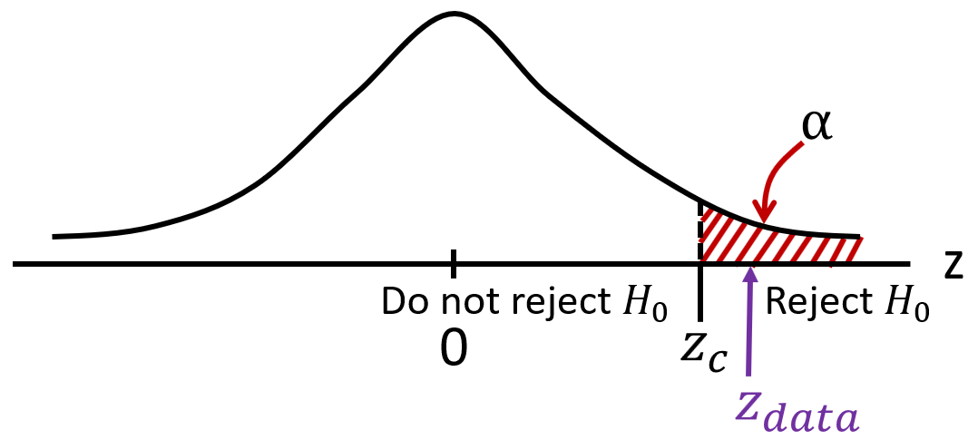
3) Decision Rule
p-value | Use probability value to determine $z_{c}$ in a Normal distribution table.
Significance level ($α$) | $$α=1-c$$  Usually at a threshold value of 0.05 (5%) or 0.01 (1%), but always ≤ 0.10 (10%).  The significance level α is the area under the curve outside the confidence interval.
Confidence Level (c) | $$c=1-α$$  With a confidence of 0.95 (95%) or 0.99 (99%), but always ≥ 0.90 (90%).
Confidence Interval for µ | A 95% confidence interval means that the interval calculated has a probability of 95% containing the population mean, µ.  σ known, normal population or large sample (n)  $$z interval=\overline{x}±SE\left(\overline{x}\right)$$  $$=\overline{x} ± z^{*}\frac{σ}{\sqrt{n}}$$  $$=[\overline{x}-SE(\overline{x}), \overline{x}+SE(\overline{x})]$$  $$\frac{α}{2}=\frac{1-c}{2}$$  $$z^{*}=z_{α/2}=z-score for probabilities of α/2 (two-tailed)$$
Examples | We will reject the null hypothesis (H₀) if:  - Significance level (α) is less than 5%  - Confidence level (c) is greater than 95%  - Confidence interval is between 5% and 95% (± 5%)  z_{data} > z* in a right-tailed test
Python | import scipy.stats as st  n = 100  df = n - 1  mean = 219  stderr = (sd = 35.0)/(n ** 0.5)  print(st.t.interval(0.95, df, mean, stderr))

4) Determine Critical Values (z*) / Rejection Region
Critical Values (z*) | Determine z* by looking up $α$, c, or p-values in a standard normal distribution table. Two-tailed tests have two values for z*.  Significance Level ($α$) Confidence Level (c) Critical Value  α = 0.10 c = 0.90 z* = 1.645  α = 0.05 c = 0.95 z* = 1.960  α = 0.01 c = 0.99 z* = 2.576  .

5) Calculate Test Statistic ($z_{data}$) or z-score
Population Mean (µ) / Sample Mean ($\overline{x}$) |  | $$z_{data}=\frac{\overline{x}-μ}{SE(x)}= \frac{\overline{x}-μ}{σ/{\sqrt{n}}}$$ | Variance known.  Assumes data is normally distributed or $n≥30$ since $t$ approaches standard normal $Z$ if n is sufficiently large due to the CLT.
 |  | $$t_{data}= \frac{\overline{x}-μ}{SE(\overline{x})}=\frac{\overline{x}-μ}{s/{\sqrt{n}}}$$ | Variance unknown.  $t$ distribution, $df=n-1$ under $H_{0}$.
Population Proportion $(p)$ / Sample Proportion $(\hat{p})$ |  | $$z_{data}= \frac{\hat{p}-p}{SE\left(\hat{p}\right)}=\frac{\hat{p}-p}{\sqrt{\frac{p(1-p)}{n}}}$$ | Population proportion known.  To be statistically significant, this assumes$np≥15 and n(1-p)≥15$.
 |  | Worst Case: $p=0.50$  $$z_{data}= \frac{\hat{p}-p}{SE\left(\hat{p}\right)}=\left(2\hat{p}-1\right) \sqrt{n}$$ | Population proportion unknown.
Python  (1 mean) | from statsmodels.stats.weightstats import ztest  import pandas as pd  from statsmodels.stats.proportion import proportions_ztest  scores = pd.read_csv('http://data-analytics.zybooks.com/ExamScores.csv')  print(ztest(x1 = scores['Exam1'], H0_value = 86))  print(st.ttest_1samp(scores['Exam1'], H0_value = 82))  print(proportions_ztest(count, nobs, value, prop_var = value)) |  |  | (-2.5113146627890988, 0.012028242796839027)  z-score = 2.511  p-value = 0.0120 / 2 = 0.0060  Ttest_1sampResult(statistic=0.5327, pvalue=0.5966)
Python  (2 means) | from statsmodels.stats.weightstats import ztest  sample1 = [21, 28, 40, 55, 58, 60]  sample2 = [13, 29, 50, 55, 71, 90]  print(ztest(x1 = sample1, x2 = sample2, value = 0)) |  |  | (-0.58017208108908169, 0.56179857900464247)  z-score = -0.5802  p-value = 0.5618 (two-tailed)

6) Calculate p-value
p-value | TI-84: DISTR 2: normalcdf(z_data, 99999999) = p  Python:  ztest(x1 = scores['Exam1'], H0_value = 86) # 1-mean  ztest(x1 = sample1, x2 = sample2, value = 0) # 2-means
 | 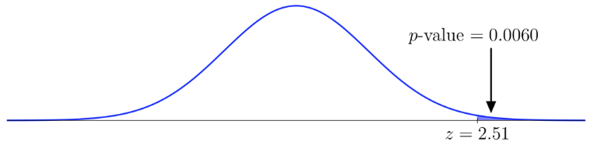

7) Conclusion
Statistical Decision | Reject the null hypothesis (supporting the alternative hypothesis) using a test below.
Conclusions of p-test | If p–value < α $⇒$ Reject H₀ in favor of H_{a}.  If p–value ≥ α $⇒$ Fail to Reject H₀.
Conclusions of mean test | If significance level ($α$) is less than 5% $⇒$ Reject H₀ in favor of H_{a}.  If confidence level (c) is greater than 95% $⇒$ Reject H₀ in favor of H_{a}.  If test statistic is greater than (right-tailed) the critical value, z_{data} > z* $⇒$ Reject H₀.
Conclusions of Confidence Interval for µ / z interval | Reject the null hypothesis if the test statistic falls in the rejection region otherwise, fail to reject the null hypothesis.  If confidence interval is between 5% and 95%, meaning ($±$5%) $⇒$ Reject H₀.

Hypothesis Testing Error Types
Ideally, a statistical test should have a low significance level (α) and high power (1−β).  Type I Error (α): False Positive  Type II Error (β): False Negative | 