Harold’s Probability
Cheat Sheet
22 October 2022

Probability
Rule | Formula | Definition
Notation | $∩$ = “and”, Intersection, or “$∧$”  $∪$ = “or”, Union, or “$∨$”  $\overline{˽}=$“not”, negation, or “$¬$” | “and” implies multiplication.  “or” implies addition.  “not” implies negation.
Independent | If $P\left(A | B\right)=P(A)$ | The occurrence of one event does not affect the probability of the other, or vice versa.
Dependent | If $P\left(A∩B\right)≠∅$ | The occurrence of one event affects the probability of the other event.
Disjoint  (“mutually exclusive”) | If $P\left(A∩B\right)=∅$  Then $P\left(A∪B\right)=P\left(A\right)+P\left(B\right)$ | The events can never occur together.
Probability  (“likelihood”) | $$0≤P\left(E\right)≤1$$  $$P\left(E\right)=\frac{\# Events (E)}{Sample Space \left(S\right)} = \frac{\# of Favorable Outcomes}{Total \# of Possible Outcomes}$$
Addition Rule  (“or”) | $$P\left(A∪B\right)=P\left(A\right)+P\left(B\right)-P(A∩B)$$ | 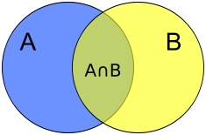  S
Multiplication Rule  (“and”) | if independent or disjoint:  $$P\left(A∩B\right)=P\left(A\right) P(B)$$  $$P\left(A∩B∩C\right)=P\left(A\right) P\left(B\right) P(C)$$  if dependent:  $$P\left(A∩B\right)=P\left(A\right) P\left(B | A\right)$$  $$P\left(A∩B\right)=P\left(B\right) P(A|B)$$  $$P\left(A∩B\right)=P\left(A\right)-P\left(A∩\overline{B}\right)$$
Complement Rule / Subtraction Rule  (“not”) | $$P\left(S\right)=P\left(A∪\overline{A}\right)=$$  $$P\left(A\right)+P\left(\overline{A}\right)=1$$  $$P(A)=1-P\left(\overline{A}\right)$$  $$P(\overline{A})=1-P\left(A\right)$$  $$P\left(A | B\right)+P\left(\overline{A} | B\right)=1$$ | The complement of event A (denoted $\overline{A} or A^{c})$ means “not A”; it consists of all simple outcomes that are not in A.
Conditional Probability  (“given that”) | $$P\left(A | B\right)=\frac{P(A∩B)}{P(B)}$$  if independent or disjoint:  $$P\left(A | B\right)=P(A)$$  $$P\left(B | A\right)=P(B)$$ | Means the probability of event A given that event B occurred. Is a rephrasing of the Multiplication Rule. P(A|B) is the proportion of elements in B that are ALSO in A.
Total Probability Rule | $$P\left(A\right)=P(A∩B_{1})+…+P(A∩B_{n})$$  $$=P\left(B_{1}\right) P\left(A | B_{1}\right)+…+P\left(B_{n}\right) P\left(A | B_{n}\right)$$  $$P\left(A\right)=P(A∩B)+P(A∩\overline{B})$$  $$=P\left(B\right) P\left(A | B\right)+P\left(\overline{B}\right) P\left(A | \overline{B}\right)$$ | To find the probability of event A, partition the sample space into several disjoint events. A must occur along with one and only one of the disjoint events.
Bayes’ Theorem | $$P\left(A | B\right)=\frac{P\left(A∩B\right)}{P\left(B\right)}=\frac{P\left(A\right) P\left(B | A\right)}{P\left(B\right)}$$  $$=\frac{ P\left(A\right) P\left(B | A\right)}{P\left(A\right) P\left(B | A\right)+P\left(\overline{A}\right) P\left(B | \overline{A}\right)}$$ | Allows P(A|B) to be calculated from P(B|A).  Meaning it allows us to reverse the order of a conditional probability statement, and is the only generally valid method!
De Morgan’s Law | $$\overline{P\left(A∪B\right)}≡\overline{P(A)}∩\overline{P(B)}$$  $$\overline{P\left(A∩B\right)}≡\overline{P(A)}∪\overline{P(B)}$$ | Uses negation to convert an “or” to an “and”.  Uses negation to convert an “and” to an “or”.

Discrete Distributions
Distribution | Formula
Probability Distribution | $$\sum_{s∈S}{p(s)=1}$$
Factorial | $$n!=n ⦁ \left(n-1\right) ⦁ \left(n-2\right) ⦁…⦁ 3 ⦁ 2 ⦁ 1$$
Permutation | $$P(n,r)={{}_{n}^{ }P}_{r}=\frac{n!}{\left(n-r\right)!}$$
Combination | $$C(n,r)={{}_{n}^{ }C}_{r}=\left({n \atop r}\right)=\frac{n!}{r!\left(n-r\right)!}$$
Uniform Discrete Distribution | $$P\left(X=x\right)=\frac{1}{b-a+1}$$  $$P\left(S=s\right)=\frac{1}{\left|S\right|} per outcome$$  $$P\left(S=E\right)=\frac{\left|E\right|}{\left|S\right|} per event$$
Binomial Distribution | $$P\left(X=k\right)=\left({n \atop k}\right)p^{k}{\left(1-p\right)}^{n-k}$$
Geometric Distribution | $$P\left(X≤x\right)=q^{x-1}p={(1-p)}^{x-1}p$$  $$P\left(X>x\right)=q^{x}={(1-p)}^{x}$$
Poisson Distribution | $$P\left(X=x\right)=\frac{λ^{x}e^{-λ}}{x!}, x=0,1,2,3,4,…$$
Bernoulli Distribution | $$P\left(k;p\right)={p^{k}(1-p)}^{1-k} for k ∈\{0, 1\}$$
Trinomial Distribution | $$P(X=x,Y=y)=\frac{n!}{x!y!(n-x-y)!}p_{1}^{x}p_{2}^{y}{(1-p_{1}-p_{2})}^{n-x-y}$$
Hypergeometric Distribution | $$P(x|N, m, n)=\frac{\left(\left({m \atop x}\right)\left({N-m \atop n-x}\right)\right)}{\left({N \atop n}\right)}$$
Negative Binomial Distribution | $$P(X=r)= _{n+r-1}C_{r-1}{ p}^{r} q^{n}$$

Venn Diagrams
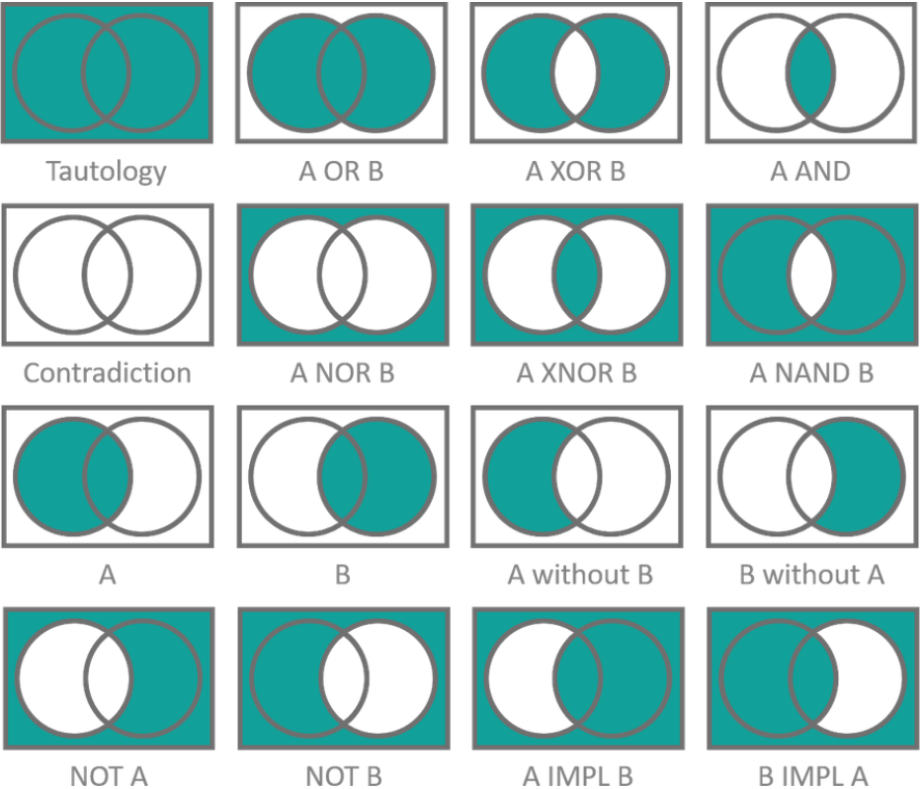
B

Sources:
- SNHU MAT 229 - Mathematical Proof and Problem Solving, How To Prove It - A Structured Approach, 3rd Edition - Daniel J. Vellman, Cambridge University Press, 2019.
- SNHU MAT 230 - Discrete Mathematics, zyBooks.

