Harold’s Prime Numbers
Cheat Sheet
10 July 2025

Prime Numbers

Range | # | Prime Numbers
1 to 100 | 25 | 2, 3, 5, 7, 11, 13, 17, 19, 23, 29, 31, 37, 41, 43, 47, 53, 59, 61, 67, 71, 73, 79, 83, 89, 97
101-200 | 21 | 101, 103, 107, 109, 113, 127, 131, 137, 139, 149, 151, 157, 163, 167, 173, 179, 181, 191, 193, 197, 199
201-300 | 16 | 211, 223, 227, 229, 233, 239, 241, 251, 257, 263, 269, 271, 277, 281, 283, 293
301-400 | 16 | 307, 311, 313, 317, 331, 337, 347, 349, 353, 359, 367, 373, 379, 383, 389, 397
401-500 | 17 | 401, 409, 419, 421, 431, 433, 439, 443, 449, 457, 461, 463, 467, 479, 487, 491, 499
501-600 | 14 | 503, 509, 521, 523, 541, 547, 557, 563, 569, 571, 577, 587, 593, 599
601-700 | 16 | 601, 607, 613, 617, 619, 631, 641, 643, 647, 653, 659, 661, 673, 677, 683, 691
701-800 | 14 | 701, 709, 719, 727, 733, 739, 743, 751, 757, 761, 769, 773, 787, 797
801-900 | 15 | 809, 811, 821, 823, 827, 829, 839, 853, 857, 859, 863, 877, 881, 883, 887
901-1000 | 14 | 907, 911, 919, 929, 937, 941, 947, 953, 967, 971, 977, 983, 991, 997
1001-1100 | 16 | 1009, 1013, 1019, 1021, 1031, 1033, 1039, 1049, 1051, 1061, 1063, 1069, 1087, 1091, 1093, 1097
1101-1200 | 12 | 1103, 1109, 1117, 1123, 1129, 1151, 1153, 1163, 1171, 1181, 1187, 1193
1201-1300 | 15 | 1201, 1213, 1217, 1223, 1229, 1231, 1237, 1249, 1259, 1277, 1279, 1283, 1289, 1291, 1297
1301-1400 | 11 | 1301, 1303, 1307, 1319, 1321, 1327, 1361, 1367, 1373, 1381, 1399
1401-1500 | 17 | 1409, 1423, 1427, 1429, 1433, 1439, 1447, 1451, 1453, 1459, 1471, 1481, 1483, 1487, 1489, 1493, 1499
1501-1600 | 12 | 1511, 1523, 1531, 1543, 1549, 1553, 1559, 1567, 1571, 1579, 1583, 1597
1601-1700 | 15 | 1601, 1607, 1609, 1613, 1619, 1621, 1627, 1637, 1657, 1663, 1667, 1669, 1693, 1697, 1699
1701-1800 | 12 | 1709, 1721, 1723, 1733, 1741, 1747, 1753, 1759, 1777, 1783, 1787, 1789
1801-1900 | 12 | 1801, 1811, 1823, 1831, 1847, 1861, 1867, 1871, 1873, 1877, 1879, 1889
1901-2000 | 13 | 1901, 1907, 1913, 1931, 1933, 1949, 1951, 1973, 1979, 1987, 1993, 1997, 1999
2001-2100 | 14 | 2003, 2011, 2017, 2027, 2029, 2039, 2053, 2063, 2069, 2081, 2083, 2087, 2089, 2099
2101-2200 | 10 | 2111, 2113, 2129, 2131, 2137, 2141, 2143, 2153, 2161, 2179
2201-2300 | 15 | 2203, 2207, 2213, 2221, 2237, 2239, 2243, 2251, 2267, 2269, 2273, 2281, 2287, 2293, 2297
2301-2400 | 15 | 2309, 2311, 2333, 2339, 2341, 2347, 2351, 2357, 2371, 2377, 2381, 2383, 2389, 2393, 2399
Primes

Term | Definition or Formula
Prime Numbers ($p$) | - A natural number which has exactly two factors, 1 and itself.  - $p>1$
Composite Numbers ($n$) | - A natural number that has more than two factors.  - It can be divided 1, itself, and by at least one natural number.  - 1 is not a composite number.
The Fundamental Theorem of Arithmetic | - Each positive integer is either prime or the product of powers of primes.  - Every integer greater than 1 can be factored uniquely into a product of primes.  - Every positive integer other than 1 can be expressed uniquely as a product of prime numbers where the prime factors are written in non-decreasing order.
Prime Factorization | $$n=p_{1}^{e_{1}} p_{2}^{e_{2}} p_{3}^{e_{3}}… p_{k}^{e_{k}}$$  where e_{i} is the multiplicity of prime p_{i}
Greatest Common Divisor (GCD) | Given  $$x=p_{1}^{α_{1}} p_{2}^{α_{2}} p_{3}^{α_{3}}… p_{k}^{α_{k}}$$  $$y=p_{1}^{β_{1}} p_{2}^{β_{2}} p_{3}^{β_{3}}… p_{k}^{β_{k}}$$  $$gcd (x,y)=p_{1}^{min\{α_{1},β_{1}\}}·p_{2}^{min\{α_{2},β_{2}\}}·p_{k}^{min\{α_{k},β_{k}\}}$$  Largest positive integer that is a factor of both x and y.  Think Intersection (∩) of $α_{i},β_{i}$.
Least Common Multiple (LCM) | $$lcm (x,y)=p_{1}^{max\{α_{1},β_{1}\}}·p_{2}^{max\{α_{2},β_{2}\}}·p_{k}^{max\{α_{k},β_{k}\}}$$  Smallest positive integer that is an integer multiple of both x and y.  Think Union (∪) of $α_{i},β_{i}$.
Relatively Prime (Coprime) | $$\gcd\left(x,y\right)=1$$

Prime Theorems

Theorem | Description
∞ Primes | There are an infinite number of primes.
Prime Number Theorem (Counting) | Let π(x) be the number of prime numbers in the range from 2 through x.  $$π(x)≈\frac{x}{ln x} or \lim_{x → ∞}{ \frac{π(x)}{x/{ln x}}}=1$$  $$\frac{x}{\ln{x}}<π\left(x\right)<1.25506 \frac{x}{\ln{x}} for x≥17$$
Chance of a Prime # | For a random positive n-digit integer, $P(n)=\frac{1}{n ln(10)}≈\frac{0.4343}{n}$.
n^{th} Prime Number | $$p_{n}\sim n·\ln{(n)}$$

Prime Number Spirals

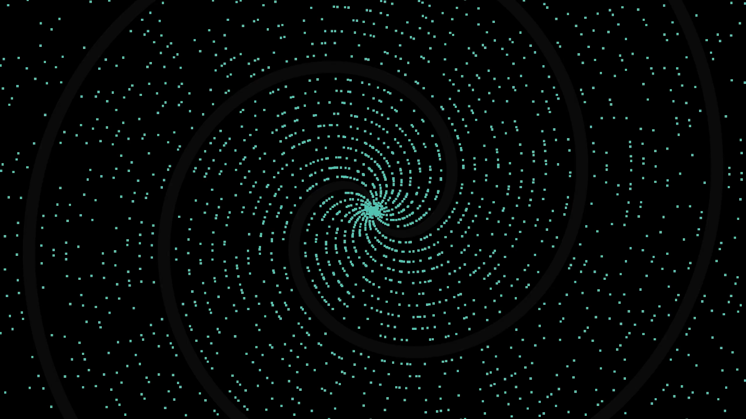
Spiral Points | $$\left(r,θ\right)=(p,p)$$
Significance of Primes | The role prime numbers play in math is similar to the role atoms play in chemistry. They're the fundamental building blocks of the integers.

Sources:
- SNHU MAT 230 - Discrete Mathematics, zyBooks.
- SNHU MAT 260 - Cryptology, Invitation to Cryptology, 1st Edition, Thomas Barr, 2001.
- The Is This Prime? Game. https://isthisprime.com/game/
- Sanderson, Grant (8 Oct 2019). 3Blue1Brown, Why do prime numbers make these spirals? https://www.3blue1brown.com/lessons/prime-spirals

