Harold’s Polynomials
Cheat Sheet
14 May 2026

Polynomials

Description | Name | Equation | Max. Roots
0th Degree | Constant | $$y=a$$ | 0
1st Degree | Linear | $$ax+b=0$$ | 1
2nd Degree | Quadratic | $$ax^{2}+bx+c=0$$ | 2
3rd Degree | Cubic | $$ax^{3}+bx^{2}+cx+d=0$$ | 3
4th Degree | Quartic | $$ax^{4}+bx^{3}+cx^{2}+dx+e=0$$ | 4
5th Degree | Qunitic | $$ax^{5}+bx^{4}+cx^{3}+dx^{2}+ex+f=0$$ | 5
n^{th} Degree | $$P_{n}(x)$$ | $$a_{n}x^{n}+a_{n-1}x^{n-1}+ ...+ a_{1}x+ a_{0}=0$$ | $$n$$

0. Constant Formula ($a$)

Description | Equation | Notes
Constant Formula Equation | $$y=a$$
Solution | No roots | Only true if $a=0$, then trivial solution.
Graph | No Real roots  $$y=2$$  $$r_{1}=DNE$$ | 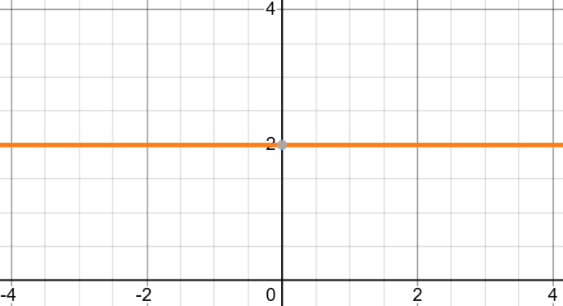

1. Linear Formula (x)

Description | Equation | Notes
Linear Formula Equation | $$ax+b=0$$ | $a$ and $b$ can be negative.
Solution | $$x=-\frac{b}{a}$$ | Simple algebra solution
Graph | 1 Real root  $$y=2x+2$$  $$r_{1}=-1$$ | 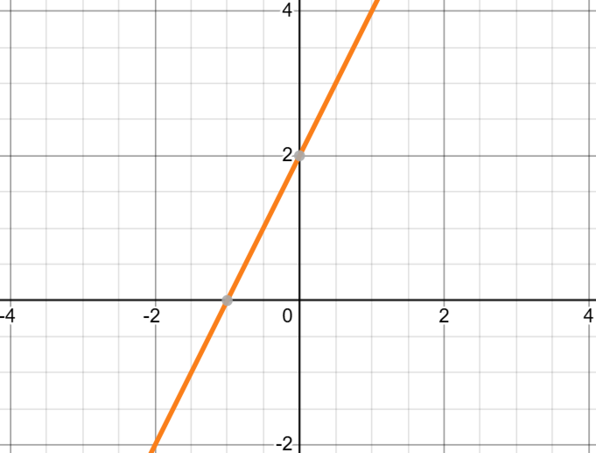
2. Quadratic Formula (x²)

Description | Equation |  | Notes
Quadratic Formula Equation | $$ax^{2}+bx+c=0$$ |  | Remember, $b$ and $c$can be negative.
Quadratic Formula  (zeros, roots, x-intercepts) | $$r_{1,2}=\frac{-b±\sqrt{b^{2}-4ac}}{2a}$$ |  | Discriminant:  - $b^{2}-4ac>0$: two real unequal roots  - $b^{2}-4ac=0$: repeated real roots (multiplicity of two)  - $b^{2}-4ac<0$: two complex roots
Completing the Square | - Start with the quadratic formula form  $$ax^{2}+bx+c=0$$  - Divide both sides by $a$  $$x^{2}+\left(\frac{b}{a}\right)x+\left(\frac{c}{a}\right)=0$$  - Subtract the constant on the left to move it to the right side  $$x^{2}+\left(\frac{b}{a}\right)x=-\left(\frac{c}{a}\right)$$  - Cut the middle term in half, square it, then add it to both sides  $$x^{2}+\left(\frac{b}{a}\right)x+{\left(\frac{b}{2a}\right)}^{2}=-\left(\frac{c}{a}\right)+{\left(\frac{b}{2a}\right)}^{2}$$  - Use an identity to factor the left side  $$a^{2}+2ab+b^{2}={\left(a+b\right)}^{2}$$  $${\left[x+\left(\frac{b}{2a}\right)\right]}^{2}={\left(\frac{b}{2a}\right)}^{2}-\left(\frac{c}{a}\right)\left(\frac{4a}{4a}\right)$$  - Take the square root of both sides  $$x+\left(\frac{b}{2a}\right)=±\frac{\sqrt{b^{2}-4ac}}{2a}$$  - Solve for $x$ by subtracting the constant on the left to move it to the right  $$x=\frac{-b±\sqrt{b^{2}-4ac}}{2a}$$
Vertex | Vertex: $x=-b/2a$  Finds the minimum / maximum of a parabola.
Vertex | $$\frac{d}{dx}\left[cx^{n}\right]=cnx^{n-1}=0$$  Calculus Power Rule method
Graphs | 0 Real roots  $$y={(x-2)}^{2}+1$$  $$r_{1,2}=Complex$$  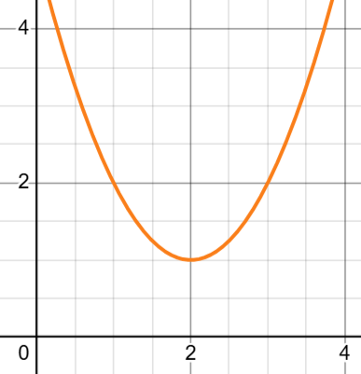 | 2 Real same roots  $$y={(x-2)}^{2}$$  $$r_{1,2}=2$$  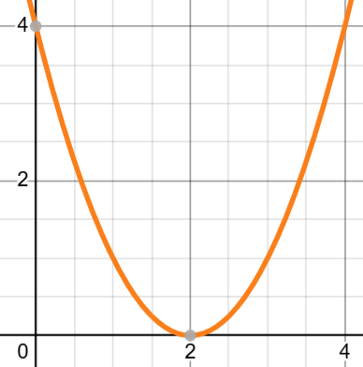 |  | 2 Real different roots  $$y={(x-2)}^{2}-1$$  $$r_{1}=1, r_{2}=3$$  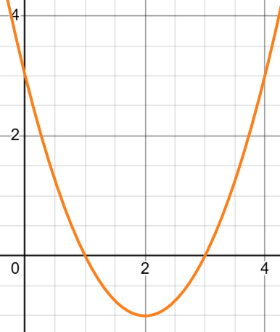
3. Cubic Formula (x³)

Description | Equation
Cubic Formula Equation | $$ax^{3}+bx^{2}+cx+d=0$$
Solution | $$∆_{0} =b^{2}-3ac$$  $$∆_{1} ={2b}^{3}-9abc+27a^{2}d$$  $$C=\sqrt[3]{\frac{∆_{1}+\sqrt{∆_{1}^{2}-{4∆}_{0}^{3}}}{2}}$$  $$r_{1}=-\frac{1}{3a}\left(b+C+\frac{∆_{0}}{C}\right)$$  $$r_{2,3}=-\frac{1}{3a}\left(b+\frac{-1±i\sqrt{3}}{2}C+\frac{-1∓i\sqrt{3}}{2}\frac{∆_{0}}{C}\right)$$
Graphs | 3 Real different roots  $$y=x^{3}-4x$$  $$r_{1}=-2, r_{2}=0, r_{3}=2$$  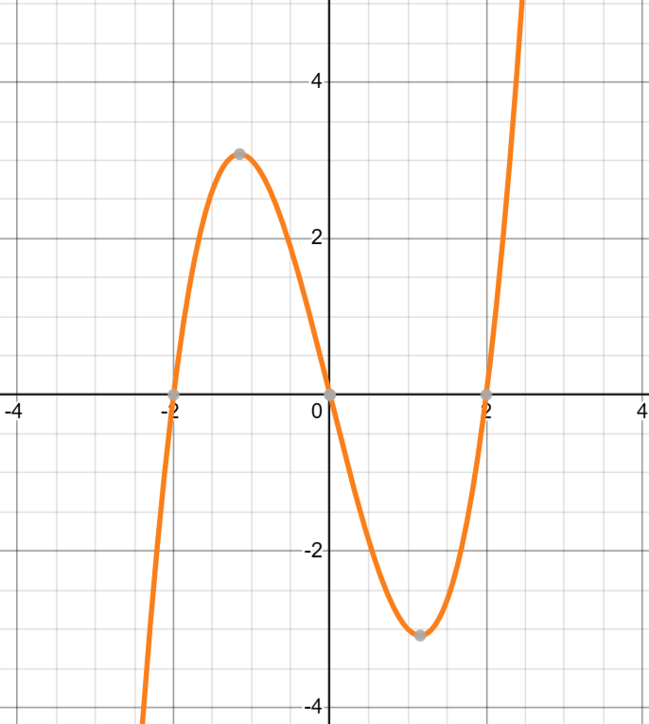 | 3 Real same roots  $$y=x^{3}-3x^{2}+3x-1$$  $$r_{1,2,3}=1$$  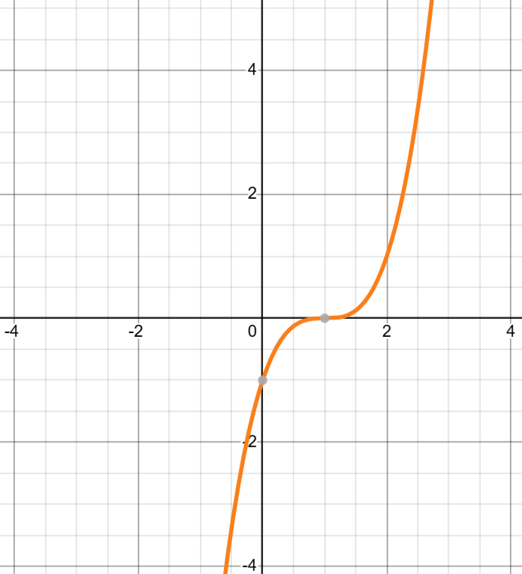
Graphs | 2 Real different roots  $$y=x^{3}-5x^{2}+8x-4$$  $$r_{1}=1, r_{2,3}=2$$  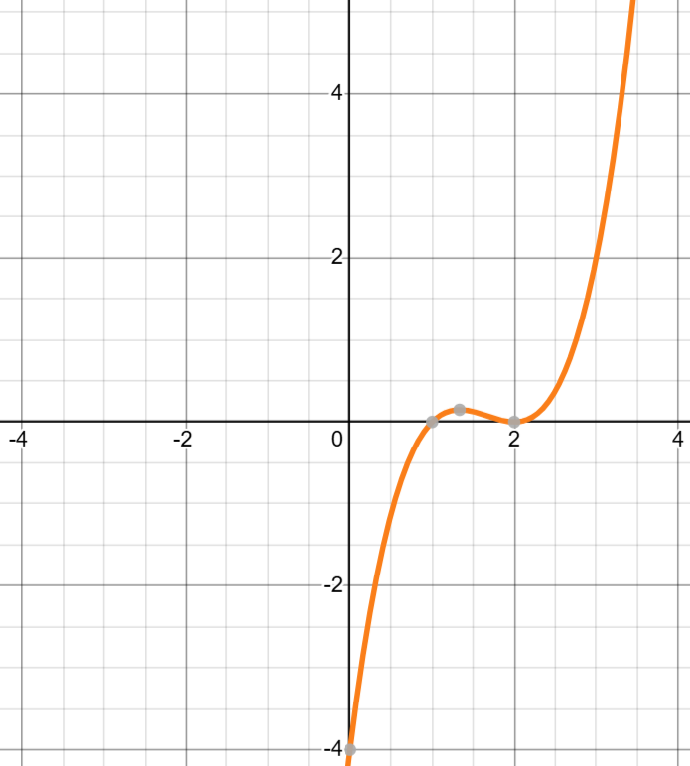 | 1 Real root  $$y=x^{3}+x^{2}+x-3$$  $$r_{1}=1, r_{2,3}=DNE$$  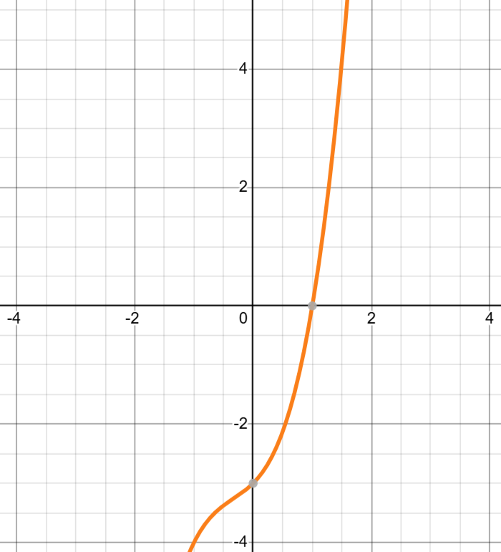

4. Quartic Formula (x⁴)

Description | Equation
Quartic Formula Equation | $$ax^{4}+bx^{3}+cx^{2}+dx+e=0$$
Solution | $$∆_{0} =c^{2}-3bd+12ae$$  $$∆_{1} ={2c}^{3}-9bcd+27ad^{2}+27b^{2}c-72ace$$  $$p=\frac{8ac-3b^{2}}{8a^{2}} q=\frac{b^{3}-4abc+8a^{2}d}{8a^{3}}$$  $$Q=\sqrt[3]{\frac{∆_{1}+\sqrt{∆_{1}^{2}-{4∆}_{0}^{3}}}{2}} S=\frac{1}{2}\sqrt{-\frac{2}{3}p+\frac{1}{3a}\left(Q+\frac{∆_{0}}{Q}\right)}$$  $$r_{1,2}=-\frac{b}{4a}-S±\frac{1}{2}\sqrt{-4S^{2}-2p+\frac{q}{S}}$$  $$r_{3,4}=-\frac{b}{4a}+S±\frac{1}{2}\sqrt{-4S^{2}-2p+\frac{q}{S}}$$
Graphs | 4 Real different roots  $$y=x^{4}-2x^{3}-x^{2}+3x-1$$  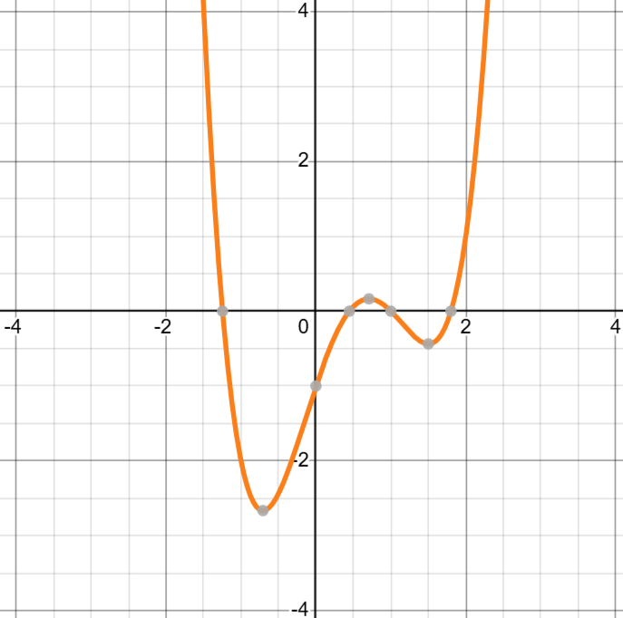 | 2 Real different roots  $$y=x^{4}-2x^{3}-x^{2}+3x$$  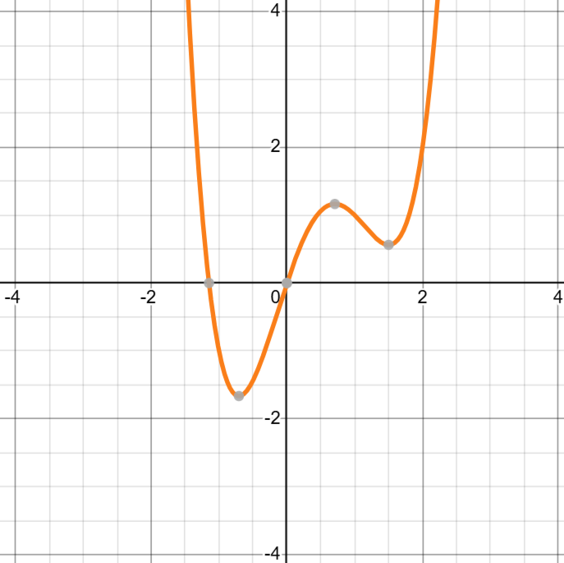
Graphs | 2 Real same roots  $$y=x^{4}-2x^{3}-x^{2}+3x+1.7$$  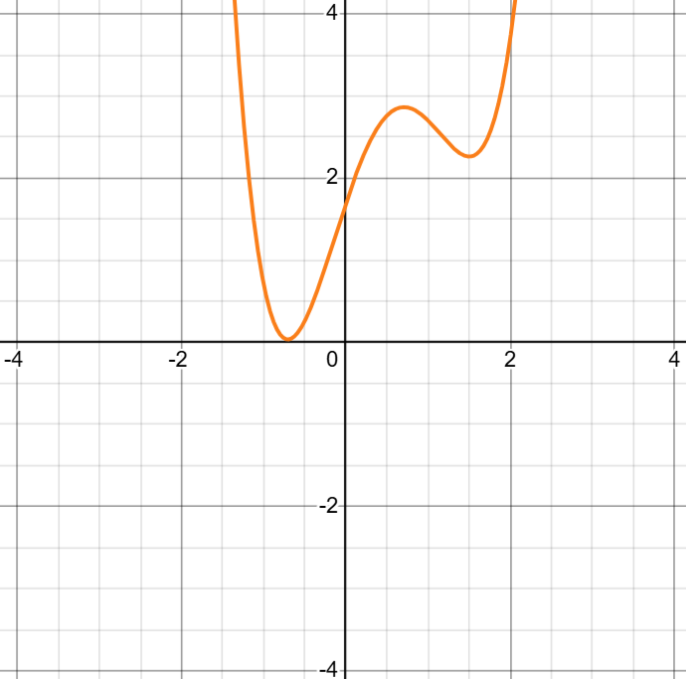 | 0 Real roots  $$y=x^{4}-2x^{3}-x^{2}+3x+2$$  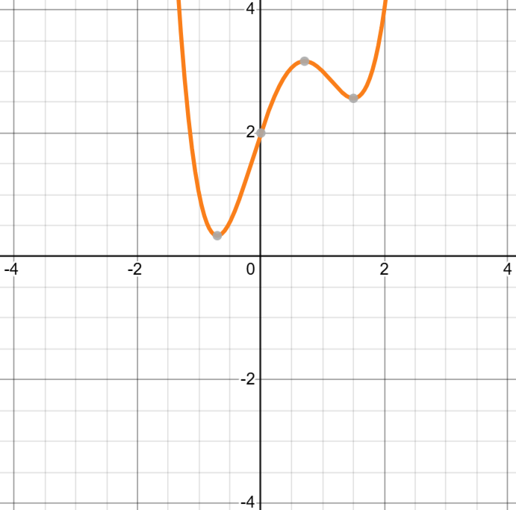

5. Quintic Formula (x⁵)

Description | Equation
Quintic Formula Form | $$ax^{5}+bx^{4}+cx^{3}+dx^{2}+ex+f=0$$
Solution | No general formula exists with arbitrary coefficients.  Abel-Ruffini Theorem:  No general solution exists for degree 5 or higher.
Graphs | 5 Real different roots  $$y=x^{5}-5x^{3}+4x$$  $$r_{1}=-2, r_{2}=-1, r_{3}=0,r_{4}=1, r_{5}=2$$  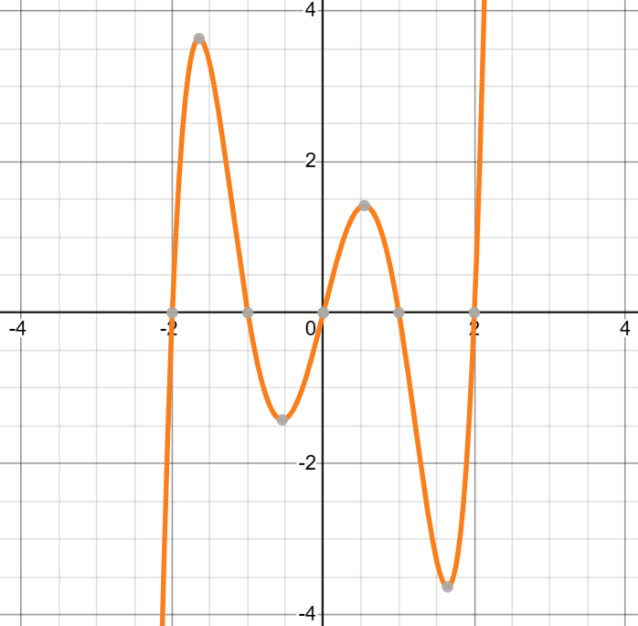 | 3 Real different roots  $$y=x^{5}-5x^{3}+4x+2$$  $$r_{1}≅-2.07, r_{2}≅1.29, r_{3}≅1.90$$  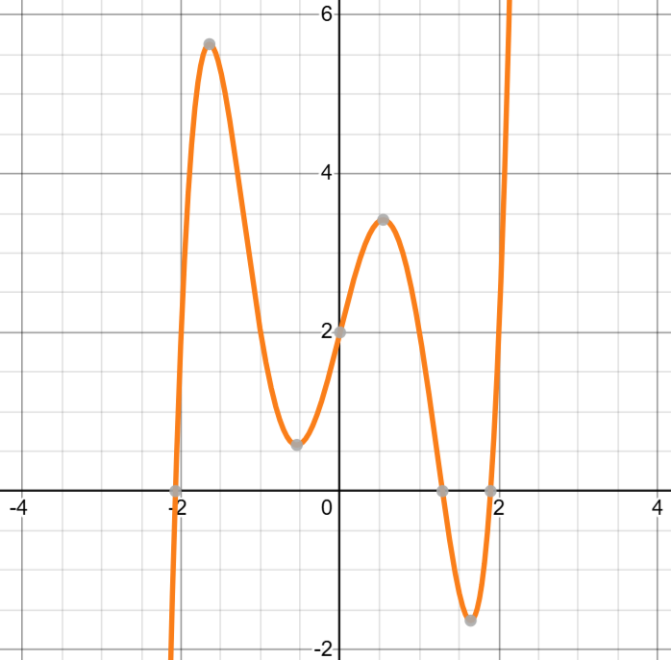
Graphs | 1 Real root  $$y=x^{5}-5x^{3}+4x+4$$  $$r_{1}≅-2.13$$  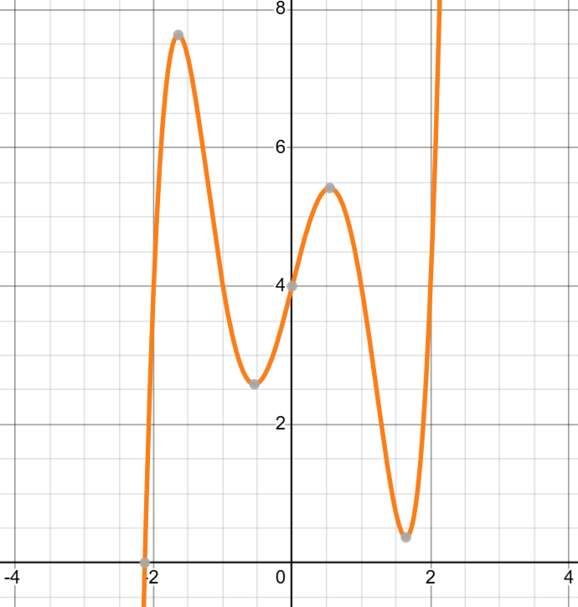

Polynomial Division

Description | Equations
Long Division | $$f(x)=\frac{x^{3}-2x^{2}-4}{x-3}$$  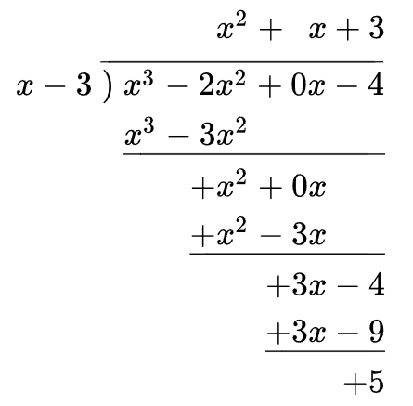  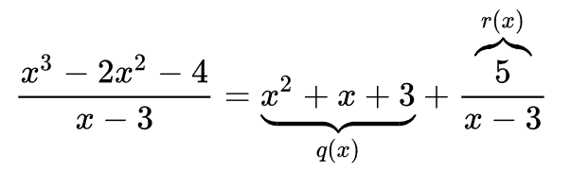
Synthetic Division | $$P_{n}(x)=a_{n}x^{n}+a_{n-1}x^{n-1}+ ...+ a_{1}x+ a_{0}$$  - Synthetic division is faster than long division.  - The top row lists the polynomial coefficients in descending order.  - If a term is missing, add a 0 as a placeholder.  - $x_{0}$ is a root candidate.  - Add columns.  - Multiple bottom terms by $x_{0}$ to get the next entry to add.  - Remainder Theorem: If 0 comes out of the bottom right, meaning $f(x_{0})=0,$then $x_{0}$ is a factor, and the bottom row is also a polynomial factor of degree $n-1$.
  $$x_{0}$$ | $$a_{n}$$ | $a_{n-1}$ … | $$a_{1}$$ | $$a_{0}$$
   | $$↓$$ | $$a_{n}x_{0}$$ | $${x_{0}(a}_{n-1}+a_{n}x_{0})$$ | (mult.)
   | $$a_{n}$$ | $$a_{n-1}+a_{n}x_{0}$$ | (add) | $$f\left(x_{0}\right)$$
Synthetic Division | Example:  $$P(x)=2x^{3}-5x^{2}+x-6$$  So, $x=2$ is a root, and $\left(x-2\right)$ is a factor of $P\left(x\right)$.  $$P(x)=2x^{3}-5x^{2}+x-6=(x-2)(2x^{2}-x+3)$$
  $$2$$ | 2 | -5 | 1 | -6
   | $$↓$$ | 4 | 2 | 6
   | 2 | -1 | 3 | 0
Remainder Theorem | - If a polynomial $P(x)$ is divided by $(x-k)$, then the remainder is $P(k)$.  - $P(a)=0$ if and only if $(x-a)$ is a factor of polynomial $P(x)$.
Rational Root Theorem

Description | Equations
Rational Root Theorem | Tells you all possible rational roots of a polynomial with integer coefficients.  It doesn’t guarantee which ones actually work — it just gives the complete list to test.
Prerequisites | - Polynomial with integer coefficients.
Results | - The set of rational root candidates in the form $\frac{p}{q}$.  - A finite list to test using synthetic division.
Polynomial Equation | $$P_{n}(x)=a_{n}x^{n}+a_{n-1}x^{n-1}+ ...+ a_{1}x+ a_{0}$$
Formula | $$x=\frac{p}{q}=±\frac{factors of a_{0}}{factors of a_{n}}$$
Example | $$P(x)=2x^{3}-5x^{2}+x-6$$  - Constant term: $a_{0}=-6$ → factors: $1, 2, 3, 6$  - Leading coefficient: $a_{n}=2$ → factors: $1, 2$  Possible rational zeros:  $$±1, ±2, ±3, ±6, ±\frac{1}{2}, ±\frac{3}{2}, ±\frac{6}{2}=±3$$  Synthetic division:  Solution:  $$P(x)=(x-2)(2x^{2}-x-3)$$  $$=(x-2)(2x-3)(x+1)$$
  $$2$$ | 2 | -5 | 1 | -6
   | $$↓$$ | 4 | 2 | 6
   | 2 | -1 | 3 | 0

Factoring Formulas

Description | Equation | Notes
Quadratic | $$x^{2}+a^{2}=\left(x+ai\right) \left(x-ai\right)$$  $$x^{2}-a^{2}=\left(x+a\right) \left(x-a\right)$$  $${\left(x+a\right)}^{2}=x^{2}+2ax+a^{2}$$  $${\left(x-a\right)}^{2}=x^{2}-2ax+a^{2}$$  $$\left(x+a\right) \left(x+b\right)=x^{2}+\left(a+b\right)x+ab$$  $$\left(x-a\right) \left(x-b\right)=x^{2}-\left(a+b\right)x+ab$$ | FOIL:  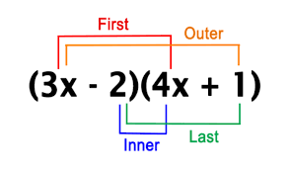
Cubic | $$x^{3}+a^{3}=\left(x+a\right) \left(x^{2}-ax+a^{2}\right)$$  $$x^{3}-a^{3}=\left(x-a\right) \left(x^{2}+ax+a^{2}\right)$$  $${\left(x+a\right)}^{3}=x^{3}+3ax^{2}+3a^{2}x+a^{3}$$  $${\left(x-a\right)}^{3}=x^{3}-3ax^{2}+3a^{2}x-a^{3}$$ | Notice one ‘$-$‘ and two ‘$+$’ for both  Binomial expansion (Pascal’s Triangle)
Even Powers | $$x^{2n}+a^{2n}=\left(a^{n}-{ix}^{n}\right) \left(a^{n}+ix^{n}\right)$$  $$x^{2n}-a^{2n}=\left(x^{n}-a^{n}\right) \left(x^{n}+a^{n}\right)$$ | The top equation is not often used since it requires imaginary numbers ($i$)
Odd Powers | $$x^{n}+a^{n}=\left(x+a\right) \left(x^{n-1}-ax^{n-2}+a^{2}x^{n-3}-…-a^{n-2}x+a^{n-1}\right)$$  $$x^{n}-a^{n}=\left(x-a\right) \left(x^{n-1}+ax^{n-2}+a^{2}x^{n-3}+…+a^{n-2}x+a^{n-1}\right)$$

Descartes’ Rule of Signs

Description | Equations
Descartes’ Rule of Signs | Counts the roots of a polynomial by examining sign changes in its coefficients. |   René Descartes (1596-1650)
Prerequisites | - Single-variable polynomial (x) with real coefficients.  - Ordered by descending variable exponent (height to low).  - Omit zero coefficients.
Results | - Finds real roots only.  - Finds the number of possible positive and negative roots.  - A root of multiplicity k is counted as k roots.
Positive Roots | The number of positive roots of the polynomial is either:  - Equal to the number of sign changes between consecutive (nonzero) coefficients, or is  - Less than it by an even number
Negative Roots | The number of negative roots of the polynomial is either  - Equal to the number of sign changes after multiplying the coefficients of odd-power terms by −1, or is  - Fewer than it by an even number
Example | $$P_{3}(x)=x^{3}+x^{2}- x-1$$  $(+ + - -)$ One sign change, so exactly 1 positive root.  $(- + + -)$ Two sign changes, so 2 or 0 negative roots.  Actual roots: –1, –1, 1  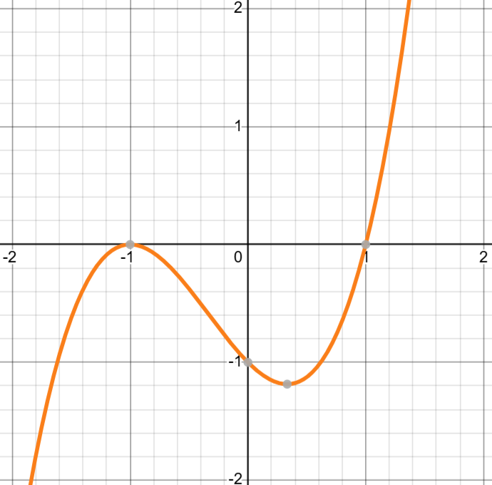

Vieta’s Formula

Description | Equations
Vieta’s Formula | Provides a direct connection between a polynomial's coefficients and its roots.  $$\sum_{1≤i_{1}<i_{2}<...<i_{k}<n}{\left(\prod_{j=1}^{k}{r_{i_{j}}}\right)={\left(-1\right)}^{k}\frac{a_{n-k}}{a_{n}}}$$ |  |   François Viète (1540-1603)  Franciscus Vieta (Latin)
Prerequisites | - Coefficients can be real or complex numbers.  - $a_{0}≠0$
Polynomial Equations | $$P_{2}(x)=ax^{2}+bx+c$$  $$P_{3}(x)=ax^{3}+bx^{2}+cx+d$$  $$P_{4}(x)=ax^{4}+bx^{3}+cx^{2}+dx+e$$  $$P_{5}(x)=a_{5}x^{5}+a_{4}x^{4}+ a_{3}x^{3}+a_{2}x^{2}+ a_{1}x+ a_{0}$$  $$P_{n}(x)=a_{n}x^{n}+a_{n-1}x^{n-1}+ ...+ a_{1}x+ a_{0}$$
 | Sum of Roots | Sum of Products of Roots |  | Product of Roots
General Formulas | $$\sum_{i=1}^{n}{r_{i}}=-\frac{a_{n-1}}{a_{n}}$$ | Pairs of two:  $$\sum_{i,j=1, i≠j}^{n}{r_{i}r_{j}}=\frac{a_{n-2}}{a_{n}}$$  Pairs of three:  $$\sum_{i,j,k=1, i≠j≠k}^{n}{r_{i}r_{j}r_{k}}=-\frac{a_{n-3}}{a_{n}}$$ |  | $$r_{1}r_{2}∙∙∙r_{n}={\left(-1\right)}^{n}\frac{a_{0}}{a_{n}}$$
2. Quadratic | $$r_{1}+r_{2}=-\frac{b}{a}$$ | (same as Product of Roots) |  | $$r_{1}r_{2}=\frac{c}{a}$$
3. Cubic | $$r_{1}+r_{2}+r_{3}=-\frac{b}{a}$$ | $$r_{1}r_{2}+r_{1}r_{3}+r_{2}r_{3}=\frac{c}{a}$$ |  | $$r_{1}r_{2}r_{3}=-\frac{d}{a}$$
4. Quartic | $$r_{1}+r_{2}+r_{3}+r_{4}=-\frac{b}{a}$$ | $$r_{1}r_{2}+ ...+ r_{3}r_{4}=\frac{c}{a}$$  $$r_{1}r_{2}r_{3}+ ...+ r_{2}r_{3}r_{4}=-\frac{d}{a}$$ |  | $$r_{1}r_{2}r_{3}r_{4}=\frac{e}{a}$$
5. Quintic | $$r_{1}+r_{2}+r_{3}+r_{4}+r_{5}=-\frac{a_{4}}{a_{5}}$$  $$r_{1}r_{2}+r_{1}r_{3} + ...+ r_{4}r_{5}=\frac{a_{3}}{a_{5}}$$  $$r_{1}r_{2}r_{3}+ ...+{ r}_{3}r_{4}r_{5}=-\frac{a_{2}}{a_{5}}$$  $$r_{1}r_{2}r_{3}r_{4} + ...+ r_{2}r_{3}r_{4}r_{5}=\frac{a_{1}}{a_{5}}$$  $$r_{1}r_{2}r_{3}r_{4}r_{5}=-\frac{a_{0}}{a_{5}}$$
Polynomial Approximation Using Calculus

Approximation Polynomial
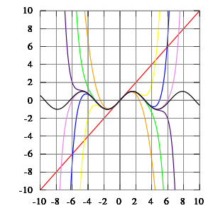 | $$f\left(x\right)=P_{n}\left(x\right)+R_{n}\left(x\right)$$  $$P_{n}\left(x\right)=n^{th} degree polynomial approximation$$  $$R_{n}\left(x\right)=n^{th} degree polynomial remainder$$  $$R_{n}\left(x\right)=± Error$$  $${NOTE: P}_{n}\left(x\right) is easy to integrate and differentiate$$

Maclaurin Series
Maclaurin Series  Taylor Series centered about $x=0$ | $$f\left(x\right)≈P_{n}(x)=\sum_{n=0}^{+∞}{\frac{f^{\left(n\right)}(0)}{n!}} x^{n}$$
Maclaurin Series Remainder | $$R_{n}\left(x\right)= \frac{f^{\left(n+1\right)}(x^{*})}{(n+1)!} x^{n+1}$$  where $x≤ x^{*}≤max$ and $\lim_{x→+∞}{R_{n}\left(x\right)=0}$  NOTE : $x^{*}$ is the worst-case scenario x for this interval.

Taylor Series
Taylor Series  Maclaurin Series if $c=0$ | $$f\left(x\right)≈P_{n}(x)=\sum_{n=0}^{+∞}{\frac{f^{\left(n\right)}(c)}{n!}} {(x-c)}^{n}$$
Taylor Series Remainder | $$R_{n}\left(x\right)=\frac{f^{\left(n+1\right)}(x^{*})}{(n+1)!} {(x-c)}^{n+1}$$  where $x≤ x^{*}≤c$ and $\lim_{x→+∞}{R_{n}\left(x\right)=0}$  NOTE : $x^{*}$ is the worst-case scenario x for this interval.
  Brook Taylor (1685-1731) | 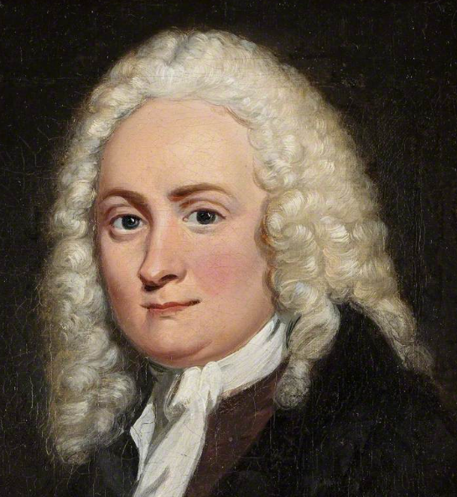  Colin Maclaurin (1698-1746)
Common Polynomial Approximations | Expanded Form
$$e^{x}=\sum_{n=0}^{∞}{\frac{x^{n}}{n!}} for all x$$ | $$1+x+\frac{x^{2}}{2!}+\frac{x^{3}}{3!}+\frac{x^{4}}{4!}+\frac{x^{5}}{5!}+\frac{x^{6}}{6!}+\frac{x^{7}}{7!}+\frac{x^{8}}{8!}+…$$
$$\ln{(1+x)}=\sum_{n=1}^{∞}{\frac{{(-1)}^{n-1}}{n}x^{n}} for \left|x\right|<1$$ | $$x-\frac{x^{2}}{2}+\frac{x^{3}}{3}-\frac{x^{4}}{4}+\frac{x^{5}}{5}-\frac{x^{6}}{6}+\frac{x^{7}}{7}-\frac{x^{8}}{8}+…$$
$$\frac{1}{1-x}=\sum_{n=0}^{∞}{x^{n}} for \left|x\right|<1$$ | $$1+x+x^{2}+x^{3}+x^{4}+x^{5}+x^{6}+x^{7}+x^{8}+…$$
$$\sin{(x)}=\sum_{n=0}^{∞}{\frac{{(-1)}^{n}}{\left(2n+1\right)!}}x^{2n+1} for all x$$ | $$x-\frac{x^{3}}{3!}+\frac{x^{5}}{5!}-\frac{x^{7}}{7!}+\frac{x^{9}}{9!}-\frac{x^{11}}{11!}+\frac{x^{13}}{13!}-\frac{x^{15}}{15!}+…$$
$$\cos{(x)}=\sum_{n=0}^{∞}{\frac{{(-1)}^{n}}{\left(2n\right)!}x^{2n}} for all x$$ | $$1-\frac{x^{2}}{2!}+\frac{x^{4}}{4!}-\frac{x^{6}}{6!}+\frac{x^{8}}{8!}-\frac{x^{10}}{10!}+\frac{x^{12}}{12!}-\frac{x^{14}}{14!}+…$$
$$\tan^{-1}{(x)}=\sum_{n=0}^{∞}{\frac{{\left(-1\right)}^{n}}{\left(2n+1\right)}x^{2n+1}}$$  $$for \left|x\right|<1$$ | $$x -\frac{x^{3}}{3}+\frac{x^{5}}{5}-\frac{x^{7}}{7}+\frac{x^{9}}{9}-… for-1<x<1$$  $$\frac{π}{2}-\frac{1}{x}+\frac{1}{3x^{3}}-\frac{1}{5x^{5}}+\frac{1}{7x^{7}}-\frac{1}{9x^{9}}+… for x≥ 1$$  $$-\frac{π}{2}-\frac{1}{x}+\frac{1}{3x^{3}}-\frac{1}{5x^{5}}+\frac{1}{7x^{7}}-\frac{1}{9x^{9}}+… for x<1$$
$$\sinh{(x)}=\frac{e^{x}-e^{-x}}{2}=\sum_{n=0}^{∞}{\frac{x^{2n+1}}{\left(2n+1\right)!}} for all x$$ | $$x+\frac{x^{3}}{3!}+\frac{x^{5}}{5!}+\frac{x^{7}}{7!}+\frac{x^{9}}{9!}+\frac{x^{11}}{11!}+\frac{x^{13}}{13!}+\frac{x^{15}}{15!}+…$$
$$\cosh{(x)}=\frac{e^{x}+e^{-x}}{2}=\sum_{n=0}^{∞}{\frac{x^{2n}}{\left(2n\right)!}} for all x$$ | $$1+\frac{x^{2}}{2!}+\frac{x^{4}}{4!}+\frac{x^{6}}{6!}+\frac{x^{8}}{8!}+\frac{x^{10}}{10!}+\frac{x^{12}}{12!}+\frac{x^{14}}{14!}+…$$
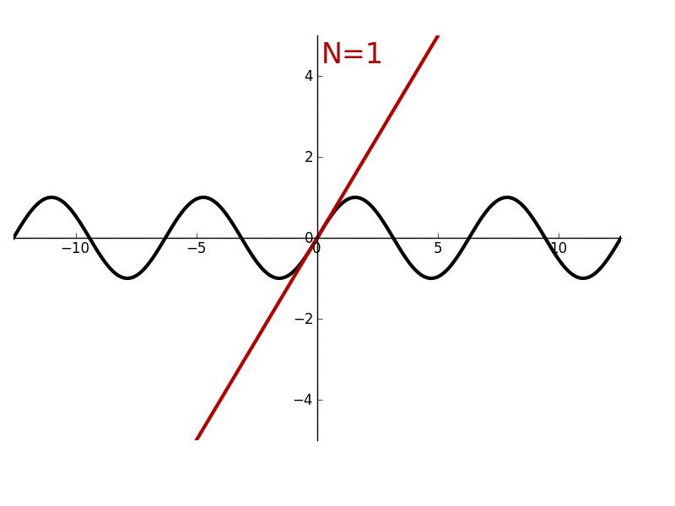

See
- Harold’s Infinite Series Cheat Sheet
- Harold’s Taylor Series Cheat Sheet
Sources
- YouTube (2026). Graphs of Cubic Polynomials. https://www.youtube.com/watch?v=9cFTetLkrfo
  - Graphical Representation Of Zeroes of Cubic Polynomial | Part 8 | Ch. 2 | English | Class 10
- Wikipedia (2026). https://en.wikipedia.org
  - Descartes' rule of signs - Wikipedia
  - Polynomial long division - Wikipedia
  - Quintic function - Wikipedia
  - Taylor series - Wikipedia
  - Vieta's formulas - Wikipedia

