Harold’s Physics Formulas – Calculus
Cheat Sheet
30 October 2026

 | Mechanics:  Linear Translation | Mechanics:  Angular / Rotational Motion | Electricity / Magnetism |  | Fluid Mechanics / Thermodynamics |  | Atomic and Nuclear /  Waves and Optics
Kinematics | Bold = Vector | See Harold’s Physics Units of Measure Cheat Sheet  See Harold’s Physics of Projectiles Cheat Sheet |  |  |  | See Harold’s Physics Optics Cheat Sheet  See Math and Greek Symbols
Position  (m)  (rad) | Constant linear acceleration:  $$s=s_{0}+v_{0}t+\frac{1}{2}at^{2}$$  $$x=x_{0}+{\left(v_{0}\right)}_{x}t$$  (constant $v$)  $$y=y_{0}+v_{0y}t-\frac{1}{2}gt^{2}$$  (up is +, constant $g$, neglect air resistance) | Constant angular acceleration:  $$θ=θ_{0}+ω_{0}t+\frac{1}{2}αt^{2}$$ | $${10}^{-30}=quecto­$$  $${10}^{-27}=ronto­$$  $${10}^{-24}=yocto­$$  $${10}^{-21}=zepto­$$  $${10}^{-18}=atto­$$  $${10}^{-15}=femto­$$  $${10}^{-12}=pico­$$  $${10}^{-9}=nano­$$  $${10}^{-6}=micro­$$  $${10}^{-3}=milli­$$  $${10}^{-2}=centi­$$  $${10}^{-1}=deci­$$  $${10}^{0}=1$$  $${10}^{1}=deca­$$  $${10}^{2}=hecto­$$  $${10}^{3}=kilo­$$  $${10}^{6}=mega­$$  $${10}^{9}=giga­$$  $${10}^{12}=tera­$$  $${10}^{15}=peta­$$  $${10}^{18}=exa­$$  $${10}^{21}=zetta­$$  $${10}^{24}=yotta­$$  $${10}^{27}=ronna­$$  $${10}^{30}=quetta­$$ |  | Fluid Mechanics:  $$∆l=αl_{0}∆T$$ |  | Optics:  $$f=\frac{v}{λ}$$  $$\frac{1}{d_{o}}+\frac{1}{d_{i}}=\frac{1}{f}$$
Refraction: (bend)
$$n=\frac{c}{v}$$
Diffraction (spread):
$$∆L=d\sin{θ}$$
 |  |  |  |  | Double-slit Maxima:  $$d\sin{θ}=mλ$$  $$m=0,±1,±2,…$$ |  | Snell’s Law:  $$n_{1}\sin{θ_{1}}=n_{2}\sin{θ_{2}}$$  $$\frac{n_{1}}{n_{2}}=\frac{v_{2}}{v_{1}}$$
Position  (m)  (rad) | Variable linear acceleration:  $$s(t)=s_{0}+\int_{t_{0}}^{t}{v dt}$$ | Variable angular acceleration:  $$θ(t)=θ_{0}+\int_{t_{0}}^{t}{ω dt}$$
 |  |  |  |  | 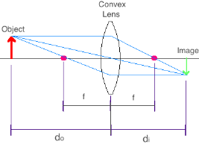
Position  (m)  (rad) | $$s=rθ$$
Position  (m)  (rad) | $$x(t)=A\cos\left(ωt+ϕ\right)$$  Waves:  $$f(x,t)=A sin⁡(2π\left(ft-\frac{x}{λ}\right)+ϕ)+k$$
Velocity  (m/s)  Angular Velocity / Angular Frequency  (rad/s) | $$v=\frac{ds}{dt}$$  Constant linear acceleration:  $$v= v_{0}+at$$  $$v= v_{0}+\dot{v}t$$  $$v^{2}=v_{0}^{2}+2a∆s$$  Variable linear acceleration:  $$v(t)=v_{0}+\int_{t_{0}}^{t}{a dt}$$  $$a ds=v dv$$  $$v_{ave}=\frac{∆s}{∆t}$$ | $$ω=\frac{dθ}{dt}$$  Constant angular acceleration:  $$ω=ω_{0}+αt$$  $$ω=ω_{0}+\dot{ω}t$$  $$ω^{2}=ω_{0}^{2}+2α∆θ$$  Variable angular acceleration:  $$ω(t)=ω_{0}+\int_{t_{0}}^{t}{α dt}$$  $$ω=\frac{2π}{T}=2πf$$  $$ω_{spring}=\sqrt{\frac{k}{m}}$$  $$ω_{pendulum}=\sqrt{\frac{g}{l}}$$  (for small $Δθ$) | Speed of Light:  $$c≈3.00×{10}^{8} \frac{m}{s}$$  Current Density:  $$j=nqu$$  $n$ = number density of charge carriers ($m^{-3}$)  $q$ = charge of each carrier (C)  $u$= drift velocity ($m/s$) |  | Fluid Mechanics:  Continuity:  $$A_{1}v_{1}=A_{2}v_{2}$$  (steady, incompressible flow)  $$v_{rms}=\sqrt{\frac{3RT}{M}}$$  $$v_{rms}=\sqrt{\frac{3k_{B}T}{μ}}$$  Torricelli’s Law:  $$v=\sqrt{2gh}$$  (speed of fluid exiting a small outlet in a lg tank.) |  | Waves and Optics:  $$v=fλ$$  Reflection:  (return into the original medium)  Critical angle:  $$\sin{θ_{c}}=\frac{n_{2}}{n_{1}}$$  For light traveling from medium 1 to medium 2, with $n_{1}>n_{2}$.  Maxima for a thin film:  Constructive  $$2d=\frac{λ}{2n},3\frac{λ}{2n},5\frac{λ}{2n}…$$  $$=\left(m+\frac{1}{2}\right)\frac{λ}{n}$$  ($λ=$ vacuum wavelen.)  Destructive  $$2d=\frac{m}{n}λ$$  Assumes normal incidence and one reflection phase reversal.
 |  |  | 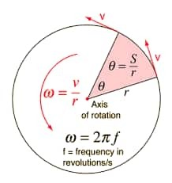
$$v=ω×r$$

$$v(t)=-Aω\sin\left(ωt+ϕ\right)$$
Polar Coordinates:
$$v_{r}=\dot{r}$$
$$v_{θ}=r\dot{θ}$$
Acceleration  (m/$s^{2}$)  (rad/$s^{2}$) | Linear:  $$a=\frac{dv}{dt}=\dot{v}$$  $$a=\frac{\sum{F}}{m}=\frac{F_{net}}{m}$$  Straight-line motion:  $$a=a_{t}$$  (no normal acceleration) | Angular:  $$α=\frac{dω}{dt}$$  $$α dθ=ω dω$$  $$α=\frac{\sum{τ}}{I}=\frac{τ_{net}}{I}$$  Centripetal (center):  $$a_{c}=a_{n}=\frac{v^{2}}{r}=ω^{2}r$$ | Physical Constants (2022 CODATA):  Gravitational Constant $G≈6.674 30(15)×10^{-11} \frac{m^{3}}{kg s^{2}}$  Std. Acceleration Gravity $g_{n}=9.806 65 \frac{m}{s^{2}}≈32.174 0 \frac{ft}{s^{2}}$, ($g≈g_{n}$)  Speed of Light in Vacuum $c=2.997 924 58×10^{8} \frac{m}{s}$  Electron-Volt $1eV=1.602 176 634×10^{-19} J$  Elementary Charge $e=1.602 176 634×10^{-19} C, (q_{e}=-e)$  Mass of an Electron $m_{e}≈9.109 383 713 9(28)×10^{-31} kg$  Mass of a Proton $m_{p}≈1.672 621 925 95(52)×10^{-27} kg$  Mass of a Neutron $m_{n}≈1.674 927 498 04(95)×10^{-27} kg$  Electric Permittivity $ε_{0}=\frac{1}{μ_{0}c^{2}}≈8.854 187 818 8(14)×10^{-12}\frac{C^{2}}{Nm^{2}}$  Magnetic Permeability $μ_{0}≈1. 256 637 061 27(20)×10^{-6}\frac{N}{A^{2}}$  Boltzmann Constant $k_{B}=1.380 649×10^{-23} \frac{J}{K}$  Coulomb Constant $k_{e}=\frac{1}{4πε_{0}}≈8.987 551 792 3×10^{9} \frac{Nm^{2}}{C^{2}}$  Faraday Constant $F=eN_{A}≈9.648 533 212×10^{4} \frac{C}{mol}$  Planck Constant $h=6.626 070 15×10^{-34} Js$  Avogadro Constant $N_{A}=6.022 140 76×10^{23} / mole$  Ideal Gas Constant $R≈0.082 057 366 080 \frac{L atm}{mole K}$  “ $R≈8.314 462 618 \frac{J}{mole K}$  pi $π≈3.141 592 653 589 793 238 462 ..$.
Acceleration  (m/$s^{2}$)  (rad/$s^{2}$) | 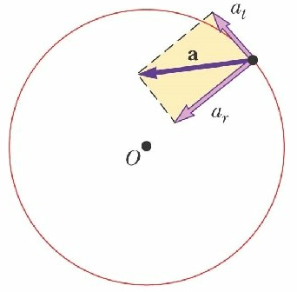 | Fixed-radius circular motion:  $$a_{r}=-\frac{v^{2}}{r}$$  General motion:  $$a_{n}=\frac{v^{2}}{ρ}$$
Acceleration  (m/$s^{2}$)  (rad/$s^{2}$) | $$a=a_{t}+a_{r}$$  $$a_{r}={-a}_{c}={-a}_{n}$$  (radial/centripetal)  $$a_{t}=a_{θ}$$  (tangential/transverse) | General polar motion coordinates:  $$a_{r}=\ddot{r}-r{\dot{θ}}^{2}$$  $$a_{θ}=r\ddot{θ}+2\dot{r}\dot{θ}$$
Acceleration  (m/$s^{2}$)  (rad/$s^{2}$) | $$a_{t}=αr$$  (fixed-radius circular motion)  $$a_{P}=\left(α×r\right)+\left(ω×\left(ω×r\right)\right)$$  (rigid body rotating about a fixed point $O$)  $$a(t)=-Aω^{2}\cos\left(ωt+ϕ\right)$$
Jerk (Jolt)  (m/$s^{3}$)  (rad/$s^{3}$) | $$j=\frac{da}{dt}$$ | $$ζ=\frac{dα}{dt}$$
Dynamics | See Harold’s Physics Forces with FBD Cheat Sheet  See Harold’s Physics Atwood Machine Cheat Sheet |  | See Harold’s Physics Forces on an Incline Cheat Sheet  See Harold’s Physics Forces on an Incline with Pulley Cheat Sheet
Mass  (kg)  /  Moment of Inertia  ($kg•m^{2}$) | $m$ = actual mass  $I$ = rotational analog of mass  Inertia is an object’s resistance to changes in its angular velocity. | $$I=\sum{mr^{2}}$$  $$I=\int{r^{2}}dm$$  $$I=\int{r_{⊥}•r dm}$$  ($r$ = perp. distance from the rotation axis.) | $$m_{p}≈m_{n}$$  $$m_{p}≈{1,836 m}_{e}$$ |  | Mass Density:  $$ρ=\frac{m}{V}$$  $$ρ_{H_{2}O} =1000 \frac{kg}{m^{3}}$$ |  | Magnification:  $$\left|M\right|=\left|\frac{d_{i}}{d_{o}}\right|=\left|\frac{h_{i}}{h_{o}}\right|$$  $$M_{Telescope}=-\frac{f_{objective lens}}{f_{eyepiece}}$$
Force  (N = kg$•$m/$s^{2}$)  /  Torque  (N$•$m) | $$F=ma$$  $$F_{g}=mg$$  (constant mass)  $$\sum{F}=F_{net}=ma$$  (See the different coordinate systems on the bottom right.)  $$\sum{F_{ext}}=\frac{dp}{dt}=\frac{d(mv)}{dt}$$  Friction:  $$F_{μ_{s}}≤μ_{s}N$$  $$F_{μ_{k}}=μ_{k}N$$  $$Typically 0≤μ_{k}≤μ_{s}$$  Gravitational Force:  $$F_{G}=-G\frac{m_{1}{ m}_{2}}{r^{2}} \hat{r}$$ | $$τ=Iα$$  (fixed-axis rotation with constant $I$)  $$τ=r×F$$  $$\sum{τ}=τ_{net}=Iα$$  $$τ=\frac{dL}{dt}=I\frac{dω}{dt}$$  $$F=ma_{c}$$  $$F=\frac{{mv}^{2}}{r}=mrω^{2}$$  (net inward force)  Hooke’s Law:  $$F_{s}=-kΔs$$ | Electricity:  Coulomb’s Law:  $$F=k\frac{q_{1} q_{2}}{r^{2}}\hat{r}$$  $$F=\frac{1}{4πϵ_{0}} \frac{q_{1} q_{2}}{r^{2}}\hat{r}$$  $$F=Eq$$  Magnetism:  $$F_{B}=qv×B$$  $$F_{B}=Il×B$$  $$F=\int{I dl}×B$$ |  | Fluid Mechanics:  $$P=\frac{F}{A}$$  $$∆P=ρhg$$  $$F_{buoy}=ρVg$$  Universal Gas Law:  $$PV=nRT=Nk_{B}T$$  (absolute $P$; $T$ in kelvins) |  | Strong Nuclear Force:  $$F_{r}(r)=-Ae^{\frac{-r}{λ}}\left(\frac{1}{r^{2}}+\frac{1}{λr}\right)$$  (Yukawa model)  Weak Nuclear Force:  $$n→p^{+}+e^{-}+\overline{ve}$$  (Beta Decay)  where $\overline{ve}$ is an antineutrino
 |  |  |  |  | Rectangular Coordinates:  $$\sum{F_{x}}=ma_{x}=m\ddot{x}$$  $$\sum{F_{y}}=ma_{y}=m\ddot{y}$$  $$\sum{F_{z}}=ma_{z}=m\ddot{z}$$ |  | Polar/Cylindrical Coordinates:  $$\sum{F_{r}}=m\left(\ddot{r}-r{\dot{θ}}^{2}\right)$$  $$\sum{F_{θ}}=m\left(r\ddot{θ}+2\dot{r}\dot{θ}\right)$$  $$\sum{F_{z}}=m\ddot{z}$$
Impulse and
Momentum
Momentum  (kg$•$m/s)  ($kg•m^{2}/s$) | Constant Mass:  $$p=mv$$  $$∆p=m∆v$$  Conservation of Linear Momentum*:  $$p_{1}=p_{2}$$  $$\sum{mv_{1}}=\sum{mv_{2}}$$  $$p=m(ω×r)$$ | Constant Mass:  $$L=r×p$$  $$L=r×(mv)$$  Conservation of Angular Momentum*:  $$L_{1}=L_{2}$$  $$\sum{Iω_{1}}=\sum{Iω_{2}}$$  $$L=\int{r×v} dm$$ |  | Electromagnetic Field Momentum:  $$P_{\text{field}}=$$  $$\frac{1}{μ_{0}c^{2}}\int{E}×B dV$$  Eccentric Impact:  $$e=\frac{v_{B2}-v_{A2}}{v_{A1}-v_{B1}}$$  (along the line of impact) | Fluid Mechanics:  $$∇P=ρg$$  (hydrostatic equilibrium)  $$\frac{dP}{dy}=-ρg$$  Steady Fluid Streams:  $$\sum{F}=\frac{dm}{dt}\left(v_{B}-v_{A}\right)$$  $$\sum{M_{O}}=\frac{dm}{dt}\left(\left(r_{B}×v_{B}\right) - \left(r_{A}×v_{A}\right)\right)$$
Momentum  (kg$•$m/s)  ($kg•m^{2}/s$) | Linear Impulse and Momentum:  $$m_{i}{\left(v_{i}\right)}_{1}+$$  $$\sum{\int_{t_{1}}^{t_{2}}{F dt}}=m_{i}{\left(v_{i}\right)}_{2}$$ | Angular Impulse and Momentum:  $$I_{i}{\left(ω_{i}\right)}_{1}+$$  $$\sum{\int_{t_{1}}^{t_{2}}{τ dt}}=I_{i}{\left(ω_{i}\right)}_{2}$$ |  | 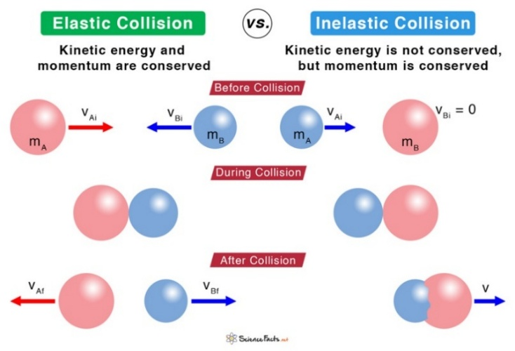  * Zero net external impulse for linear momentum. Zero net external angular impulse about the chosen origin for angular momentum.
Momentum  (kg$•$m/s)  ($kg•m^{2}/s$) | Elastic Collision:  $$m_{A}{\left(v_{A}\right)}_{1}+m_{B}{\left(v_{B}\right)}_{1}=m_{A}{\left(v_{A}\right)}_{2}+m_{B}{\left(v_{B}\right)}_{2}$$  $$K_{A1}+K_{B1}=K_{A2}+K_{B2}$$ | $$∆L=\int{τ} dt=I∆ω$$  (fixed axis, constant $I$)  Normal component of acceleration:  $$a_{n}=\frac{v^{2}}{ρ}$$  ($a_{n}$ is always directed in the +$n$ direction.)  Radius of Curvature:  $$ρ=\left|\frac{{\left(1+y^{' 2}\right)}^{\frac{3}{2}}}{y^{''}}\right|$$
Momentum  (kg$•$m/s)  ($kg•m^{2}/s$) | Perfectly Inelastic Collision:  $$m_{A}{\left(v_{A}\right)}_{1}+m_{B}{\left(v_{B}\right)}_{1}=\left(m_{A}+m_{B}\right)v_{2}$$
Momentum  (kg$•$m/s)  ($kg•m^{2}/s$) | Propulsion with Variable Mass: (– rocket, + shovel)  $$\sum{F_{cv}}=m\frac{dv}{dt}±v_{D/e}\frac{dm_{e}}{dt}$$
Impulse  (N$•$s)  (N$•$m$•$s) | Constant net force:  $$J=F ∆t=∆p=m∆v$$  (constant $m$)  $$J=\sum{\int_{t_{1}}^{t_{2}}{F dt}}=F_{net}(t_{2}-t_{1})$$  Variable net force:  $$J=\sum{\int_{t_{1}}^{t_{2}}{F dt}}=∆p$$ | Constant net torque:  $$H=∆L=τ ∆t=I∆ω$$  (fixed-axis rotation, constant $I$)  $$∆L=\int_{t_{1}}^{t_{2}}{τ_{net,ext} dt}=τ_{net,ext}(t_{2}-t_{1})$$  Variable net torque:  $$∆L=\int_{t_{1}}^{t_{2}}{τ_{net} dt}$$  $$∆L=\int_{t_{1}}^{t_{2}}{\left(r×F\right) dt}$$  (single external force; fixed origin) |  |  | 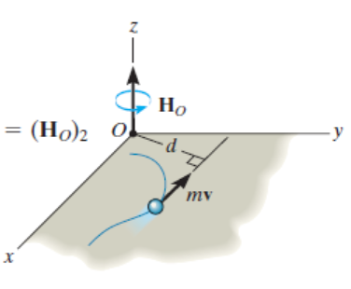  Angular Momentum
Yank  (N/s)  / Rotatum  (N•m/s)  (torque jerk) | $$Y=mj=m\frac{da}{dt}$$  (constant mass)  $$Y=\frac{dF}{dt}=m\overset{⃛}{x}$$ | $$R=Iζ=I\frac{dα}{dt}$$  (fixed-axis rotation, constant $I$)  $$R=\frac{dτ}{dt}=I\overset{⃛}{θ}$$ |  |  | $$R=r×Y$$  (fixed $r$)  $$R=\left(v×F\right)+\left(r×Y\right)$$  (fixed origin) |  | Atomic and Nuclear:  $$λ=\frac{h}{p}$$

Energy
Work  (J = N$•$m) | Constant force:  $$W=F•Δs$$  ($Δs$ is displacement)  Variable force:  $$W=\int{F•ds}$$  $$W=\int{F•v dt}$$ | Constant torque:  $$W=τ Δθ$$  (fixed axis, $θ$ in rad)  Variable torque:  $$W=\int{τ_{axis}}dθ$$  $$W=\int{τ•ω dt}$$ | $$W=QV_{drop}$$  $$W_{\text{electric}}=-qΔV$$ | Thermodynamics:  $$W=\int{P} dV$$  $$e=\left|\frac{W}{Q_{H}}\right|=\left|\frac{output/cycle}{heat absorbed}\right|$$  Max. Carnot efficiency:  $$e_{c}=\frac{T_{H}-T_{C}}{T_{H}}$$  ($T_{H},T_{C}$ in kelvins) | ¹ Needs steady, incompressible, inviscid flow along a streamline, with no pump/turbine work.  ² Closed system; negligible changes in macroscopic kinetic and potential energy.
Kinetic  Energy  (J) | Translational:  $$K_{trans}=\frac{1}{2}mv^{2}$$ | Rotational:  $$K_{rotat}=\frac{1}{2}Iω^{2}$$ | $$1 eV≈1.60×{10}^{-19} J$$ | Fluid Mechanics:  Bernoulli’s Equation¹:  $$P_{1}+ρgy_{1}+\frac{1}{2}ρ{v_{1}}^{2}=P_{2}+ρgy_{2}+\frac{1}{2}ρ{v_{2}}^{2}$$
Kinetic  Energy  (J) | Work-Energy Theorem:  $$W_{net}=∆K$$  $$W_{net}=W_{other}-ΔU=W_{other}-ΔU_{g}-ΔU_{s}$$  $$∆K=K_{2}-K_{1}=\frac{1}{2}m\left(v_{2}^{2}-v_{1}^{2}\right)+\frac{1}{2}I\left(ω_{2}^{2}-ω_{1}^{2}\right)$$ |  | Mechanical Energy:  $$E_{mech}=K+U$$  $$K=K_{trans}+K_{rotat}$$  $$U=U_{g}+U_{s}$$ | Thermodynamics:  $$K_{avg}=\frac{3}{2}k_{B}T$$  (T is in kelvins) | Atomic and Nuclear:  $$K_{max}=hf-ϕ$$  (emission requires $hf≥ϕ$)
Potential  Energy  (J) | Surface of Earth Gravity:  $$∆U_{g}=mg∆h$$  $$U_{g}=mgh$$  Planetary Gravity:  $$U_{G}=-G\frac{m_{1}m_{2}}{r}$$  Conservation of Mechanical Energy:  $$∆E_{mech}=$$  $$∆\left(K+U_{g}+U_{s}\right)=0$$ | Coiled Spring:  $$U_{s}=\frac{1}{2}k{Δs}^{2}$$  Nonconservative Work:  $$W_{noncons.}=$$  $$∆\left(K+U_{g}+U_{s}\right)$$ | Point charges:  $$U_{E}=qV$$  $$U_{E}=\frac{1}{4πϵ_{0}} \frac{q_{1}q_{2}}{r}$$  Capacitor/inductor:  $$U_{C}=\frac{1}{2}QV=\frac{1}{2}CV^{2}$$  $$U_{L}=\frac{1}{2}LI^{2}$$ | Fluid Mechanics:  $$P=P_{0}+ρgh$$  Continuity of Mass:  $$ρ_{1}A_{1}v_{1}=ρ_{2}A_{2}v_{2}$$  Continuity of Volume:  $$A_{1}v_{1}=A_{2}v_{2}$$  Thermodynamics 1st Law²:  $${∆U}_{internal}=Q-W_{by}$$ | Atomic and Nuclear:  $$E=hf$$  $$E_{0}=mc^{2}$$  $$∆E=(∆m)c^{2}$$  Relativity:  $$E=mc^{2}\left(\frac{1}{\sqrt{1-\frac{v^{2}}{c^{2}}}}\right)$$
Heat  Energy  (J) | Energy transferred by heating is $Q$.  Closed-system energy balance:  $Q>0$ into the system  $W_{\text{by}}>0$ for work done by it |  |  | Thermodynamics:  $$H=\frac{Q}{∆t}=\frac{kA∆T}{L}$$  (steady heat conduction)  $$Q=mL_{f}$$  $$Q=mL_{v}$$ | Hydrogen Electron Energy Levels:  $$E_{n}=\frac{-13.6 eV}{n^{2}}$$  n = principal quantum number (1, 2, 3, etc.)
Energy  (J) | Conservation of Energy for an isolated system:  $${E_{total}=E}_{i}=E_{f}$$  $$E_{total}=\sum{E_{i}}=\sum{E_{f}}$$  $$E_{total}=K+U_{potential}+U_{internal}$$  Closed-system energy balance:  $$ΔE_{\text{total}}=∆K+{∆U}_{potential}+{∆U}_{internal}=Q-W_{by}$$ |  |  | $$∆E=Q=mc∆T=mc\left(T_{f}-T_{i}\right)$$  (Heat is the only energy transfer, no phase change, and approximately constant specific heat)  $$T_{f}=\frac{m_{1}c_{1}T_{1i}+m_{2}c_{2}T_{2i}}{m_{1}c_{1}+m_{2}c_{2}}$$  (No heat exchange with surroundings, no phase change, negligible calorimeter heat capacity, constant specific heats)  $$c_{H_{2}O}=4,184 \frac{J}{kg∙K}$$
Power  (W) | $$P_{ave}=\frac{∆E_{transferred}}{∆t}$$ | $$P=\frac{dW}{dt}$$ | $$P=IV$$  $$P=I^{2}R$$  $$P=\frac{V^{2}}{R}$$ | $$P=Δp Q$$  where:  $$p=pressure \left(\frac{N}{m^{2}}\right)$$  $$Q=volumetric$$  $$flow rate \left(\frac{m^{3}}{s}\right)$$
Power  (W) | $$P=F•v$$  Energy transferred by the process:  $$P=\frac{dE}{dt}$$  Efficiency:  $$ε=\frac{power output}{power input}$$ | $$P=τ•ω$$  Energy transferred by the process:  $$P=\frac{dW}{dt}$$ | $$P=IV$$  $$P=I^{2}R$$  $$P=\frac{V^{2}}{R}$$

Engineering Application |  | See Harold’s Center of Mass / Moment of Inertia Cheat Sheet  See Harold’s Physics Doppler Effect Cheat Sheet
Period (s) / Frequency  (Hz) | $$T=\frac{1}{f}$$  $$f=\frac{1}{T}$$  Kepler’s Third Law:  $$T^{2}=\left(\frac{4π^{2}}{GM}\right)r^{3}$$  ($M$ dominant; $r$ is circular-orbit radius) | $$T=\frac{1}{f}=\frac{2π}{ω}=\frac{2πr}{v}$$  $$T_{spring}=2π\sqrt{\frac{m}{k}}$$  $$T_{pendulum}=2π\sqrt{\frac{l}{g}}$$  (small oscillations) | $$T_{angular}=\frac{2π}{\left|b\right|}$$  For:  $$y=\sin\left(bθ\right)$$  $$y=\cos\left(bθ\right)$$ |  | 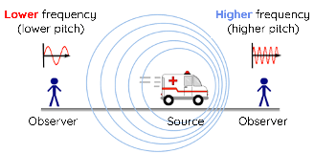 | Waves and Optics:  $$f=\frac{v}{λ}$$  Doppler Effect:  $$f_{r}=f_{s}{\left(\frac{v±v_{r}}{v∓v_{s}}\right)}^{*}$$
 |  |  |  |  | * = Receiver toward source: numerator +; source toward receiver: denominator −, with speeds measured relative to the medium.
Center  of Mass  (m) | $$x_{CM}=\frac{m_{1}x_{1}+m_{2}x_{2}}{m_{1}+m_{2}}$$  $$r_{CM}=\frac{\sum{mr}}{\sum{m}}$$  $$\overline{x}=\frac{1}{M} \int_{0}^{M}{x dm}$$  where $M=\int_{0}^{M}{dm}$  and $dm=ρ dz dy dx$ |  |  |  | $$x_{CM}=\frac{\sum{m_{i}x_{i}}}{\sum{m_{i}}}$$ | $$y_{CM}=\frac{\sum{m_{i}y_{i}}}{\sum{m_{i}}}$$
Center  of Mass  (m) |  | 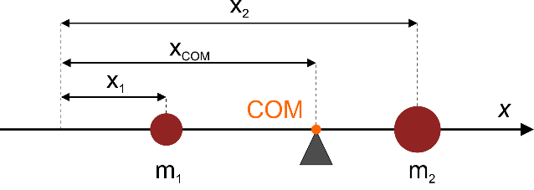 |  |  | 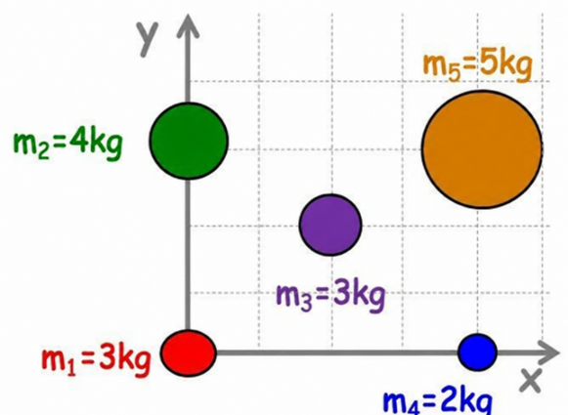
Rigid Bodies  (Statics) | $$\sum{F_{x}=0}$$  (Right = ‘+‘)  $$\sum{F_{y}=0}$$  (Down = ‘−‘) | $$\sum{τ=0}$$  (CW = ‘−‘)  $$\sum{τ=\sum{\left(F_{y,i}{ x}_{i}-F_{x,i}{ y}_{i}\right)=0}}$$ |  | 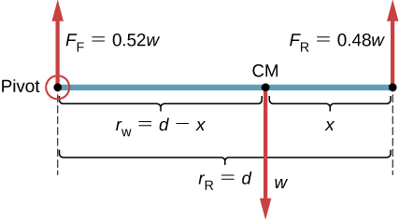
Conservation Laws
Fundamental Principle | Conservation of  Linear Momentum | Conservation of  Angular Momentum | Conservation of  Electric Charge |  | Conservation of  Mass (or Matter) | Conservation of  Energy
Discipline | Physics | Physics | Chemistry & Circuits |  | Chemistry & Fluid Mechanics | Physics
Formula | $$\sum{p_{i}}=\sum{p_{f}}$$  $$\sum{mv_{i}}=\sum{mv_{f}}$$ | $$\sum{L_{i}}=\sum{L_{f}}$$  $$\sum{Iω_{i}}=\sum{Iω_{f}}$$ | $$\sum{Q_{i}}=\sum{Q_{f}}$$ |  | $$\sum{m_{i}}=\sum{m_{f}}$$ | $$\sum{E_{i}}=\sum{E_{f}}$$
Example | Zero net external impulse for linear momentum. Zero net external angular impulse about the chosen origin for angular momentum. |  | Kirchhoff's Current Law (KCL):  $$\sum_{i=1}^{n}{I_{i}}=0$$ |  | Continuity of Mass:  $$ρ_{1}A_{1}v_{1}=ρ_{2}A_{2}v_{2}$$  (Classical mass conservation, since mass alone is not conserved in nuclear reactions.) | $$\sum{E_{i}}=constant$$  $$ΔE_{\text{total}}=∆K+{∆U}_{potential}+{∆U}_{internal}=Q-W_{by}$$
 | 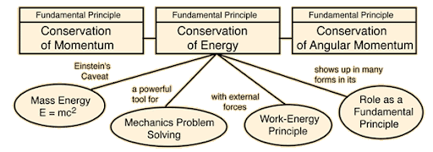 |  |  |  |  | For an isolated system:  $$E_{total}=K+U_{potential}+U_{internal}=constant$$

Electricity
Terms | Formulas | See Harold’s Electromagnetic Spectrum Cheat Sheet  See Harold’s DC Circuits Cheat Sheet
Electric Field  (V/m or N/C) | $$E=\frac{F}{q}$$  $$E_{x,avg}=-\frac{∆V}{∆x}$$  $$E=ρJ$$  ($ρ=$ electrical resistivity) | $$E_{r}=-\frac{dV}{dr}$$  Electrostatic:  $$E=-∇V$$ | Gauss’s Law:  $$ϕ=\oint{E•dA=\frac{Q_{enc}}{ϵ_{0}}}$$
Potential / Voltage  (V) | $$V=IR$$  $$V=\frac{Q}{C}$$ | $$V=k\sum_{i}{\frac{q_{i}}{r_{i}}}$$  $$V=\frac{1}{4πϵ_{0}}\sum_{i}{\frac{q_{i}}{r_{i}}}$$ | 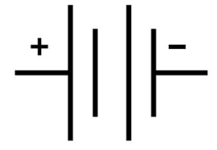
Current  (A) | $$I_{ave}=\frac{∆Q}{∆t}$$  $$I=\frac{V}{R}$$ | $$I=\frac{dQ}{dt}$$  $$I=n|e|v_{d}A$$ | 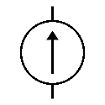
Circuits |  | Series | Parallel
Circuit Terms | 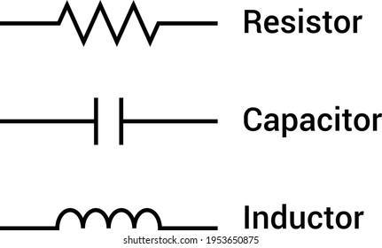 | 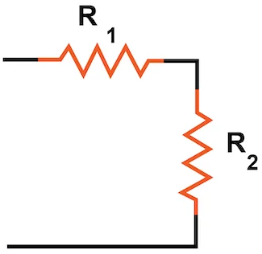 | 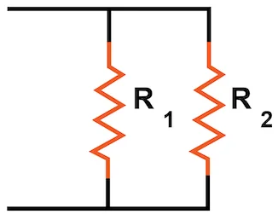
Resistance  (Ω) | $$R=\frac{V}{I}$$  $$R=\frac{ρl}{A}$$ | $$R_{s}= \sum_{i}{R_{i}}$$ | $$\frac{1}{R_{p}}= \sum_{i}{\frac{1}{R_{i}}}$$  $$R_{p}=\frac{R_{1}R_{2}}{R_{1}+R_{2}}$$
Inductance  (H) | $$L=N\frac{Φ}{I}$$  $$L=\frac{V_{L}}{{dI}/{dt}}$$  $$L=μ_{0}{\frac{N^{2}A}{l}}^{ 1}$$ | $$L_{s}= \sum_{i}{L_{i}}$$ | $$\frac{1}{L_{p}}= \sum_{i}{\frac{1}{L_{i}}}$$
Inductance  (H) |  | $L_{s}$ and $L_{p}$assume negligible mutual inductance.  ¹ For a long air-core solenoid; negligible end effects.
Capacitance  (F) | $$C=\frac{Q}{V}$$  $$C=\frac{κϵ_{0}A}{d}$$ | $$\frac{1}{C_{s}}= \sum_{i}{\frac{1}{C_{i}}}$$ | $$C_{p}= \sum_{i}{C_{i}}$$
Kirchhoff's Current Law (KCL) | $$\sum_{i=1}^{n}{I_{i}}=0$$  The algebraic sum of currents in a network of conductors meeting at a point (node) is zero. |  | 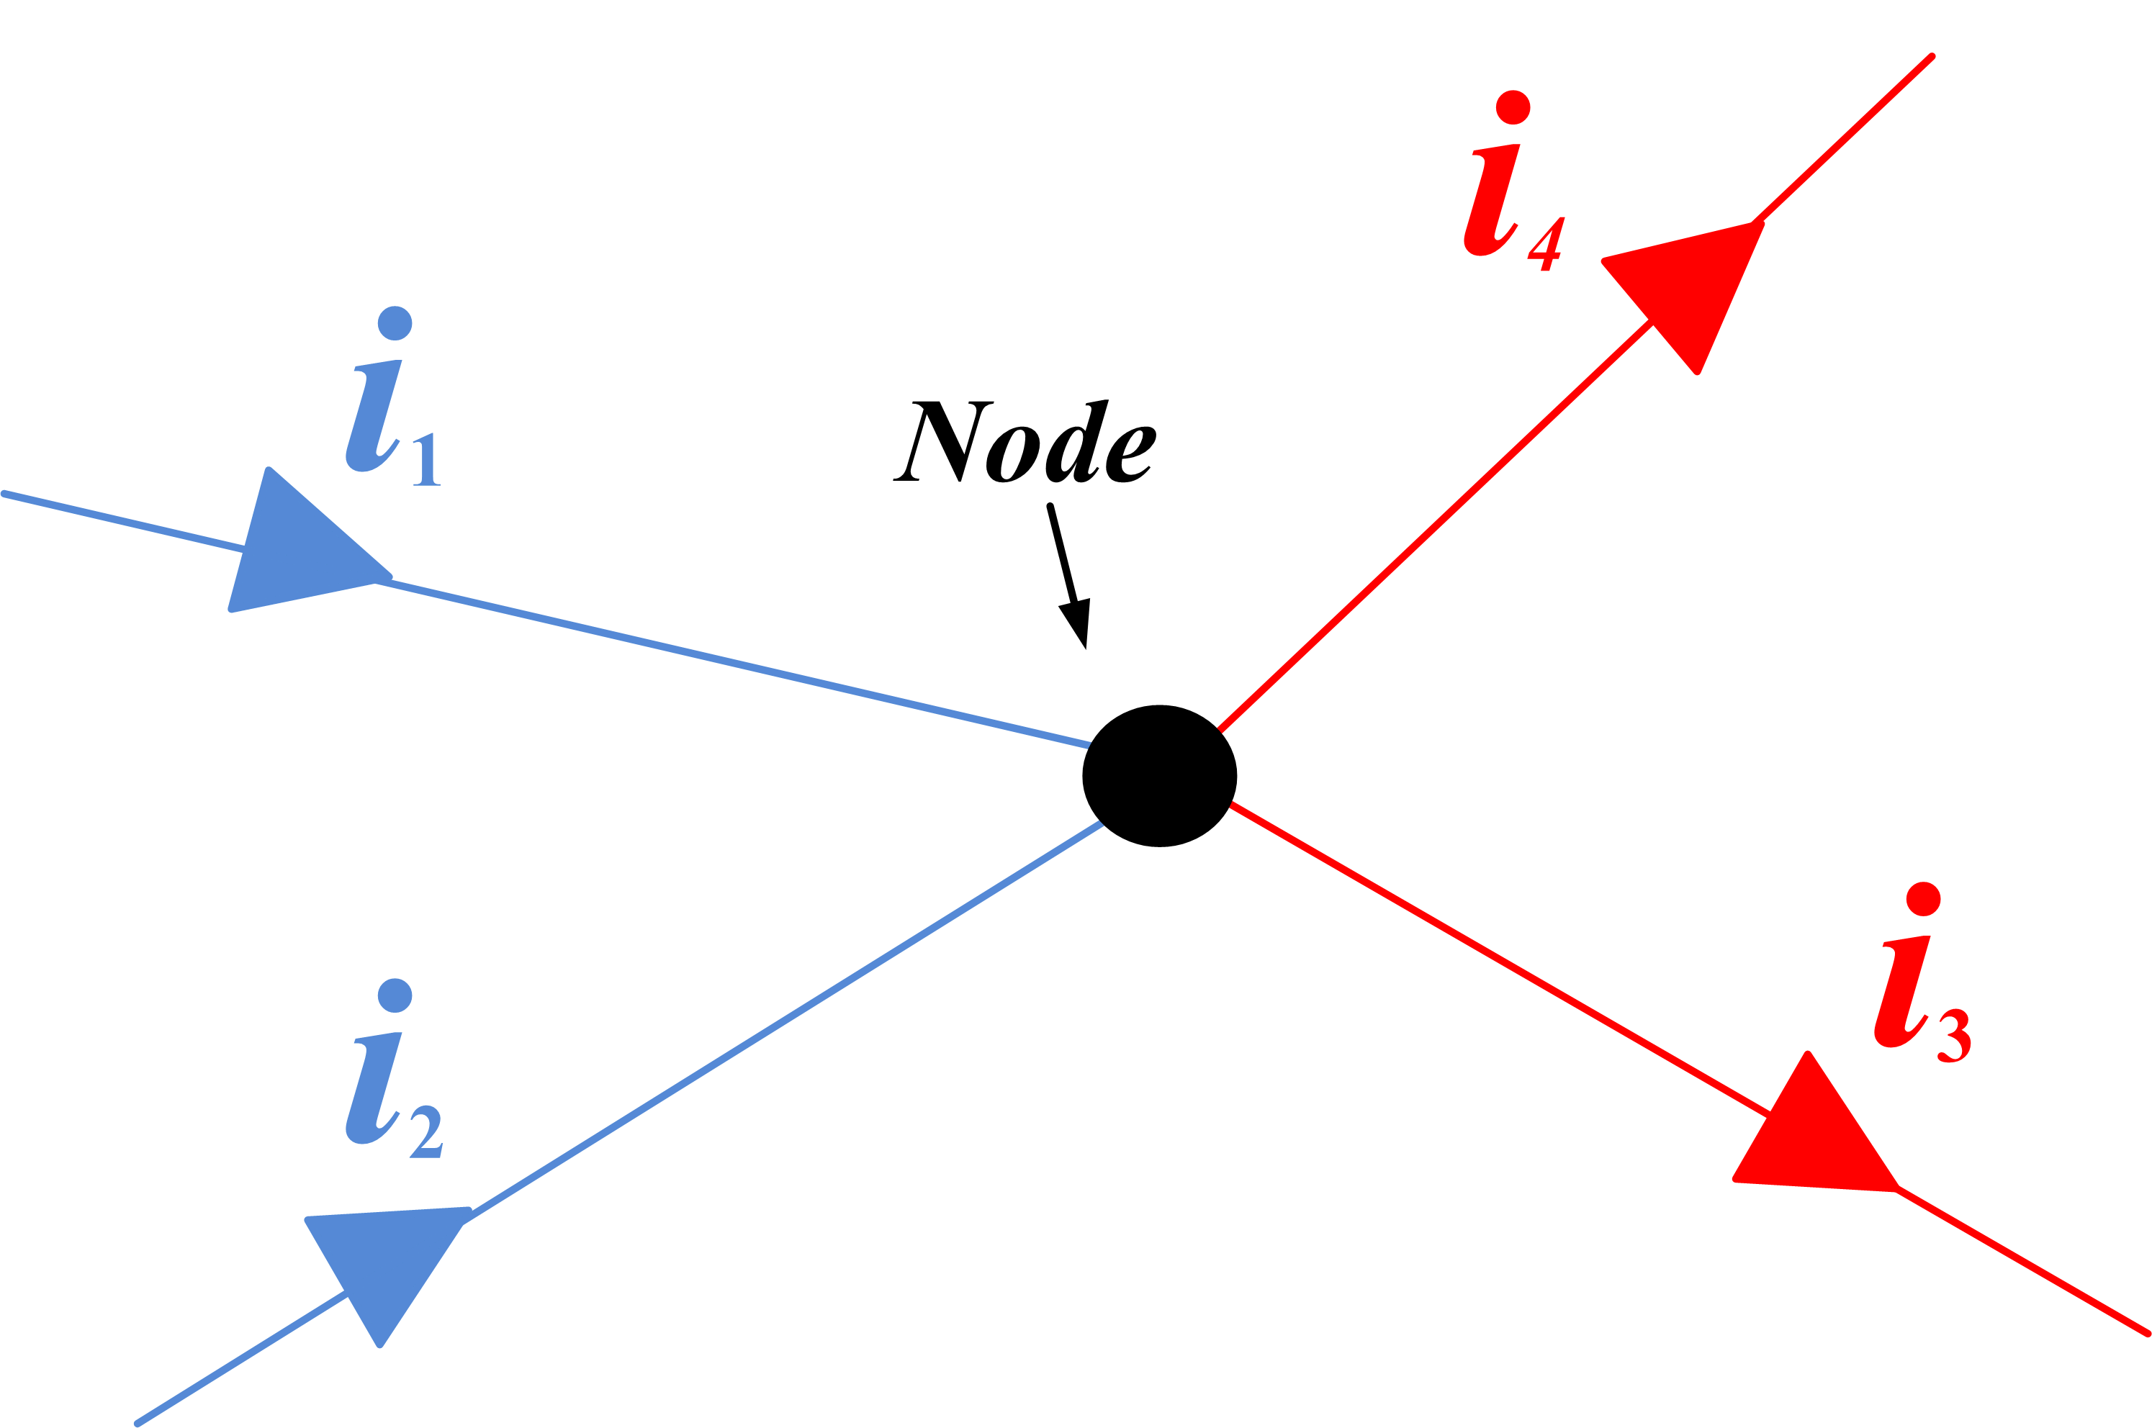
Kirchhoff's Voltage Law (KVL) | $$\sum_{i=1}^{n}{V_{i}}=0$$  The directed sum of the potential differences (voltages) around any closed loop is zero. |  | 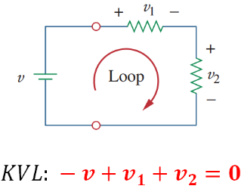

Magnetism
 | See Harold’s Physics Maxwell’s Equations Cheat Sheet
Term | Formulas | Laws
Magnetic  Field  (T) | $$B=\frac{μ_{0}}{2π} \frac{I}{r}$$  (Long straight wire)  $$Solenoid:$$  $$B_{s}=μ_{0}nI$$  $$where n=\frac{N}{l} turns per meter$$  (Long air-core solenoid,  away from the ends)  Moving-charge magnetic-field:  $$B=\frac{μ_{0}}{4π} \frac{qv×r}{r^{3}}$$  $$B=\frac{μ_{0}}{4π} \frac{qv×\hat{r}}{r^{2}}$$  (Nonrelativistic approximation, $v≪c$.  $r$ points from the charge to the observation point.) | Ampère–Maxwell Law:  $$\oint{B•dl=μ_{o}I}+μ_{0}ε_{0}\frac{dϕ_{E}}{dt}$$  Gauss’s Law:  $$\oint{B•dA=0}$$  $$dB=\frac{μ_{0}}{4π} \frac{I dl×r}{r^{3}}$$
Magnetic  Flux  (Wb) | $$ϕ_{B}=B•A$$  (Uniform field through a flat surface; $θ$ is measured from the surface normal) | Magnetic Flux:  $$ϕ_{B}=\int{B•dA}$$
EMF  (V) | $$ε=Blv$$  (magnitude; perpendicular rod, velocity, and uniform magnetic field)  $$ε_{avg}= - \frac{N∆ϕ_{B}}{∆t}$$  ($N$ turns, stationary loop)  $$ε=\oint{E•ds=} -\frac{dϕ_{B}}{dt}$$  (single stationary loop) | Faraday’s Law of Induction:  $$\oint{E•dl=-\frac{dϕ_{B}}{dt}}$$  $$ε=-L\frac{dI}{dt}$$

Sources
- Hibbeler, Russell C. (2022). Engineering Mechanics – Dynamics. 15th Edition. Pearson.
- NIST SP 961 (2022). CODATA Recommended Values of the Fundamental Physical Constants: 2022. https://physics.nist.gov/cuu/pdf/wall_2022.pdf
- Wikipedia (2025).
  - Metric prefix. https://en.wikipedia.org/wiki/Metric_prefix
  - SI derived unit. https://en.wikipedia.org/wiki/SI_derived_unit
Acknowledgements
- Proofread with assistance from ChatGPT 6.1 Sol, https://chatgpt.com/

