Harold’s Physics Formulas – Algebra
Cheat Sheet
30 October 2026

 | Mechanics:  Linear Translation | Mechanics:  Angular / Rotational | Electricity / Magnetism | Fluid Mechanics / Thermodynamics |  | Atomic and Nuclear /  Waves and Optics
Kinematics | Bold = Vector  Red = Memorize | See Harold’s Physics Units of Measure Cheat Sheet  See Harold’s Physics of Projectiles Cheat Sheet |  |  | See Harold’s Physics Optics Cheat Sheet  See Math and Greek Symbols
Position  (m)  (rad) | Horizontal:  $$x=x_{0}+v_{0x}t+\frac{1}{2}a_{x}t^{2}$$  (constant $a_{x}$)  Vertical:  $$y=y_{0}+v_{0y}t-\frac{1}{2}gt^{2}$$  (up is +, constant $g$, neglect air resistance)  $$∆x=x_{f}-x_{0}$$  $$x=x_{0}+vt$$  (constant $v$) | Circular:  $$θ=θ_{0}+ω_{0}t+\frac{1}{2}αt^{2}$$  (constant $α$)  $$∆θ=θ_{f}-θ_{0}$$  $$θ=θ_{0}+ωt$$  (constant $ω$) | $${10}^{-30}=quecto­$$  $${10}^{-27}=ronto­$$  $${10}^{-24}=yocto­$$  $${10}^{-21}=zepto­$$  $${10}^{-18}=atto­$$  $${10}^{-15}=femto­$$  $${10}^{-12}=pico­$$  $${10}^{-9}=nano­$$  $${10}^{-6}=micro­$$  $${10}^{-3}=milli­$$  $${10}^{-2}=centi­$$  $${10}^{-1}=deci­$$  $${10}^{0}=1$$  $${10}^{1}=deca­$$  $${10}^{2}=hecto­$$  $${10}^{3}=kilo­$$  $${10}^{6}=mega­$$  $${10}^{9}=giga­$$  $${10}^{12}=tera­$$  $${10}^{15}=peta­$$  $${10}^{18}=exa­$$  $${10}^{21}=zetta­$$  $${10}^{24}=yotta­$$  $${10}^{27}=ronna­$$  $${10}^{30}=quetta­$$ | Fluid Mechanics:  Mass Density:  $$ρ=\frac{m}{V}$$  $$∆l=αl_{0}∆T$$ |  | Optics:  $$f=\frac{v}{λ}$$  $$\frac{1}{d_{o}}+\frac{1}{d_{i}}=\frac{1}{f}$$  Refraction (bend):  $$n=\frac{c}{v}$$  Snell’s Law:  $$n_{1}\sin{θ_{1}}=n_{2}\sin{θ_{2}}$$  (angles measured from the normal)  $$\frac{n_{1}}{n_{2}}=\frac{v_{2}}{v_{1}}$$  Diffraction (spread):  $$∆L=d\sin{θ}$$  Double-slit Maxima:  $$d\sin{θ}=mλ$$  $$m=0,±1,±2,…$$
Position  (m)  (rad) | $$s=rθ$$
Position  (m)  (rad) | $$x(t)=A\cos\left(ωt+ϕ\right)$$  $$x\left(t\right)=A\cos\left(2πft+ϕ\right)$$  Waves:  $$f(x,t)=A sin⁡(2π\left(ft-\frac{x}{λ}\right)+ϕ)+k$$ |  |  | Optics:  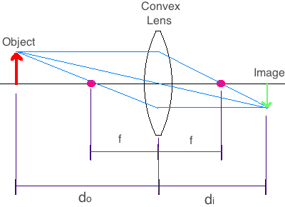
Velocity  (m/s)  Angular Velocity / Angular Frequency  (rad/s) | $$v_{ave}=\frac{∆x}{∆t}$$  $$∆v=v_{f}-v_{0}$$  Constant linear acceleration:  $$v= v_{0}+at$$  $$v^{2}=v_{0}^{2}+2a∆x$$  $$\overline{v}=\frac{v_{0}+v}{2}$$ | $$ω_{ave}=\frac{∆θ}{∆t}$$  $$∆ω=ω_{f}-ω_{0}$$  Constant angular acceleration:  $$ω=ω_{0}+αt$$  $$ω^{2}=ω_{0}^{2}+2α∆θ$$  $$\overline{ω}=\frac{ω_{0}+ω}{2}$$  $$ω=\frac{2π}{T}=2πf$$  $$ω_{spring}=\sqrt{\frac{k}{m}}$$  $$ω_{pendulum}=\sqrt{\frac{g}{l}}$$  (for small $Δθ$) | Speed of Light:  $$c≈3.00×{10}^{8} \frac{m}{s}$$ | Fluid Mechanics:  Continuity:  $$A_{1}v_{1}=A_{2}v_{2}$$  (Steady incompressible flow)  Torricelli’s Law:  $$v=\sqrt{2gh}$$  (Speed of fluid exiting a small outlet in a large tank, equal pressure at the surface and outlet, negligible losses.) |  | Waves and Optics:  $$v=fλ$$  Reflection:  (return into the original medium)  Critical angle:  $$\sin{θ_{c}}=\frac{n_{2}}{n_{1}}$$  For light traveling from medium 1 to medium 2, with $n_{1}>n_{2}$.  Maxima for a thin film:  Constructive  $$2d=\frac{λ}{2n},3\frac{λ}{2n},5\frac{λ}{2n}…$$  $$=\left(m+\frac{1}{2}\right)\frac{λ}{n}$$  ($λ=$ vacuum wavelen.)  Destructive  $$2d=\frac{m}{n}λ$$  (Assumes normal incidence and one reflection phase reversal)
 |  |  | 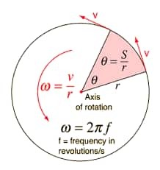
$$v=ωr$$

$$v(t)=-Aω\sin\left(ωt+ϕ\right)$$
$$v(t)=-A(2πf)\sin\left(2πft+ϕ\right)$$

Acceleration  (m/$s^{2}$)  (rad/$s^{2}$) | Linear:  $$a_{ave}=\frac{∆v}{∆t}$$  $$a=\frac{\sum{F}}{m}=\frac{F_{net}}{m}$$  Straight-line motion:  $$a=a_{t}$$  ($a$ has no normal acceleration component) | Angular:  $$α_{ave}=\frac{∆ω}{∆t}$$  $$α=\frac{\sum{τ}}{I}=\frac{τ_{net}}{I}$$  Centripetal (center):  $$a_{c}= \frac{v^{2}}{r}=ω^{2}r$$ | Physical Constants (2022 CODATA):  Gravitational Constant $G≈6.6743×10^{-11} \frac{m^{3}}{kg s^{2}}$  Std. Acceleration Gravity $g_{n}≈9.81 \frac{m}{s^{2}}≈32.1740 \frac{ft}{s^{2}}$, ($g≈g_{n}$)  Speed of Light in Vacuum $c≈3.00×10^{8} \frac{m}{s}$  Electron-Volt $1eV≈1.6022×10^{-19} J$  Elementary Charge $e≈1.6022×10^{-19} C, (q_{e}=-e)$  Mass of an Electron $m_{e}≈9.1094×10^{-31} kg$  Mass of a Proton $m_{p}≈1.6726×10^{-27} kg$  Mass of a Neutron $m_{n}≈1.6749×10^{-27} kg$  Electric Permittivity $ε_{0}=\frac{1}{μ_{0}c^{2}}≈8.8542×10^{-12}\frac{C^{2}}{Nm^{2}}$  Magnetic Permeability $μ_{0}≈1. 2566×10^{-6}\frac{N}{A^{2}}$  Boltzmann Constant $k_{B}≈1.3806×10^{-23} \frac{J}{K}$  Coulomb Constant $k_{e}=\frac{1}{4πε_{0}}≈8.9876×10^{9} \frac{Nm^{2}}{C^{2}}$  Faraday Constant $F≈eN_{A}≈9.6485×10^{4} \frac{C}{mol}$  Planck Constant $h≈6.6261×10^{-34} Js$  Avogadro Constant $N_{A}≈6.0221×10^{23} / mole$  Ideal Gas Constant $R≈0.08206 \frac{L atm}{mole K}$  “ $R≈8.3145 \frac{J}{mole K}$  pi $π≈3.1416$
Acceleration  (m/$s^{2}$)  (rad/$s^{2}$) | 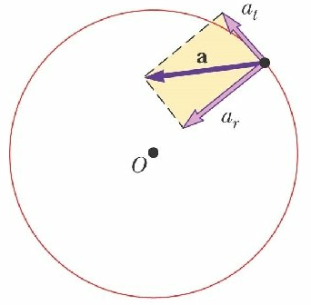
Acceleration  (m/$s^{2}$)  (rad/$s^{2}$) | $$a^{2}=a_{t}^{2}+a_{r}^{2}$$  $a_{r}={-a}_{c}$ radial/centripetal (outward radial is +)  $a_{t}=a_{θ}$ tangential/transverse
Acceleration  (m/$s^{2}$)  (rad/$s^{2}$) | $$a_{t}=αr$$  (fixed-radius circular motion)  $$a(t)=-Aω^{2}\cos\left(ωt+ϕ\right)$$
Dynamics | See Harold’s Physics Forces with FBD Cheat Sheet  See Harold’s Physics Atwood Machine Cheat Sheet |  | See Harold’s Physics Forces on an Incline Cheat Sheet  See Harold’s Physics Forces on an Incline with Pulley Cheat Sheet
Mass  (kg)  /  Moment of Inertia  ($kg•m^{2}$) | $m$ = actual mass  $I$ = rotational analog of mass  Inertia is an object’s resistance to changes in its state of motion. | $$I=\sum{mr^{2}}$$  ($r$ = perp. distance from the rotation axis.) | $$m_{p}≈m_{n}$$  $$m_{p}≈{1,836 m}_{e}$$ | Density:  $$ρ=\frac{m}{V}$$  $$ρ_{H_{2}O} =1000 \frac{kg}{m^{3}}$$ |  | Magnification:  $$\left|M\right|=\left|\frac{d_{i}}{d_{o}}\right|=\left|\frac{h_{i}}{h_{o}}\right|$$  $$M_{Telescope}=-\frac{f_{objective lens}}{f_{eyepiece}}$$
Momentum  (kg$•$m/s)  ($kg•m^{2}/s$) | Constant Mass:  $$p=mv$$  $$p=mωr$$  Constant $m$:  $$∆p=m∆v$$  $$∆p=mv_{2}-mv_{1}$$ | Constant Mass:  $$L=pr sin θ$$  $$L=mvr sin θ$$  Fixed-axis constant $I$:  $$∆L=I∆ω$$  $$∆L=Iω_{2}-Iω_{1}$$ |  | Fluid Mechanics:  $$∆P=ρg∆h$$  ($Δh$ is the increase in depth)  $$F=ρVg$$ |  | Atomic and Nuclear:  $$λ=\frac{h}{p}$$
Momentum  (kg$•$m/s)  ($kg•m^{2}/s$) | Conservation of Linear Momentum:  $$p_{i}=p_{f}$$  $$\sum{mv_{i}}=\sum{mv_{f}}$$ | Conservation of Angular Momentum:  $$L_{i}=L_{f}$$  $$\sum{Iω_{i}}=\sum{Iω_{f}}$$ | 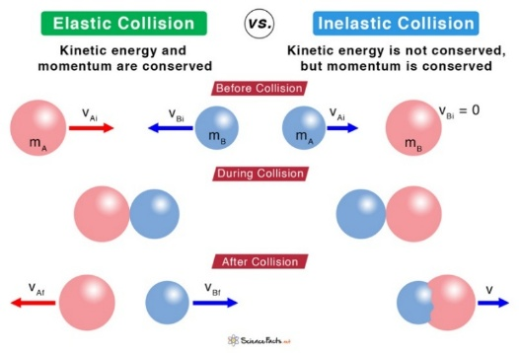
Momentum  (kg$•$m/s)  ($kg•m^{2}/s$) | Elastic Collision:  $$m_{A}{\left(v_{A}\right)}_{1}+m_{B}{\left(v_{B}\right)}_{1}=m_{A}{\left(v_{A}\right)}_{2}+m_{B}{\left(v_{B}\right)}_{2}$$  (conservation of momentum)  $$K_{A1}+K_{B1}=K_{A2}+K_{B2}$$  (conservation of kinetic energy) | Perfectly Inelastic Collision:  $$m_{A}{\left(v_{A}\right)}_{1}+m_{B}{\left(v_{B}\right)}_{1}=\left(m_{A}+m_{B}\right)v_{2}$$  (conservation of momentum)
Force  (N = kg$•$m/$s^{2}$)  /  Torque  (N$•$m) | $$F=ma$$  $$F_{g}=mg$$  (constant mass)  $$\sum{F}=F_{net}=ma$$  $$F_{net, ave}=\frac{∆p}{∆t}$$  Friction:  $$F_{μ_{s}}≤μ_{s}N$$  $$F_{μ_{k}}=μ_{k}N$$  $$Typically 0≤μ_{k}≤μ_{s}$$  Gravitational Force:  $$F_{G}=G\frac{m_{1}{ m}_{2}}{r^{2}}$$  Hooke’s Law:  $$F_{s}=-kΔx$$ | $$τ=Iα$$  (fixed-axis rotation with constant $I$)  $$τ=rF\sin{θ}=rF_{⊥}$$  $$\sum{τ}=τ_{net}=Iα$$  $$τ_{net, ave}=\frac{∆L}{∆t}$$  $$F=ma_{c}$$  $$F=\frac{{mv}^{2}}{r}=mrω^{2}$$  (net inward force) | Electricity:  Coulomb’s Law:  $$F=k\frac{\left|q_{1} q_{2}\right|}{r^{2}}$$  $$F=\frac{1}{4πϵ_{0}} \frac{\left|q_{1} q_{2}\right|}{r^{2}}$$  $$F=Eq$$  Magnetism:  $$F_{B}=\left|qvB\sin{θ}\right|$$  $$F_{B}=BIl\sin{θ}$$ | Fluid Mechanics:  $$P=\frac{F}{A}$$  $$∆P=ρhg$$  $$F_{buoy}=ρVg$$  Universal Gas Law:  $$PV=nRT=Nk_{B}T$$  (absolute pressure; $T$ is in kelvins)
Impulse  (N$•$s)  (N$•$m$•$s) | Constant net force:  $$J=F∆t$$  $$J=∆p=m∆v$$ | Constant net torque:  $$H=∆L=τ∆t$$  $$H=I∆ω$$

Energy
Work  (J = N$•$m) | Constant force:  $$W=F_{∥}s=Fs\cos{θ}$$  ($s$ is displacement) | Constant torque:  $$W=τ Δθ$$  (fixed axis, $θ$ in rad) | $$W=QV_{drop}$$  $$W_{\text{electric}}=-qΔV$$ | Thermodynamics:  $$W=P∆V$$  (constant pressure)  $$e=\left|\frac{W}{Q_{H}}\right|=\left|\frac{output/cycle}{heat absorbed}\right|$$  Max. Carnot efficiency²:  $$e_{c}=\frac{T_{H}-T_{C}}{T_{H}}$$ | ¹ Needs steady, incompressible, inviscid flow along a streamline, with no pump/turbine work.  ² $T_{H},T_{C}$ in kelvins
Kinetic  Energy  (J) | Translational:  $$K_{trans}=\frac{1}{2}mv^{2}$$ | Rotational:  $$K_{rotat}=\frac{1}{2}Iω^{2}$$ | $$1 eV≈1.60×{10}^{-19} J$$ | Fluid Mechanics:  Bernoulli’s Equation¹:  $$P_{1}+ρgy_{1}+\frac{1}{2}ρ{v_{1}}^{2}=P_{2}+ρgy_{2}+\frac{1}{2}ρ{v_{2}}^{2}$$
Kinetic  Energy  (J) | Work-Energy Theorem:  $$W_{net}=∆K$$  $$W_{net}=W_{other}-ΔU=W_{other}-ΔU_{g}-ΔU_{s}$$  $$∆K=K_{2}-K_{1}=\frac{1}{2}m\left(v_{2}^{2}-v_{1}^{2}\right)+\frac{1}{2}I\left(ω_{2}^{2}-ω_{1}^{2}\right)$$ |  | Mechanical Energy:  $$E_{mech}=K+U$$  $$K=K_{trans}+K_{rotat}$$  $$U=U_{g}+U_{s}$$
Kinetic  Energy  (J) |  |  |  | Thermodynamics:  $$K_{avg}=\frac{3}{2}k_{B}T$$  (T is in kelvins) | Atomic and Nuclear:  $$K_{max}=hf-ϕ$$  (emission requires $hf≥ϕ$)
Potential  Energy  (J) | Surface of Earth Gravity:  $$∆U_{g}=mg∆h$$  $$U_{g}=mgh$$  Planetary Gravity:  $$U_{G}=-G\frac{m_{1}m_{2}}{r}$$  Conservation of Mechanical Energy:  $$∆E_{mech}=$$  $$∆\left(K+U_{g}+U_{s}\right)=0$$  (if only conservative forces do work) | Coiled Spring:  $$U_{s}=\frac{1}{2}k{Δx}^{2}$$  Nonconservative Work:  $$W_{noncons.}=$$  $$∆\left(K+U_{g}+U_{s}\right)$$ | Point charges:  $$U_{E}=qV$$  $$U_{E}=\frac{1}{4πϵ_{0}} \frac{q_{1}q_{2}}{r}$$  Capacitor/inductor:  $$U_{C}=\frac{1}{2}QV=\frac{1}{2}CV^{2}$$  $$U_{L}=\frac{1}{2}LI^{2}$$ | Fluid Mechanics:  $$P=P_{0}+ρgh$$  Continuity of Mass:  $$ρ_{1}A_{1}v_{1}=ρ_{2}A_{2}v_{2}$$  Continuity of Volume:  $$A_{1}v_{1}=A_{2}v_{2}$$  Thermodynamics 1st Law³:  $${∆U}_{internal}=Q-W_{by}$$ | Atomic and Nuclear:  $$E=hf$$  $$E_{0}=mc^{2}$$  $$∆E=(∆m)c^{2}$$
 |  |  |  |  | ³ Closed system; negligible changes in macroscopic kinetic and potential energy.
Heat  Energy  (J) | Energy transferred by heating is $Q$.  Closed-system energy balance:  $Q>0$ into the system  $W_{\text{by}}>0$ for work done by it |  |  | Thermodynamics:  $$H=\frac{Q}{∆t}=\frac{kA∆T}{L}$$  (steady heat conduction)  $$Q=mL_{f}$$  $$Q=mL_{v}$$ | Hydrogen Electron Energy Levels:  $$E_{n}=\frac{-13.6 eV}{n^{2}}$$  n = principal quantum number (1, 2, 3, etc.)
Energy  (J) | Conservation of Energy for an isolated system:  $${E_{total}=E}_{i}=E_{f}$$  $$E_{total}=\sum{E_{i}}=\sum{E_{f}}$$  $$E_{total}=K+U_{potential}+U_{internal}$$  Closed-system energy balance:  $$ΔE_{\text{total}}=∆K+{∆U}_{potential}+{∆U}_{internal}=Q-W_{by}$$ |  |  | $$∆E=Q=mc∆T=mc\left(T_{f}-T_{i}\right)$$  (Heat is the only energy transfer, no phase change, and approximately constant specific heat)  $$T_{f}=\frac{m_{1}c_{1}T_{1i}+m_{2}c_{2}T_{2i}}{m_{1}c_{1}+m_{2}c_{2}}$$  (No heat exchange with surroundings, no phase change, negligible calorimeter heat capacity, constant specific heats)  $$c_{H_{2}O}=4,184 \frac{J}{kg∙K}$$
Power  (W) | Energy transferred by the process:  $$P_{ave}=\frac{W}{Δt}=\frac{∆E_{transferred}}{∆t}$$ |  | $$P=IV$$  $$P=I^{2}R$$  $$P=\frac{V^{2}}{R}$$ | $$P=Δp Q$$  where:  $$p=pressure \left(\frac{N}{m^{2}}\right)$$  $$Q=volumetric$$  $$flow rate \left(\frac{m^{3}}{s}\right)$$
Power  (W) | $$P=F_{∥}v$$  $$P=Fv\cos{θ}$$ | $$P=τ_{∥}ω$$  $$P=τω\cos{ϕ}$$ | $$P=IV$$  $$P=I^{2}R$$  $$P=\frac{V^{2}}{R}$$

Engineering Application |  | See Harold’s Center of Mass / Moment of Inertia Cheat Sheet  See Harold’s Physics Doppler Effect Cheat Sheet
Period (s) / Frequency  (Hz) | $$T=\frac{1}{f}$$  $$f=\frac{1}{T}$$  Kepler’s Third Law:  $$T^{2}=\left(\frac{4π^{2}}{GM}\right)r^{3}$$  ($M$ dominant; $r$ is circular-orbit radius) | $$T=\frac{1}{f}=\frac{2π}{ω}=\frac{2πr}{v}$$  $$T_{spring}=2π\sqrt{\frac{m}{k}}$$  $$T_{pendulum}=2π\sqrt{\frac{l}{g}}$$  (small oscillations) | $$T_{angular}=\frac{2π}{\left|b\right|}$$  For:  $$y=\sin\left(bθ\right)$$  $$y=\cos\left(bθ\right)$$ |  | 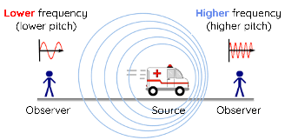 | Waves and Optics:  $$f=\frac{v}{λ}$$  Doppler Effect:  $$f_{r}=f_{s}{\left(\frac{v±v_{r}}{v∓v_{s}}\right)}^{*}$$
 |  |  |  |  | * = Receiver toward source: numerator +; source toward receiver: denominator −, with speeds measured relative to the medium.
Center  of Mass  (m) | $$x_{CM}=\frac{m_{1}x_{1}+m_{2}x_{2}}{m_{1}+m_{2}}$$  $$r_{CM}=\frac{\sum{mr}}{\sum{m}}$$ |  |  |  | $$x_{CM}=\frac{\sum{m_{i}x_{i}}}{\sum{m_{i}}}$$ | $$y_{CM}=\frac{\sum{m_{i}y_{i}}}{\sum{m_{i}}}$$
Center  of Mass  (m) |  | 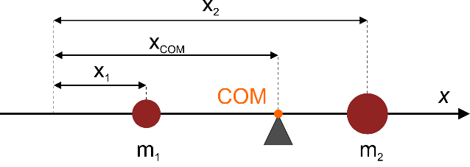 |  |  | 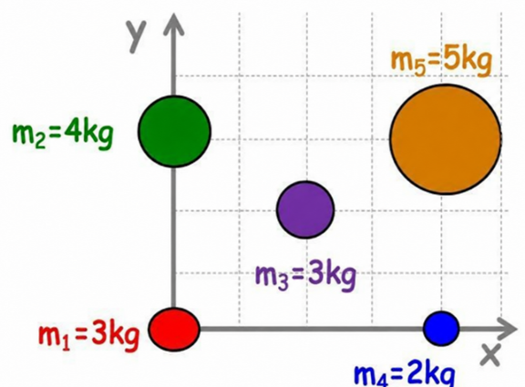
Rigid Bodies  (Statics) | $$\sum{F_{x}=0}$$  (Right = ‘+‘)  $$\sum{F_{y}=0}$$  (Down = ‘−‘) | $$\sum{τ=0}$$  (CW = ‘−‘) |  | 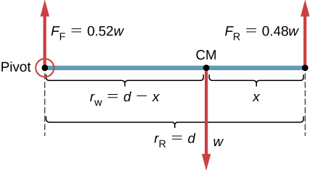
Conservation Laws
Fundamental Principle | Conservation of  Linear Momentum | Conservation of  Angular Momentum | Conservation of  Electric Charge |  | Conservation of  Mass (or Matter) | Conservation of  Energy
Discipline | Physics | Physics | Chemistry & Circuits |  | Chemistry & Fluid Mechanics | Physics
Formula | $$\sum{p_{i}}=\sum{p_{f}}$$  $$\sum{mv_{i}}=\sum{mv_{f}}$$ | $$\sum{L_{i}}=\sum{L_{f}}$$  $$\sum{Iω_{i}}=\sum{Iω_{f}}$$ | $$\sum{Q_{i}}=\sum{Q_{f}}$$ |  | $$\sum{m_{i}}=\sum{m_{f}}$$ | $$\sum{E_{i}}=\sum{E_{f}}$$
Example | Zero net external impulse for linear momentum. Zero net external angular impulse about the chosen origin for angular momentum. |  | Kirchhoff's Current Law (KCL):  $$\sum_{i=1}^{n}{I_{i}}=0$$ |  | Continuity of Mass:  $$ρ_{1}A_{1}v_{1}=ρ_{2}A_{2}v_{2}$$  (Classical mass conservation, since mass alone is not conserved in nuclear reactions.) | $$\sum{E_{i}}=constant$$  $$ΔE_{\text{total}}=∆K+{∆U}_{potential}+{∆U}_{internal}=Q-W_{by}$$
 | 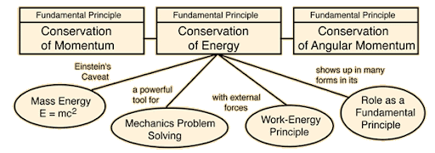 |  |  |  |  | For an isolated system:  $$E_{total}=K+U_{potential}+U_{internal}=constant$$

Electricity
Terms | Formulas | See Harold’s Electromagnetic Spectrum Cheat Sheet  See Harold’s DC Circuits Cheat Sheet
Electric Field  (V/m or N/C) | $$E=\frac{F}{q}$$  $$E_{x,avg}=-\frac{∆V}{∆x}$$  $$E=ρJ$$  ($ρ=$ electrical resistivity) | $$E_{r,avg}=-\frac{∆V}{∆r}$$ | Gauss’s Law:  $$ϕ=\frac{Q_{enc}}{ϵ_{0}}$$
Potential / Voltage  (V) | $$V=IR$$  $$V=\frac{Q}{C}$$ | $$V=k\sum_{i}{\frac{q_{i}}{r_{i}}}$$  $$V=\frac{1}{4πϵ_{0}}\sum_{i}{\frac{q_{i}}{r_{i}}}$$ | 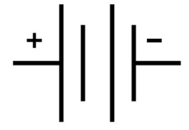
Current  (A) | $$I_{ave}=\frac{∆Q}{∆t}$$  $$I=\frac{V}{R}$$ | $$I=n|e|v_{d}A$$ | 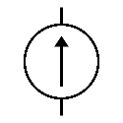
Circuits |  | Series | Parallel
Circuit Terms | 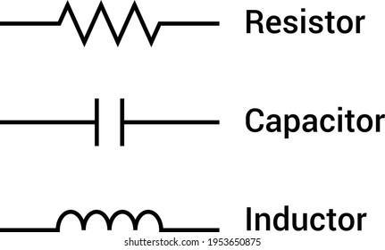 | 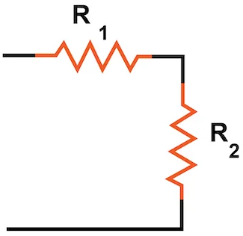 | 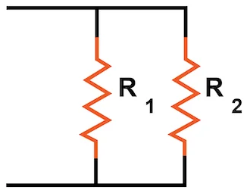
Resistance  (Ω) | $$R=\frac{V}{I}$$  $$R=\frac{ρl}{A}$$ | $$R_{s}= \sum_{i}{R_{i}}$$ | $$\frac{1}{R_{p}}= \sum_{i}{\frac{1}{R_{i}}}$$  $$R_{p}=\frac{R_{1}R_{2}}{R_{1}+R_{2}}$$
Inductance  (H) | $$L=N\frac{Φ}{I}$$  $$L=μ_{0}{\frac{N^{2}A}{l}}^{ 1}$$ | $$L_{s}= \sum_{i}{L_{i}}$$ | $$\frac{1}{L_{p}}= \sum_{i}{\frac{1}{L_{i}}}$$
Inductance  (H) | $$L=N\frac{Φ}{I}$$  $$L=μ_{0}{\frac{N^{2}A}{l}}^{ 1}$$ | $L_{s}$ and $L_{p}$assume negligible mutual inductance.  ¹ For a long air-core solenoid; negligible end effects.
Capacitance  (F) | $$C=\frac{Q}{V}$$  $$C=\frac{κϵ_{0}A}{d}$$ | $$\frac{1}{C_{s}}= \sum_{i}{\frac{1}{C_{i}}}$$ | $$C_{p}= \sum_{i}{C_{i}}$$
Kirchhoff's Current Law (KCL) | $$\sum_{i=1}^{n}{I_{i}}=0$$  The algebraic sum of currents in a network of conductors meeting at a point (node) is zero. |  | 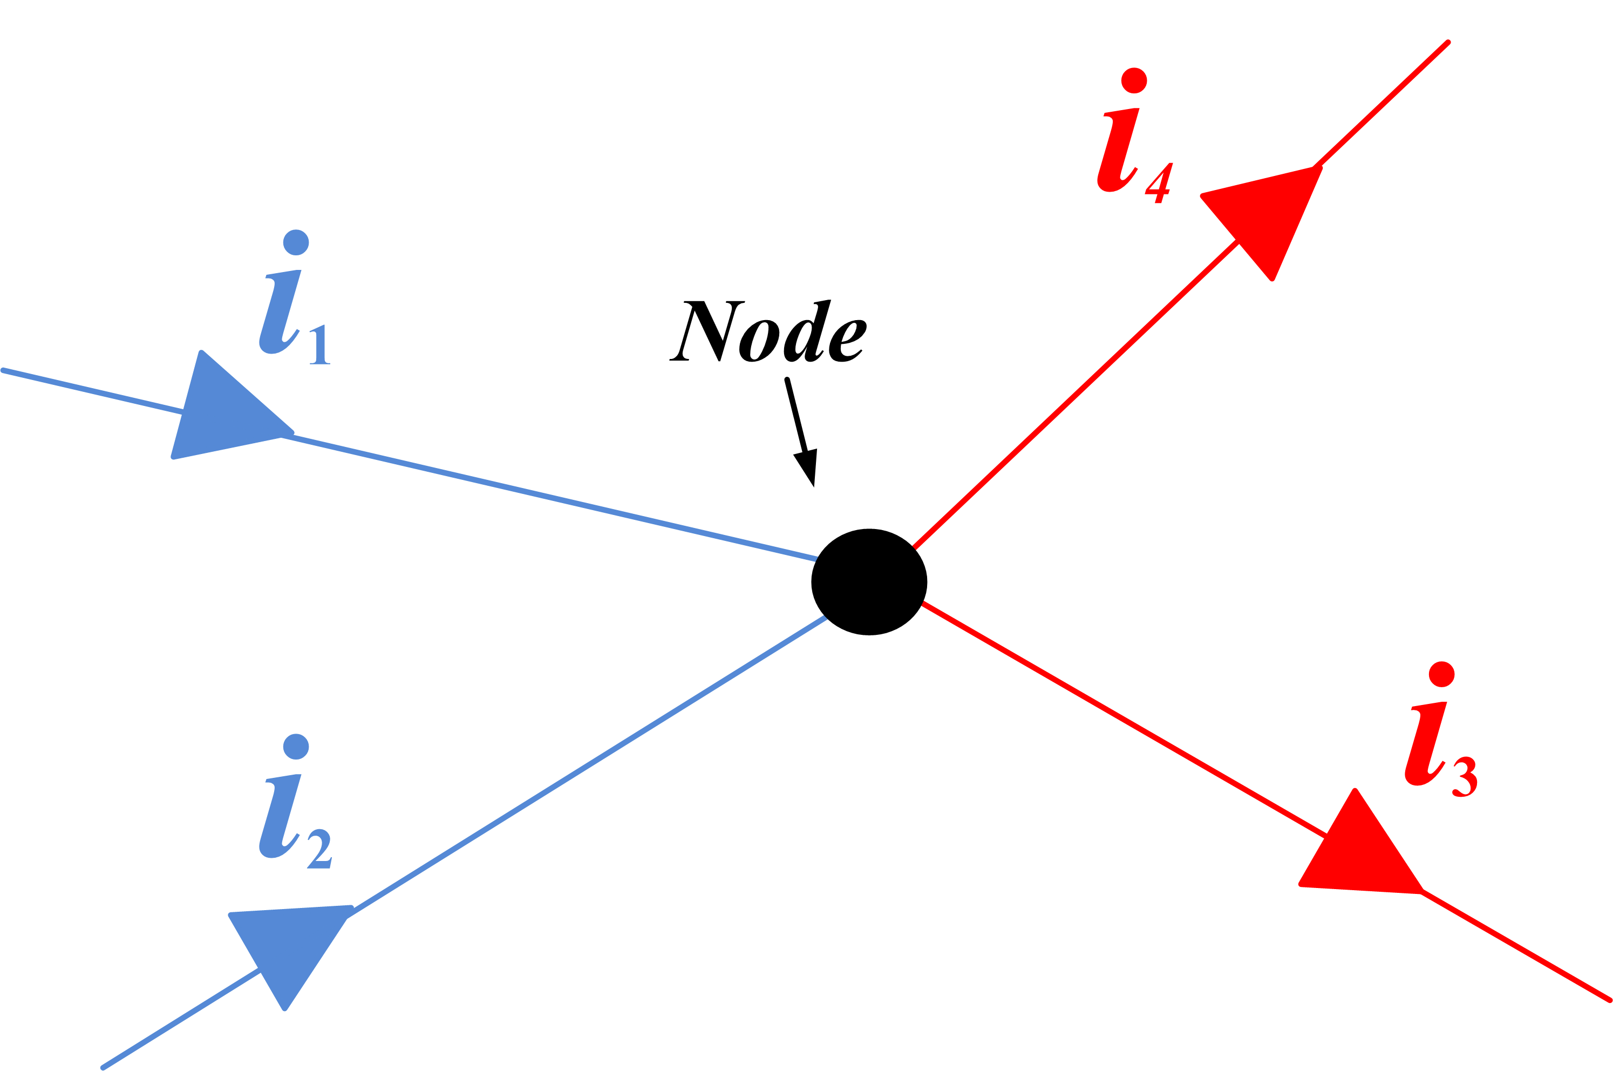
Kirchhoff's Voltage Law (KVL) | $$\sum_{i=1}^{n}{V_{i}}=0$$  The directed sum of the potential differences (voltages) around any closed loop is zero. |  | 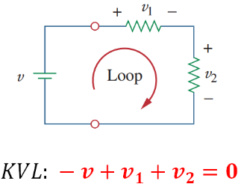

Magnetism
Term | Formulas
Magnetic  Field  (T) | $$B=\frac{μ_{0}}{2π} \frac{I}{r}$$  (Long straight wire)  $$Solenoid:$$  $$B_{s}=μ_{0}nI$$  (Long air-core solenoid, away from the ends)  $$where n=\frac{N}{l} turns per meter$$  Moving-charge magnetic field:  $$B=\frac{μ_{0}\left|q\right|vr}{4πr^{3}}\sin{θ}$$  (Nonrelativistic approximation, $v≪c$)
Magnetic  Flux  (Wb) | $$ϕ_{B}=BA\cos{θ}$$  (Uniform field through a flat surface;  $θ$ is measured from the surface normal)
EMF  (V) | $$ε=Blv$$  (magnitude; perpendicular rod, velocity, and uniform magnetic field)  $$ε_{avg}= - \frac{N∆ϕ_{B}}{∆t}$$  ($N$ turns, stationary loop)

Sources
- NIST SP 961 (2022). CODATA Recommended Values of the Fundamental Physical Constants: 2022. https://physics.nist.gov/cuu/pdf/wall_2022.pdf
- Wikipedia (2025).
  - Metric prefix. https://en.wikipedia.org/wiki/Metric_prefix
  - SI derived unit. https://en.wikipedia.org/wiki/SI_derived_unit
Acknowledgements
- Proofread with assistance from ChatGPT 6.1 Sol, https://chatgpt.com/

