Harold’s Physics
Forces with FBD
Cheat Sheet
1 October 2026

Forces on a Pulled Box
Question | A man pulls a 50 kg box with a force of 300 N. As the box slides to the right on a horizontal floor and remains in contact with it, it experiences an opposing frictional force. As a result of the forces acting on it, the box accelerates to the right at 4.0 m/s².  Diagram:  - The pulling force is directed at 30° above the horizontal.  - The positive x-axis points right, and the positive y-axis points upward.  - Draw the free-body diagram (FBD) of the box.  - Calculate the net force ($F_{net}$) acting on the box.  - Write the equation expressing Newton’s Second Law for the x-components of the forces acting on the box and use it to calculate the force of friction ($F_{μ}$) acting on the box.  - Write the equation expressing Newton’s Second Law for the y-components of the forces acting on the box and use it to calculate the normal force ($F_{N}$) acting on the box.  - Calculate the coefficient of kinetic friction ($μ_{k}$) for the box on the floor.
Diagrams | 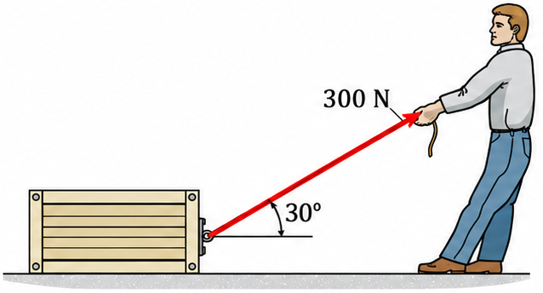 | 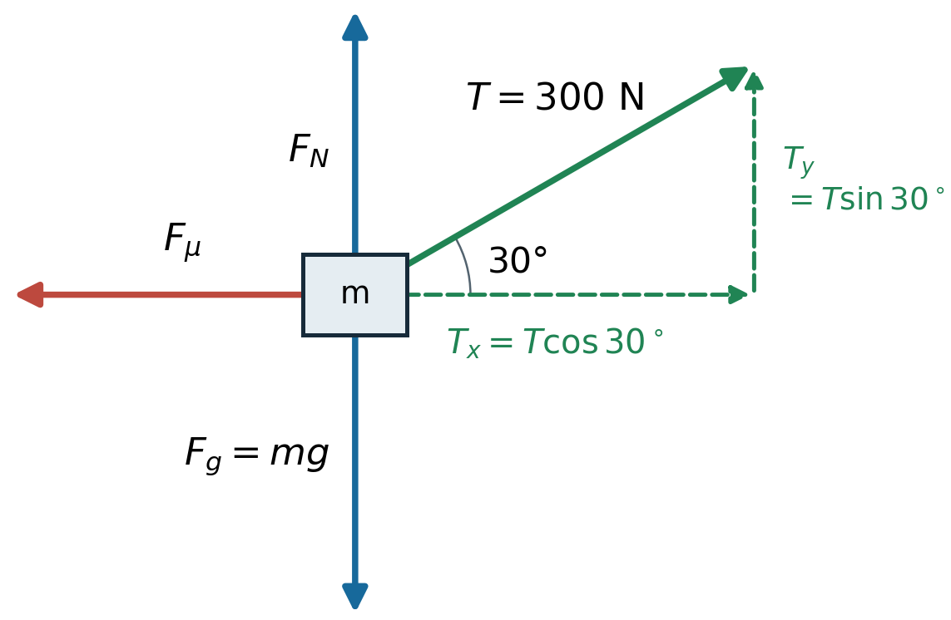  Part a) FBD  Dashed green arrows represent components of T, not additional forces. Diagram not to scale.
FBD Procedure | Identify the object, draw only external forces, choose axes, resolve components, and apply  $\sum{F_{x}}=ma_{x}, \sum{F_{y}}=ma_{y}$.
Givens | $$m=50 kg$$  $$T=300 N$$  $θ={30}^{°}$ inclined from the horizontal  $$a=4.0 \frac{m}{s^{2}} to the right$$ | $$μ_{k}>0$$
Observations | $$a_{x}=a$$  $$a_{y}=0$$  $$g=9.81 \frac{m}{s^{2}}$$ | $$0≤F_{μ_{s}}≤ μ_{s} F_{N}$$  $$F_{μ}=F_{μ_{k}}= μ_{k} F_{N}$$
Part b) | Calculate the net force ($F_{net}$) acting on the box.
Equation | $$F_{net}=ma$$
Solution | $$=(50 kg)\left(4.0 \frac{m}{s^{2}}\right)$$  $$F_{net}=200 N right$$
Part c) | Write the equation expressing Newton’s Second Law for the x-components of the forces acting on the box and use it to calculate the force of friction ($F_{μ_{k}}$) acting on the box.
Equation | $$F_{net,x}=\sum{F_{x}}=ma_{x}=T_{x}-F_{μ_{k}}$$
Solution | $$F_{μ_{k}}=T_{x}-F_{net,x}$$  $$F_{μ_{k}}=T cos 30°-F_{net,x}$$  $$=(300 N) cos 30°-200 N$$  $$=259.8 N-200 N$$  $$F_{μ_{k}}=59.8 N left$$
Part d) | Write the equation expressing Newton’s Second Law for the y-components of the forces acting on the box and use it to calculate the normal force ($F_{N}$) acting on the box.
Equation | $$\sum{F_{y}}=0$$  $$F_{N}+T_{y}-F_{g}=0$$
Solution | $$F_{N}={F_{g}-T}_{y}$$  $$F_{N}=(50 kg)\left(9.81\frac{m}{s^{2}}\right) -(300 N) sin 30°$$  $$=490.5 N-150 N=340.5 N$$  $$F_{N}≈340 N upward$$
Part e) | Calculate the coefficient of kinetic friction ($μ_{k}$) for the box on the floor.
Equation | $$F_{μ}=μ_{k}{ F}_{N}$$
Solution | $$μ_{k}=\frac{F_{μ}}{{ F}_{N}}$$  $$μ_{k}=\frac{59.8076 N}{340.5 N}=0.17565$$  $$μ_{k}≈0.18$$  The coefficient of kinetic friction is dimensionless.

Sources
- Young, Hugh D. and Freedman, Roger A. (2015). University Physics with Modern Physics, 14th Edition, Section 4.6, Free-Body Diagrams. https://www.amazon.com/University-Physics-Modern-14th/dp/0321973615
- Numerade (n.d.). QUESTION 3. https://www.numerade.com/ask/question/question-3-a-man-is-pulling-a-box-of-a-mass-of-50-kg-with-a-force-of-300-n-as-the-box-moves-across-the-surface-it-experiences-a-friction-force-as-a-result-of-the-forces-acting-on-it-the-box--57916/

Acknowledgements
- Proofread with assistance from ChatGPT 6.1 Sol, https://chatgpt.com/

