Harold’s Physics
Blocks and Pulleys
(Comparing Force FBDs with Impulse-Momentum)
Cheat Sheet
13 October 2026

Blocks + Movable Pulley
Question | Block A weighs 10 lbf.  Block B weighs 3 lbf.  Block B is moving downward with an initial velocity $v_{B1}=3 \frac{ft}{s} at t=0$.  The coefficient of kinetic friction between the horizontal plane and block A is $μ_{kA}=0.15$.  Determine the velocity of block A at $t=1 s$.  Assume:  - The fixed pulley has negligible rotational inertia, so torque balance makes the rope tension uniform (T).  - The moving pulley is supported by two rope segments (2T).  - The mass of the rope is negligible.
Diagram | 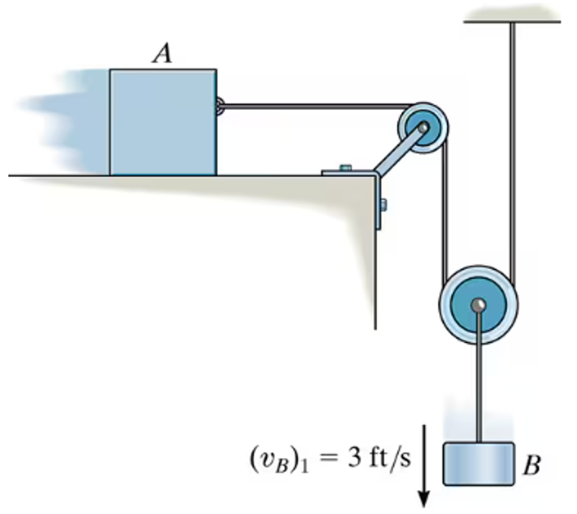
Givens | $$W_{A}=10 lb$$  $$W_{B}=3 lb$$  $$v_{B1}=3 \frac{ft}{s} at t=0$$ | $$t_{1}=0 s$$  $$t_{2}=1 s$$  $$μ_{kA}=0.15$$
Observations | $$g=32.2 \frac{ft}{s^{2}}$$ | $$F_{μ}=F_{μ_{k}}= μ_{k} F_{N}$$  $$∆t=t_{2}-t_{1}=1 s$$
Solution Methods | Method 1: Force FBDs | Method 2: Linear Impulse-Momentum
FBD Procedures | Identify the object, draw only external forces, choose axes, resolve components, and apply equations. | Identify each object’s initial momentum, net impulse, and final momentum, then show them as an L→ R box flow diagram with the vector magnitude and direction indicated per box.
FBDs | 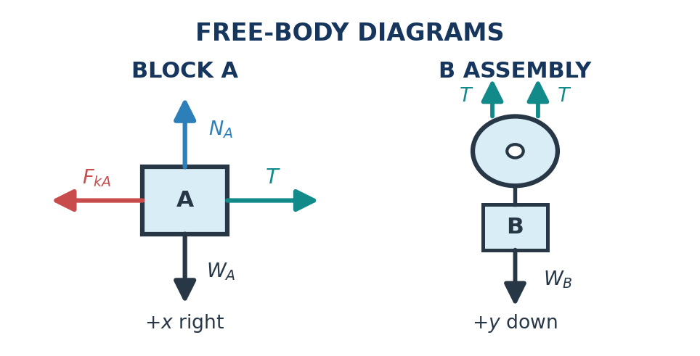 | 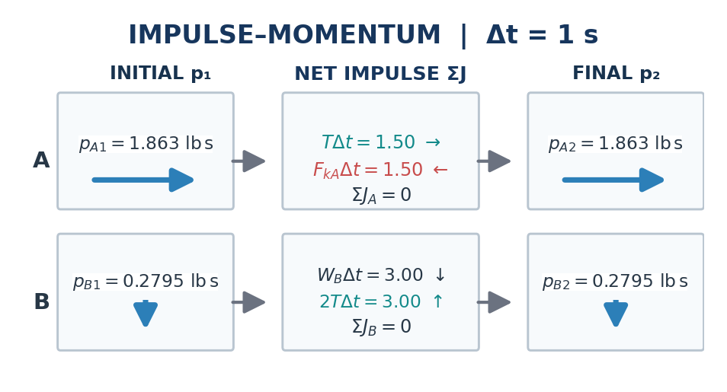
Equations | Newton’s 2nd Law:  $$\sum{F_{x}}=ma_{x}$$  $$\sum{F_{y}}=ma_{y}$$ | Momentum:  $$p=mv$$  $$∆p=mv_{2}-mv_{1}$$  Impulse:  $$J=\int_{t_{1}}^{t_{2}}{F(t) dt}$$  If a constant force,  $$J=F ∆t=F (t_{2}-t_{1})$$  Combined:  $$\sum{J}=∆p$$  $$\sum{\int_{t_{1}}^{t_{2}}{F(t) dt}}=mv_{2}-mv_{1}$$
Choose Signs | +x right for A | +y down for B
Constraints | Due to the pulley rope configuration,  $$a_{A}=2 a_{B}$$  $$v_{A}=2 v_{B}$$ | Due to the pulley rope configuration, when B moves down, A moves right twice as fast.  $$v_{A}=2 v_{B}$$  $$v_{A1}=2 v_{B1}=2 \left(3 \frac{ft}{s}\right)=6 \frac{ft}{s}$$
Friction | $$N_{A}=F_{N_{A}}=W_{A}=10 lb$$  $F_{μ_{k}}=μ_{k} F_{N_{A}}=(0.15)(10 lb)=1.50 lb$ acting left
Block A  (Horizontal Equation) | $$T-F_{μ_{k}}=m_{A}{ a}_{A}$$  $$T-F_{μ_{k}}=\left(\frac{W_{A}}{g}\right){ a}_{A}$$  $$T-1.50 lb=\left(\frac{10 lb}{32.2 \frac{ft}{s^{2}}}\right) a_{A}$$  $$T-1.50 lb=0.3106 a_{A}$$ | $$p_{A1}+J_{T}-J_{μ_{k}}=p_{A2}$$  $$m_{A} v_{A1}+T\left(∆t\right)-F_{μ_{k}}\left(∆t\right)=m_{A} v_{A2}$$  $$\left(\frac{W_{A}}{g}\right)\left(v_{A1}\right)+T\left(∆t\right)-F_{μ_{k}}\left(∆t\right)=\left(\frac{W_{A}}{g}\right)v_{A2}$$  $$\left(\frac{10}{32.2}\right)\left(6 \frac{ft}{s}\right)+T \left(1 s\right)-1.5 \left(1 s\right)=\left(\frac{10}{32.2}\right)v_{A2}$$
Block B  (Vertical Equation) | $$W_{B}-2 T=\left(\frac{W_{B}}{g}\right)a_{B}$$  $$3.00 lb-2 T=\left(\frac{3 lb}{32.2 \frac{ft}{s^{2}}}\right) a_{B}$$  $$3.00 lb-2 T=0.0932 a_{B}$$ | $$p_{B1}+J_{W_{B}}-J_{2T}=p_{B2}$$  $$m_{B} v_{B1}+W_{B}\left(∆t\right)-2T\left(∆t\right)=m_{B} v_{B2}$$  $$\left(\frac{W_{B}}{g}\right)\left(v_{B1}\right)+W_{B}\left(∆t\right)-2T\left(∆t\right)=\left(\frac{W_{B}}{g}\right)v_{B2}$$  $$\left(\frac{3}{32.2}\right)\left(3 \frac{ft}{s}\right)+3 \left(1 s\right)-2T\left(1 s\right)=\left(\frac{3}{32.2}\right)v_{B2}$$  $$3.2795-2T=0.09317 v_{B2}$$
Solve | Solve for T in the block A equation.  $$T-1.50 lb=0.3106 (2 a_{B})$$  $$T=1.50 lb+0.6212 a_{B}$$  Substitute T into the block B equation.  $$3.00 lb-2T=0.0932 a_{B}$$  $$3.00 lb-2 (1.50 lb+0.6212 a_{B})=0.0932 a_{B}$$  $$-1.2424 a_{B}=0.0932 a_{B}$$  $$a_{B} = 0$$  $$T=1.50 lb$$  $$a_{A}=a_{B}=0 \frac{ft}{s^{2}}$$ | Solve for T in the block A equation.  $$T +0.3634 =0.3106 v_{A2}$$  Substitute ($v_{A2}=2 v_{B2}$) into the block A equation.  $$T +0.3634 =0.3106 v_{A2}$$  $$T +0.3634 =0.3106 \left(2 v_{B2}\right)$$  $$T +0.3634 =0.6211 v_{B2}$$  $$T =0.6211 v_{B2}- 0.3634$$  Solve with the block B equation.  $$3.2795-2T=0.09317 v_{B2}$$  $$3.2795-2 \left(0.6211 v_{B2}- 0.3634\right)=0.09317 v_{B2}$$  $v_{B2}=3 \frac{ft}{s}$ downward
Velocity | The blocks have zero acceleration, so their velocities remain constant.  $$v_{B1}=3 \frac{ft}{s} at t=0$$  $$v_{A1}=2 (v_{B1})=2\left(3 \frac{ft}{s}\right)= 6 \frac{ft}{s}$$  $$v_{A2}=v_{A1}+a_{A2}t$$  $$=6 \frac{ft}{s}+\left(0 \frac{ft}{s^{2}}\right)\left(1 s\right)$$  $v_{A2}=6 \frac{ft}{s}$ to the right | - On A, the rightward tension impulse $TΔt$ balances the leftward friction impulse $Fₖ Δt$.  - On B, the downward weight impulse $W_{B} Δt$ balances the upward rope impulse $2TΔt$.  - Both net impulses are zero, so both velocities remain constant.  $v_{A2}=2 v_{B2}=6 \frac{ft}{s}$ to the right
Solution | The velocity of block A at $t=1 s$ is $6 \frac{ft}{s}$ to the right.

Sources
- Hibbeler, R. C. (April 1, 2012). Engineering Mechanics: Dynamics, 13th Edition, Prob. 15–32 (problem image supplied).

Acknowledgements
- Proofread with assistance from ChatGPT 6.1 Sol, https://chatgpt.com/

