Harold’s Parent Functions
“Cheat Sheet”
AKA Library of Functions
18 September 2022

Function Name | Parent Function | Graph | Characteristics
Algebra
Constant | $$f\left(x\right)=c$$ | 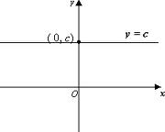 | Domain: ($-$∞, ∞)  Range: [c, c]  Inverse Function: Undefined (asymptote)  Restrictions: c is a real number  Odd/Even: Even  General Form:  $$Ay+B=0$$
Linear  or  Identity | $$f\left(x\right)=x$$ | 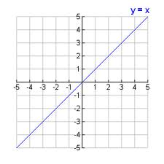 | Domain: ($-$∞, ∞)  Range: ($-$∞, ∞)  Inverse Function: Same as parent  Restrictions: m ≠ 0  Odd/Even: Odd  General Forms:  $$Ax+By+C=0$$  $$y=mx+b$$  $$y- y_{0}=m(x-x_{0})$$
Quadratic  or  Square | $$f\left(x\right)=x^{2}$$ | 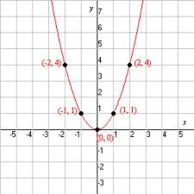 | Domain: ($-$∞, ∞)  Range: [0, ∞)  Inverse Function: $$f^{-1 }\left(x\right)= \sqrt{x}$$  Restrictions: None  Odd/Even: Even  General Form:  $$Ax^{2}+By+Cx+D=0$$
Square Root | $$f\left(x\right)= \sqrt{x}$$ | 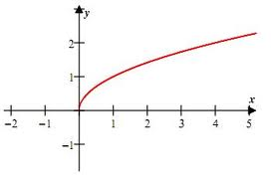 | Domain: [0, ∞)  Range: [0, ∞)  Inverse Function: $$f^{-1 }\left(x\right)= x^{2}$$  Restrictions: $x≥0$  Odd/Even: Neither  General Form:  $$f\left(x\right)= a\sqrt{b(x-h)}+k$$
Cubic | $$f\left(x\right)=x^{3}$$ | 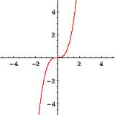 | Domain: ($-$∞, ∞)  Range: ($-$∞, ∞)  Inverse Function: $$f^{-1 }\left(x\right)=\sqrt[3]{x}$$  Restrictions: None  Odd/Even: Odd  General Form:  $$f\left(x\right)={a(b\left(x-h\right))}^{3}+k$$
Cube Root | $$f\left(x\right)=\sqrt[3]{x}$$ | 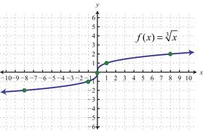 | Domain: ($-$∞, ∞)  Range: ($-$∞, ∞)  Inverse Function: $$f^{-1 }\left(x\right)=x^{3}$$  Restrictions: None  Odd/Even: Odd  General Form:  $$f\left(x\right)=a\sqrt[3]{b(x-h)}+k$$
Reciprocal  or  Rational | $$f\left(x\right)= \frac{1}{x}$$ | 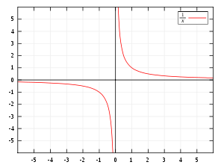 | Domain: ($-$∞, 0) $∪$ (0, ∞)  Range: ($-$∞, 0) $∪$ (0, ∞)  Inverse Function: Same as parent  Restrictions: x ≠ 0  Odd/Even: Odd  General Form:  $$f\left(x\right)= \frac{a}{b(x-h)}+k$$
Transcendentals
Exponential | $$f\left(x\right)={10}^{x}$$  $$or$$  $$f\left(x\right)=e^{x}$$ | 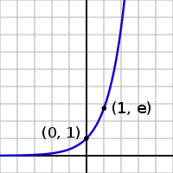 | Domain: ($-$∞, ∞)  Range: (0, ∞)  Inverse Function: $$f^{-1 }\left(x\right)=\log{x}$$  $$or$$  $$f^{-1 }\left(x\right)=\ln{x}$$  Restrictions: None, x can be complex  Odd/Even: Neither  General Form:  $$f\left(x\right)={a 10}^{(b(x-h))}+k$$
Logarithmic | $$f\left(x\right)=\log{x}$$  $$or$$  $$f\left(x\right)=\ln{x}$$ | 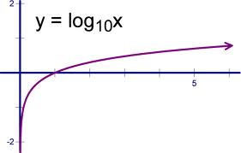 | Domain: (0, ∞)  Range: ($-$∞, ∞)  Inverse Function: $$f^{-1 }\left(x\right)={10}^{x}$$  $$or$$  $$f^{-1 }\left(x\right)=e^{x}$$  Restrictions: x > 0  Odd/Even: Neither  General Form:  $$f\left(x\right)=a\log\left(b(x-h)\right)+k$$
Absolute Value | $$f\left(x\right)=\left|x\right|$$ | 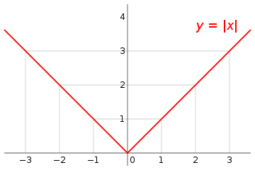 | Domain: ($-$∞, ∞)  Range: [0, ∞)  Inverse Function:  $$f^{-1 }\left(x\right)=x for x ≥0$$  Restrictions:  $$f\left(x\right)=\left\{\begin{aligned} x, if x≥0 \\ -x, if x<0\end{aligned}\right.$$  Odd/Even: Even  General Form:  $$f\left(x\right)=a\left|b(x-h)\right|+k$$
Greatest Integer  or  Floor | $$f\left(x\right)=\left[x\right]$$ | 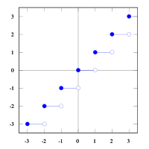 | Domain: ($-$∞, ∞)  Range: ($-$∞, ∞) whole numbers only  Inverse Function: Undefined (asymptotic)  Restrictions: Real numbers only  Odd/Even: Neither  General Form:  $$f\left(x\right)=a\left[b(x-h)\right]+k$$
Inverse Functions | $$f\left(f^{-1 }\left(x\right)\right)=x$$  $$f^{-1 }(f\left(x\right))=x$$ | 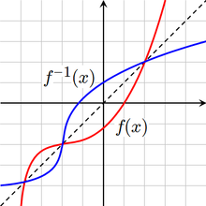 | Domain of x Domain of y  Range of y Range of x  Inverse Function: By definition  Restrictions: None  Odd/Even: Odd  General Form:  $$f\left(x\right)=a f(b\left(x-h\right))+k$$  Algebraically: Swap $x↔y$, then solve for $y$  Graphically: Rotate about 45⁰ line $y=x$
Conic Sections
Parabola | $${y=ax}^{2}$$ | 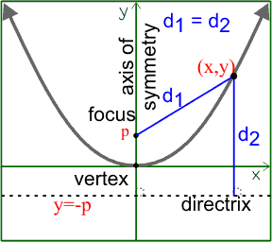 | Domain: ($-$∞, ∞)  Range: $[k,∞)$ or $(-∞,k]$  Inverse Function:  $$f^{-1 }\left(x\right)= \sqrt{x}$$  Restrictions: None  Odd/Even: Even  Vertex : $(h, k)$  Focus : $(h, k+p)$  General Forms:  $${\left(x-h\right)}^{2}=4p(y-k)$$  $$Ax^{2}+Bxy+Cy^{2}+Dx+Ey+F=0$$  where $B^{2}-4AC=0$
Circle | $$x^{2}+y^{2}=r^{2}$$ | 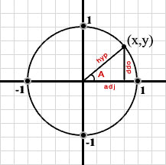 | Domain: $[-r+h, r+h]$  Range: $[-r+k, r+k]$  Inverse Function: Same as parent  Restrictions: None  Odd/Even: Both  Focus : $(h, k)$  General Forms:  $${(x-h)}^{2}+{(y-k)}^{2}=r^{2}$$  $$Ax^{2}+Bxy+Cy^{2}+Dx+Ey+F=0$$  $$where A=C and B=0$$
Ellipse | $$\frac{x^{2}}{a^{2}}+\frac{y^{2}}{b^{2}}=1$$ | 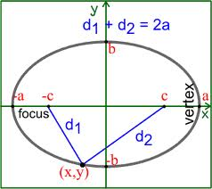 | Domain: $[-a+h, a+h]$  Range: $[-b+k, b+k]$  Inverse Function:  $$\frac{x^{2}}{b^{2}}+\frac{y^{2}}{a^{2}}=1$$  Restrictions: None  Odd/Even: Both  Foci : $c^{2}=a^{2}-b^{2}$  General Forms:  $$\frac{{(x-h)}^{2}}{a^{2}}+\frac{{(y-k)}^{2}}{b^{2}}=1$$  $$Ax^{2}+Bxy+Cy^{2}+Dx+Ey+F=0$$  where $B^{2}-4AC<0$
Hyperbola | $$\frac{x^{2}}{a^{2}}-\frac{y^{2}}{b^{2}}=1$$ | 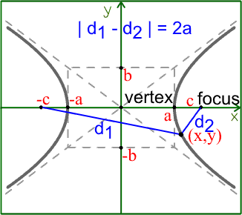 | Domain: ($-$∞, -a+h] $∪$ [a+h, ∞)  Range: ($-$∞, ∞)  Inverse Function:  $$\frac{y^{2}}{a^{2}}-\frac{x^{2}}{b^{2}}=1$$  Restrictions: Domain is restricted  Odd/Even: Both  Foci : $c^{2}=a^{2}+b^{2}$  General Forms:  $$\frac{{\left(x-h\right)}^{2}}{a^{2}}-\frac{{\left(y-k\right)}^{2}}{b^{2}}=1$$  $$Ax^{2}+Bxy+Cy^{2}+Dx+Ey+F=0$$  where $B^{2}-4AC>0$

Trigonometry
Sine | $$f(x)=sin x$$ | 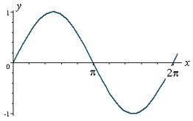 |  | Domain: ($-$∞, ∞) with T = 2π/|b|  Range: [$-$1, 1]  Inverse Function: $f^{-1 }(x)=\sin^{-1}{x}$  Restrictions: None  Odd/Even: Odd  General Form:  $$f\left(x\right)=a sin \left(b\left(x-h\right)\right)+k$$
Cosine | $$f(x)=\cos{x}$$ | 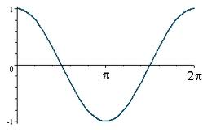 |  | Domain: ($-$∞, ∞) with T = 2π/|b|  Range: [$-$1, 1]  Inverse Function: $f^{-1 }(x)=\cos^{-1}{x}$  Restrictions: None  Odd/Even: Even  General Form:  $$f\left(x\right)=a \cos{ \left(b\left(x-h\right)\right)+k}$$
Tangent | $$f\left(x\right)=\tan{x}$$  $$= \frac{\sin{x}}{\cos{x}}$$ | 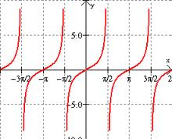 |  | Domain: ($-$∞, ∞) except for $x=\frac{π}{2}±nπ$  Range: ($-$∞, ∞)  Inverse Function: $f^{-1 }(x)=\tan^{-1}{x}$  Restrictions: Asymptotes at $x=\frac{π}{2}±nπ$  Odd/Even: Odd  General Form:  $$f\left(x\right)=a\tan{ \left(b\left(x-h\right)\right)+k}$$
Cosecant | $$f\left(x\right)=\csc{x}$$  $$= \frac{1}{\sin{x}}$$ | 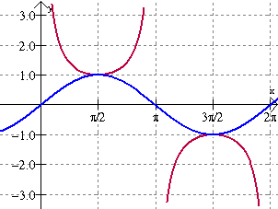 |  | Domain: ($-$∞, ∞) except for $x=±nπ$  Range: ($-$∞, -1] $∪$ [1, ∞)  Inverse Function: $f^{-1 }(x)=\csc^{-1}{x}$  Restrictions: Range is bounded  Odd/Even: Odd  General Form:  $$f\left(x\right)=a \csc{ \left(b\left(x-h\right)\right)+k}$$
Secant | $$f\left(x\right)=\sec{x}$$  $$= \frac{1}{\cos{x}}$$ | 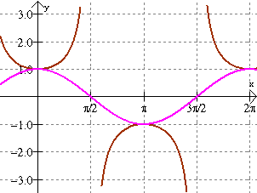 |  | Domain: ($-$∞, ∞) except for $x=\frac{π}{2}±nπ$  Range: ($-$∞,$-$1] $∪$ [1, ∞)  Inverse Function: $f^{-1 }(x)=\sec^{-1}{x}$  Restrictions: Range is bounded  Odd/Even: Even  General Form:  $$f\left(x\right)=a sec \left(b\left(x-h\right)\right)+k$$
Cotangent | $$f\left(x\right)=\cot{x}$$  $$= \frac{1}{\tan{x}}$$ | 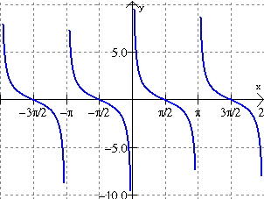 |  | Domain: ($-$∞, ∞) except for $x=±nπ$  Range: ($-$∞, ∞)  Inverse Function: $f^{-1 }(x)=\cot^{-1}{x}$  Restrictions: Asymptotes at x = $±nπ$  Odd/Even: Odd  General Form:  $$f\left(x\right)=a\cot{ \left(b\left(x-h\right)\right)+k}$$
Arcsine | $$f(x)=\sin^{-1}{x}$$ | 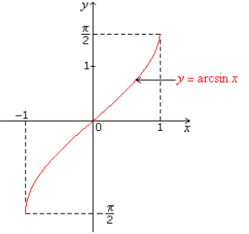 |  | Domain: [$-$1, 1]  Range: $\left[\frac{-π}{2}, \frac{π}{2}\right]$ or Quadrants I & IV  Inverse Function: $f^{-1 }\left(x\right)=\sin{x}$  Restrictions: Range & Domain are bounded  Odd/Even: Odd  General Form:  $$f\left(x\right)=a \sin^{-1 }\left(b\left(x-h\right)\right)+k$$
Arccosine | $$f(x)=\cos^{-1}{x}$$ | 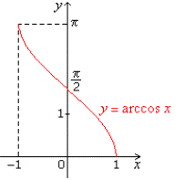 |  | Domain: [$-$1, 1]  Range: $\left[0, π\right]$ or Quadrants I & II  Inverse Function: $f^{-1 }\left(x\right)=\cos{x}$  Restrictions: Range & Domain are bounded  Odd/Even: None  General Form:  $$f\left(x\right)=a \cos^{-1}{ \left(b\left(x-h\right)\right)+k}$$
Arctangent | $$f(x)=\tan^{-1}{x}$$ | 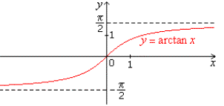 |  | Domain: ($-$∞, ∞)  Range: $\left(\frac{-π}{2}, \frac{π}{2}\right)$ or Quadrants I & IV  Inverse Function: $f^{-1 }\left(x\right)=\tan{x}$  Restrictions: Range is bounded  Odd/Even: Odd  General Form:  $$f\left(x\right)=a\tan^{-1}{ \left(b\left(x-h\right)\right)}{+ k}$$
Arccosecant | $$f(x)=\csc^{-1}{x}$$ | 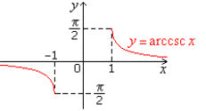 |  | Domain: ($-$∞,$-$1] $∪$ [1, ∞)  Range: $[ -\frac{π}{2}, 0)$ $∪$ $(0, \frac{π}{2}]$ or Quadrants I & IV  Inverse Function: $f^{-1 }\left(x\right)=\csc{x}$  Restrictions: Range & Domain are bounded  Odd/Even: Odd  General Form:  $$f\left(x\right)=a \csc^{-1}\left(b\left(x-h\right)\right)+k$$
Arcsecant | $$f(x)=\sec^{-1}{x}$$ | 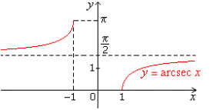 |  | Domain: ($-$∞,$-$1] $∪$ [1, ∞)  Range: $[0, \frac{π}{2})$ $∪$ ($\frac{π}{2}, π]$ or Quadrants I & II  Inverse Function: $f^{-1 }\left(x\right)=\sec{x}$  Restrictions: Range & Domain are bounded  Odd/Even: Neither  General Form:  $$f\left(x\right)=a \sec^{-1} \left(b\left(x-h\right)\right)+k$$
Arccotangent | $$f(x)=\cot^{-1}{x}$$ | 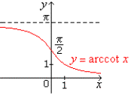 |  | Domain: ($-$∞, ∞)  Range: $(0, π)$ or Quadrants I & II  Inverse Function: $f^{-1 }\left(x\right)=\cot{x}$  Restrictions: Range is bounded  Odd/Even: Neither  General Form:  $$f\left(x\right)=a\cot^{-1}{ \left(b\left(x-h\right)\right)}{+k}$$
Hyperbolics
Hyperbolic Sine | $$f\left(x\right)=\sinh{x}$$  $$= \frac{e^{x}-e^{-x}}{2}$$ |  | 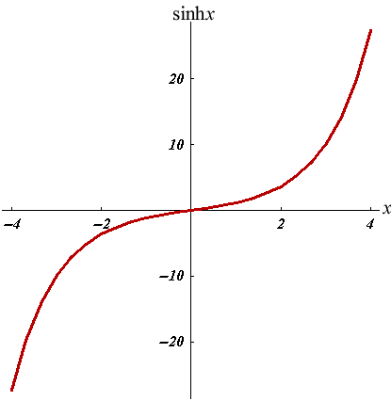 | Domain: ($-$∞, ∞)  Range: ($-$∞, ∞)  Inverse Function: $f^{-1 }(x)=\sinh^{-1}{x}$  Restrictions: None  Odd/Even: Odd  General Form:  $$f\left(x\right)=a sinh \left(b\left(x-h\right)\right)+k$$
Hyperbolic Cosine | $$f(x)=\cosh{x}$$  $$= \frac{e^{x}+e^{-x}}{2}$$ |  | 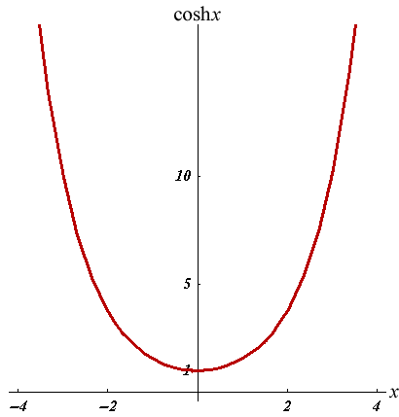 | Domain: ($-$∞, ∞)  Range: [1, ∞)  Inverse Function: $f^{-1 }(x)=\cosh^{-1}{x}$  Restrictions: None  Odd/Even: Even  General Form:  $$f\left(x\right)=a \cosh{ \left(b\left(x-h\right)\right)+k}$$
Hyperbolic Tangent | $$f\left(x\right)=\tanh{x}$$  $$= \frac{e^{2x}-1}{e^{2x}+1}$$ |  | 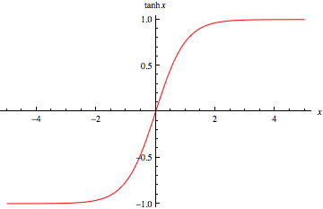 | Domain: ($-$∞, ∞)  Range: ($-$1, 1)  Inverse Function: $f^{-1 }(x)=\tanh^{-1}{x}$  Restrictions: Asymptotes at $y=±1$  Odd/Even: Odd  General Form:  $$f\left(x\right)=a\tanh{ \left(b\left(x-h\right)\right)+k}$$
Hyperbolic Cosecant | $$f\left(x\right)=\operatorname{csch}{x}$$  $$= \frac{1}{\sinh{x}}$$ |  | 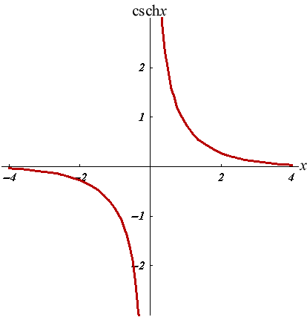 | Domain: ($-$∞, 0) $∪$ (0, ∞)  Range: ($-$∞, 0] $∪$ [0, ∞)  Inverse Function: $f^{-1 }(x)={csch}^{-1}{x}$  Restrictions: Asymptotes at $x=0, y=0$  Odd/Even: Odd  General Form:  $$f\left(x\right)=a \operatorname{csch}\left(b\left(x-h\right)\right)+k$$
Hyperbolic Secant | $$f\left(x\right)=\operatorname{sech}{x}$$  $$= \frac{1}{\cosh{x}}$$ |  | 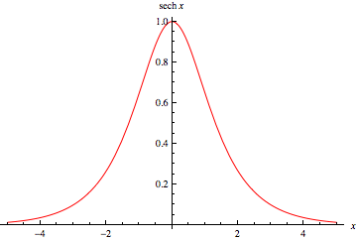 | Domain: ($-$∞, ∞)  Range: (0, 1]  Inverse Function: $f^{-1 }(x)={sech}^{-1}{x}$  Restrictions: Asymptote at $y=0$  Odd/Even: Even  General Form:  $$f\left(x\right)=a sech \left(b\left(x-h\right)\right)+k$$
Hyperbolic Cotangent | $$f\left(x\right)=\coth{x}$$  $$= \frac{1}{\tanh{x}}$$ |  | 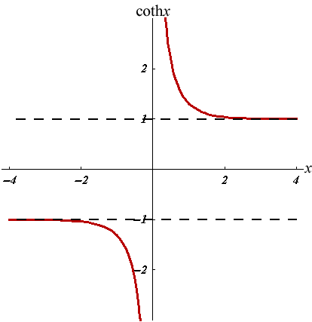 | Domain: ($-$∞, 0) $∪$ (0, ∞)  Range: ($-$∞, 1) $∪$ (1, ∞)  Inverse Function: $f^{-1 }(x)=\coth^{-1}{x}$  Restrictions: Asymptotes at $x=0, y=±1$  Odd/Even: Odd  General Form:  $$f\left(x\right)=a\coth\left(b\left(x-h\right)\right)+k$$
Hyperbolic Arcsine | $$f(x)=\sinh^{-1}{x}$$  $$=\ln{(x+\sqrt{x^{2}+1)}}$$ |  | 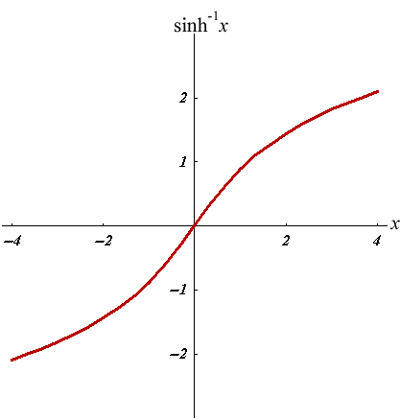 | Domain: ($-$∞, ∞)  Range: ($-$∞, ∞)  Inverse Function: $f^{-1 }\left(x\right)=\sinh{x}$  Restrictions: None  Odd/Even: Odd  General Form:  $$f\left(x\right)=a \sinh^{-1 }\left(b\left(x-h\right)\right)+k$$
Hyperbolic Arccosine | $$f(x)=\cosh^{-1}{x}$$  $$=\ln{(x+\sqrt{x^{2}-1)}}$$ |  | 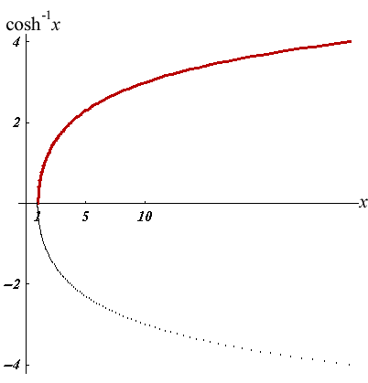 | Domain: [1, ∞)  Range: [0, ∞)  Inverse Function: $f^{-1 }\left(x\right)=\cosh{x}$  Restrictions: $y≥0$  Odd/Even: Neither  General Form:  $$f\left(x\right)=a \cosh^{-1}{ \left(b\left(x-h\right)\right)+k}$$
Hyperbolic Arctangent | $$f(x)=\tanh^{-1}{x}$$  $$=\frac{1}{2}\ln\left(\frac{1+x}{1-x}\right)$$ |  | 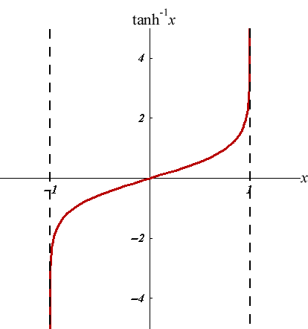 | Domain: ($-$1, 1)  Range: ($-$∞, ∞)  Inverse Function: $f^{-1 }\left(x\right)=\tanh{x}$  Restrictions: Asymptotes at $x=±1$  Odd/Even: Odd  General Form:  $$f\left(x\right)=a\tanh^{-1}{ \left(b\left(x-h\right)\right)}{+ k}$$
Hyperbolic Arccosecant | $$f\left(x\right)={csch}^{-1}{x}$$  $$=\ln\left(\frac{1}{x}+\sqrt{\frac{1}{x^{2}}+1}\right)$$ |  | 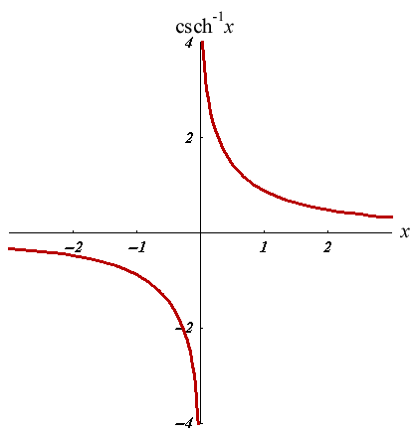 | Domain: ($-$∞, 0) $∪$ (0, ∞)  Range: ($-$∞, 0] $∪$ [0, ∞)  Inverse Function: $f^{-1 }\left(x\right)=\operatorname{csch}{x}$  Restrictions: Asymptotes at $x=0, y=0$  Odd/Even: Odd  General Form:  $$f\left(x\right)=a {csch}^{-1}\left(b\left(x-h\right)\right)+k$$
Hyperbolic Arcsecant | $$f\left(x\right)={sech}^{-1}{x}$$  $$=\ln\left(\frac{1}{x}+\sqrt{\frac{1}{x^{2}}-1}\right)$$ |  | 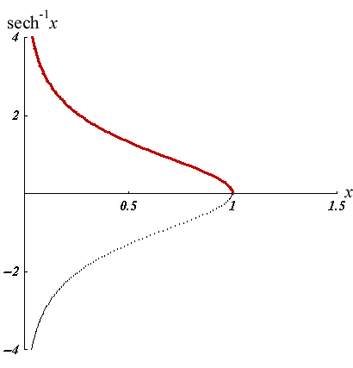 | Domain: (0, 1]  Range: [0, ∞)  Inverse Function: $f^{-1 }\left(x\right)=\operatorname{sech}{x}$  Restrictions:  Odd/Even: Neither  General Form:  $$f\left(x\right)=a {sech}^{-1} \left(b\left(x-h\right)\right)+k$$
Hyperbolic Arccotangent | $$f(x)=\coth^{-1}{x}$$  $$=\frac{1}{2}\ln\left(\frac{x+1}{x-1}\right)$$ |  | 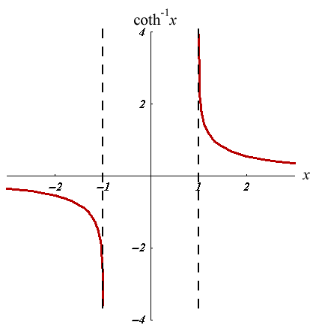 | Domain: $[-∞, -1)$ $∪$ $(1, ∞]$  Range: $(-∞, 0)$ $∪$ $(0, ∞)$  Inverse Function: $f^{-1 }\left(x\right)=\coth{x}$  Restrictions: Asymptotes at $x=0, y=±1$  Odd/Even: Odd  General Form:  $$f\left(x\right)=a\coth^{-1}{ \left(b\left(x-h\right)\right)}{+k}$$

Graphing Tips

All Functions

The Seven Function “Levers” | y = a f (b (x - h)) + k | Graphing Tips
- Move up/down ↕ | k (Vertical translation) | “+” Moves it up
- Move left/right ↔ | h (Horizontal translation) | “+“ Moves it right
- Stretch up/down ↕ | a (Vertical dilation) | Larger stretches it taller or makes it grow faster
- Stretch left/right ↔ | b (Horizontal dilation) | Larger stretches it out wider
- Flip about x-axis | a → $-$a | $f(x)$ → $-f(x)$  If $f(x)=-f(-x)$ then “odd” function
- Flip about y-axis | b → $-$b | $f(x)$→ $f(-x)$  If $f(x)=f(-x)$ then “even” function
- Rotate CW/CCW | $$\cot{2θ}=\frac{A-C}{B}$$ | “+” $θ$ rotates CCW  For conic sections, where:  $$Ax^{2}+Bxy+Cy^{2}+Dx+Ey+F=0$$

Trigonometric Functions f(x) = a <trig> (b (x - h)) + k

The Six Trig “Levers” | y = a sin (b (x - h)) + k | Graphing Tips | Notes
- Move up/down ↕ | k (Vertical translation) | $$k= \frac{(max + min)}{2}$$ | If $k=f(x)$ then x-axis is replaced by $f(x)$-axis
- Move left/right ↔ | h (Phase shift) | ‘+‘ shifts right | $$\sin{(x)}=\cos{(x-π/2)}$$
- Stretch up/down ↕ | a (Amplitude) | $$a= \frac{(max - min)}{2}$$ | a is NOT peak-to-peak on y-axis
- Stretch left/right ↔ | b (Frequency $⦁$ 2$π$) | $$T=\frac{2π}{\left|b\right|}= \frac{1}{ƒ}$$ | T = peak-to-peak on $θ$-axis  $T=\frac{π}{|b|}$ for $tan (bx)$
- Flip about y-axis | b → $-$b | $f(x)$ → $f(-x)$ | Even Function: $\cos{(x)}=\cos{(-x)}$
- Flip about x-axis | a → $-$a | $f(x)$ → $-f(-x)$ | Odd Function: $\sin{(x)}=-sin{(-x)}$

