Harold’s PEMDAS
Cheat Sheet
22 September 2025

Order of Operations

Mnemonic | Operation | Symbols | Order | Alt. Name
P | Parenthesis | ( ), [ ], { } | Always do first | Grouping
E | Exponents | x^{n}, x^n | Do next | Powers
M  D | Multiplication  Division | ⨯, ⦁  ÷, / | From Left to Right | Product  Quotient
A  S | Addition  Subtraction | +  - | From Left to Right | Sum  Difference
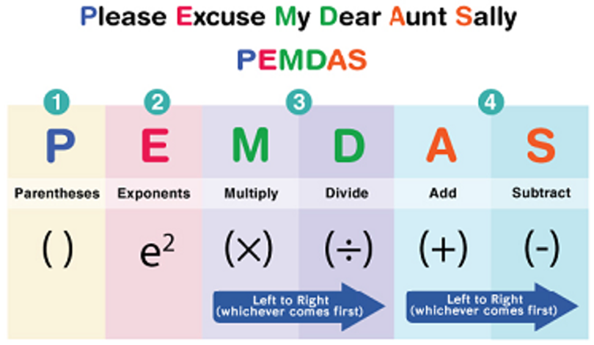
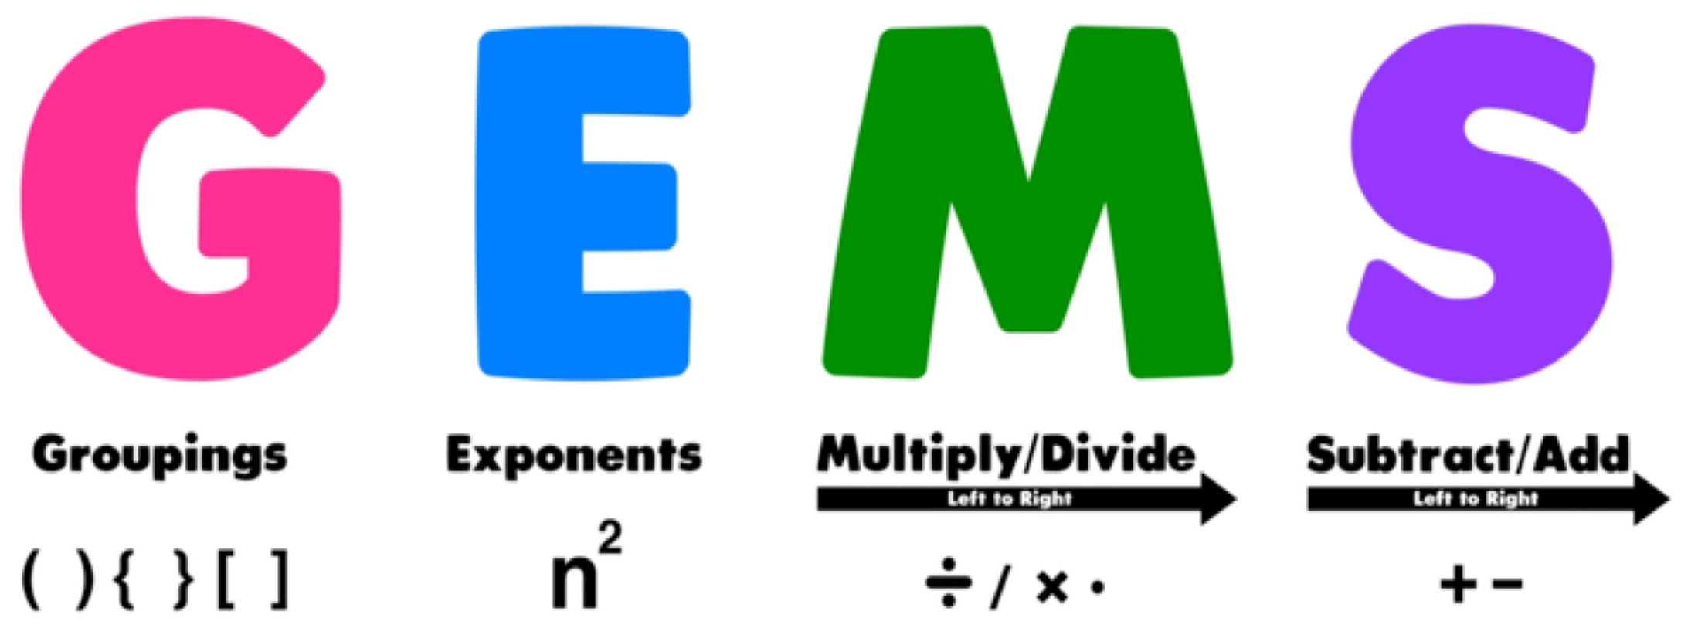

See Also
- Harold’s Prime Numbers Cheat Sheet
- Harold's Times Tables Worksheet

