**Harold’s Math is Fun**

**Cheat Sheet**

1 September 2025

**Cool Graph Equations**

|  |  |  |
| --- | --- | --- |
| **Description** | **Equation** | **Graph** |
| **Heart – Rectangular** | $$f\left(x\right)=x^{2/3}+0.9 sin\left(kx\right) \sqrt{3-x^{2}}$$ $$k=81.5$$ |  |
| **Heart – Polar** |  |  |
| **Heart – Parametric** | $$x\left(t\right)=16{\left(sin t\right)}^{3}$$ $$y\left(t\right)=13 cos\left(t\right)-5 cos\left(2t\right)-2 cos(3t)-cos(4t)$$ $$0≤t≤2π$$ |  |
| **Persian Rug** | sin(cos(tan(*xy*))) = sin(cos(tan(*x*))) + sin(cos(tan(*y*))) |  |
| **Batman Equation** |  | |
| Upper Part: $$f\left(x\right)=\left(h-l\right)H\left(x+1\right)+\left(r-h\right)H\left(x-1\right)+\left(l-w\right)H\left(x+3\right)+\left(w-r\right)H\left(x-3\right)+w$$ | |
| Lower Part : | |
| Where $H(x)$ is the Heaviside step function $$H\left(x\right)=\left\{\begin{matrix}0 x<0 \\ \frac{1}{2} x=0 \\ 1 x>0\end{matrix}\right.$$ and | |
| **Superman** | [Desmos](https://www.desmos.com/calculator/dycm63a2b3) | [Picture](https://www.desmos.com/calculator/dycm63a2b3) |

**Fun Math Quotes**

|  |  |  |  |  |  |
| --- | --- | --- | --- | --- | --- |
| **Description** | **Equation** | | | **Note** | |
| **Then a Miracle Occurs** | [A famous cartoon by Sidney Harris shows two scientists at work at a ...](https://i.pinimg.com/736x/d6/e7/54/d6e754d24aaef324c1595e68583ace7a.jpg) | | | | |
| **Math Teacher Signs** |  | [How To Be A Math Person Do Math Be A Person For Teachers Acrylic Print by  Tom Publishing - Pixels](https://encrypted-tbn0.gstatic.com/images?q=tbn:ANd9GcQ7O6bobwmU4h10xNfmvc7lxh7VK6etryJ9Gg&s) | | [Amazon.com: English Is Important But Math Is Importanter Funny Poster Metal  Sign Retro Home Decorative Vintage Tin Sign 12 x 8 Inch: Posters & Prints](https://m.media-amazon.com/images/I/61ZZl7ztdHL._UF894,1000_QL80_.jpg) | [Find x - There It Is! - NEW Funny Humor Math Algebra Joke POSTER -  Walmart.com](https://m.media-amazon.com/images/I/71zVpbawYRL._UF894,1000_QL80_.jpg) |
| **Find** |  | | | [Find x](https://ih1.redbubble.net/image.706606612.7441/raf,360x360,075,t,fafafa:ca443f4786.jpg) | |
| **3 Types of People** | “*There are three types of people: those who can count and those who cannot.*” - Gene Wolfe | | | | |
| **Lottery Tax** | "*Lottery: A tax on people who are bad at math.*" | | | | |
| **Carnivorous Integers** | Q: Why was 6 afraid of 7?  A: Because 7 ate 9, since you are supposed to eat 3 squared meals a day. | | | | |
| **Old MacDonald** | "Old Macdonald had a form, eᵢ ∧ eᵢ = 0.” | | | | |
| **Pierre de Fermat** | Pierre de Fermat walks into a bar. “*I have devised a most humorous punchline to this joke, but this margin is too narrow to contain it.*” | | | | |
| **Hiitchhiker** | A kindergarten teacher asked students to introduce their parents.   * "My mom is a doctor. She saves lives!" "Wonderful!" * "My dad drives for Uber. He takes people where they need to go!" "That's nice." * "My dad kills hitchhikers and sells their valuables on eBay!" "Goodness gracious!"   + "Actually, I'm a mathematician, but how can you explain that to kids?" | | | | |
| **Breaking Bad Parody** | “*I took care of it. I divided by zero.*” | | [Studio C](https://youtu.be/6xi2Bl50XPc) two math teachers' parody of the TV series “Breaking Bad”, where they were dealing in Math, not Meth. | | |

**Beautiful Math**

|  |  |  |
| --- | --- | --- |
| **Description** | **Equation** | **Note** |
| **Euler’s Identity** | [A screenshot of a cell phone  AI-generated content may be incorrect.](https://www.facebook.com/abhijeetphysics/posts/in-this-post-i-will-discuss-about-one-of-the-most-beautiful-equation-of-mathemat/109163324729417/) | |
| **Gamma Function: Factorial of a Fraction** | $$\left(\frac{1}{2}\right)!=\frac{\sqrt{π}}{2}$$ | |

**Deceptive Algebra Proofs**

|  |  |  |
| --- | --- | --- |
| **Description** | **Equation** | **Note** |
|  | *a* = *b*  *a2* = *a· b*  *a2 – b2* = *a· b – b2*  *(a* + *b) (a – b)* = *b (a – b)*  *a* + *b* = *b*  *b* + *b* = *b*  2*b* = *b*  **2 = 1** | Can you find the illegal operation? |
| $$2+2=5$$ | $$0=0$$ $$20x-20x=25x-25x$$ $$4x∙5-4x∙5=5x∙5-5x∙5$$ $$4x\left(5-5\right)=5x\left(5-5\right)$$ $$4x=5x$$ $$4=5$$ $$2+2=5$$ | That darn zero again |
| $$2=0$$ | $$2=1+1$$ $$2=1+\sqrt{1}$$ $$2=1+\sqrt{(-1)(-1)}$$ $$2=1+\sqrt{(-1)} •\sqrt{(-1)}$$ $$2=1+i•i$$ $$2=1+i^{2}$$ $$2=1-1$$ $$2=0$$ | Complex numbers |
| $$1=-1$$ | $$1=1$$ $$1=\sqrt{1}$$ $$1=\sqrt{{\left(-1\right)}^{2}}$$ $$1=\sqrt{-1} \sqrt{-1}$$ $$1=i^{2}$$ $$1=-1$$ | Imaginary numbers |
| $$\$1=1¢$$ | $1 = 100 cents  $1 = (10 cents)2 $1 = ($0.1)2 $1 = $0.01 | Proof that $1 = 1 cent |
| $$π=3$$ | $$x=\left(π+3\right)/2$$ $$2x=π+3$$ $$2x\left(π-3\right)=\left(π+3\right)\left(π-3\right)$$ $$2πx-6x=π^{2}-9$$ $$9-6x=π^{2}-2πx$$ $$9-6x+x^{2}=π^{2}-2πx+x^{2}$$ $${\left(3-x\right)}^{2}={\left(π-x\right)}^{2}$$ $$3-x=π-x$$ $$π=3$$ | "And he made a molten [sea](https://www.churchofjesuschrist.org/study/scriptures/ot/1-kgs/7?lang=eng#note23a), ten cubits from the one brim to the other: *it was* round all about, and his height *was* five cubits: and a line of thirty cubits did compass it round about.".  - [1 Kings 7:23](https://www.churchofjesuschrist.org/study/scriptures/ot/1-kgs/7?lang=eng) |
| **Girls are Evil** | **Given:**  Girls = Time x Money  Time = Money  Money = $\sqrt{Evil}$ **Proof:**  Girls = ${\left(Money\right)}^{2}$ Girls = ${\left(\sqrt{Evil}\right)}^{2}$ Girls = Evil | Proof that girls are evil |
| **Dilbert’s Salary Theorem** | **Given:**  Knowledge is Power  Time is Money  Power = Work/Time  **Proof:**  Knowledge = Power  Knowledge = Work/Time  Knowledge = Work/Money  Money = Work/Knowledge $$Money=\lim_{Knowledge→0}{\frac{Work}{Knowledge}}→∞$$ **Conclusion:**  All else being equal, the less you know, the more money you make. | Proof relating to Knowledge, Power, and Money  If Work is held constant as a positive number, Money approaches infinity (∞) as Knowledge approaches zero (0). |
| **Halloween = Christmas** | $$OCT 31=DEC 25$$ Halloween = Christmas | Think of octal and decimal. |
| **Merry Christmas** | $$y=\frac{\ln\left(\frac{x}{m}-sa\right)}{r^{2}}$$ $$r^{2}y=\ln\left(\frac{x}{m}-sa\right)$$ $$e^{r^{2}y}=\frac{x}{m}-sa$$ $$me^{r^{2}y}=x-sam$$ $$me^{rry}=x-mas$$ |  |
| **Spreadsheets** |  | |

**Deceptive Geometry Proofs**

|  |  |
| --- | --- |
| **Description** | **Picture** |
| **Lost Squares** |  |
| [enter image description here](https://math.stackexchange.com/questions/743067/visually-deceptive-proofs-which-are-mathematically-wrong) | |
| **Free Chocolate** | [soft question - Visually deceptive "proofs" which are mathematically wrong  - Mathematics Stack Exchange](https://i.sstatic.net/ajcnD.gif) |

**Math Puzzles**

|  |  |  |  |
| --- | --- | --- | --- |
| **Description** | **Equation** | | **Note** |
| **How many numbers can you see?** |  | [How Many Numbers Can You Find In This Brain Teaser? | Logic puzzles ...](https://www.psychiccafe.nz/many-hidden-numbers-can-find-puzzle/) | |
| **Where did the other dollar go?** | Three guys in a hotel call room service and order two large pizzas.  The delivery boy brings them up with a bill for exactly $30.00.  Each guy gives him a $10.00 bill, and he leaves.    When he hands the $30.00 to the cashier, he is told that a mistake has been made.  The bill was only $25.00, not $30.00.  The cashier gives the delivery boy five $1.00 bills and tells him to take them back to the 3 guys who ordered the pizza.    On the way back to their room, the delivery boy has a thought... these guys did not give him a tip.  He figures that since there is no way to split $5.00 evenly three ways anyhow, he will keep two dollars for himself and give them back three dollars.    He knocks on the door, and one fellow answers.  He explains about a mix-up in the bill, and hands the guy the three dollars, then departs with his two-dollar tip in his pocket.    Now the fun begins!  $30 - $25 = $5  $5 - $3 = $2    Answer this:  Each of the three guys originally gave $10.00 each.  They each got back $1.00 in change.  That means they paid $9.00 each, which times three is $27.00.  The delivery boy kept $2.00 for a tip.  $27.00 plus $2.00 equals $29.00.  Where is the other dollar? | | |

**Marital Relationship Math**

|  |  |  |
| --- | --- | --- |
| **Description** | **Equation** | **Note** |
| **Romance** | Smart man + smart woman = romance  Smart man + dumb woman = affair  Dumb man + smart woman = marriage  Dumb man + dumb woman = pregnancy | |
| **Office** | Smart boss + smart employee = profit  Smart boss + dumb employee = production  Dumb boss + smart employee = promotion  Dumb boss + dumb employee = overtime | |
| **Shopping** | A man will pay $2 for a $1 item he needs.  A woman will pay $1 for a $2 item that she doesn't need. | |
| **Future** | A woman worries about the future until she gets a husband.  A man never worries about the future until he gets a wife. | |
| **Success** | A successful man is one who makes more money than his wife can spend.  A successful woman is one who can find such a man. | |
| **Happiness** | To be happy with a man, you must understand him a lot and love him a little.  To be happy with a woman, you must love her a lot and not try to understand her at all. | |
| **Longevity** | Married men live longer than single men do, but married men are a lot more willing to die. | |
| **Propensity to Change** | A woman marries a man expecting he will change, but he doesn't.  A man marries a woman expecting that she won't change, and she does. | |
| **Discussions** | A woman has the last word in any argument.  Anything a man says after that is the beginning of a new argument. | |
| **You’re Next** | Old aunts used to come up to me at weddings, poking me in the ribs and cackling, telling me, "You're next."  They stopped after I started doing the same thing to them at funerals. | |
| **Conclusion** | Show this list to a smart woman who needs a laugh, and to the smart guys you know can handle it. | |

[](https://i.imgflip.com/2gcefm.jpg)

**Sources**

* Busch, Andrew (2025). Desmos Art! Geometry. <https://www.andrewbusch.us/home/desmos-art-geometry>
* Jeon, Charles (April 24, 2011). Dilbert’s Salary Theorem, University of Pennsylvania. <https://www.scribd.com/document/317411126/Dilbert>
* OnlineMath Learning.com (2025). Funny Math Proofs. <https://www.onlinemathlearning.com/funny-math-proofs.html>
* Quora (2020). What are some cool graph equations? <https://www.quora.com/What-are-some-cool-graph-equations>
* Reddit.com (July 28, 2011). Batman Curve. <https://mathworld.wolfram.com/BatmanCurve.html>
* Romance Mathematics. <https://faculty.kfupm.edu.sa/COE/gutub/English_Misc/math_english.htm>
* Tiwari, A. K. (June 11, 2021). What makes an equation beautiful? A. K. Tiwari Physics Classes’ post. <https://www.facebook.com/abhijeetphysics/posts/in-this-post-i-will-discuss-about-one-of-the-most-beautiful-equation-of-mathemat/109163324729417/>
* Wolfram World (2025). Heart Curve. <https://mathworld.wolfram.com/HeartCurve.html>

[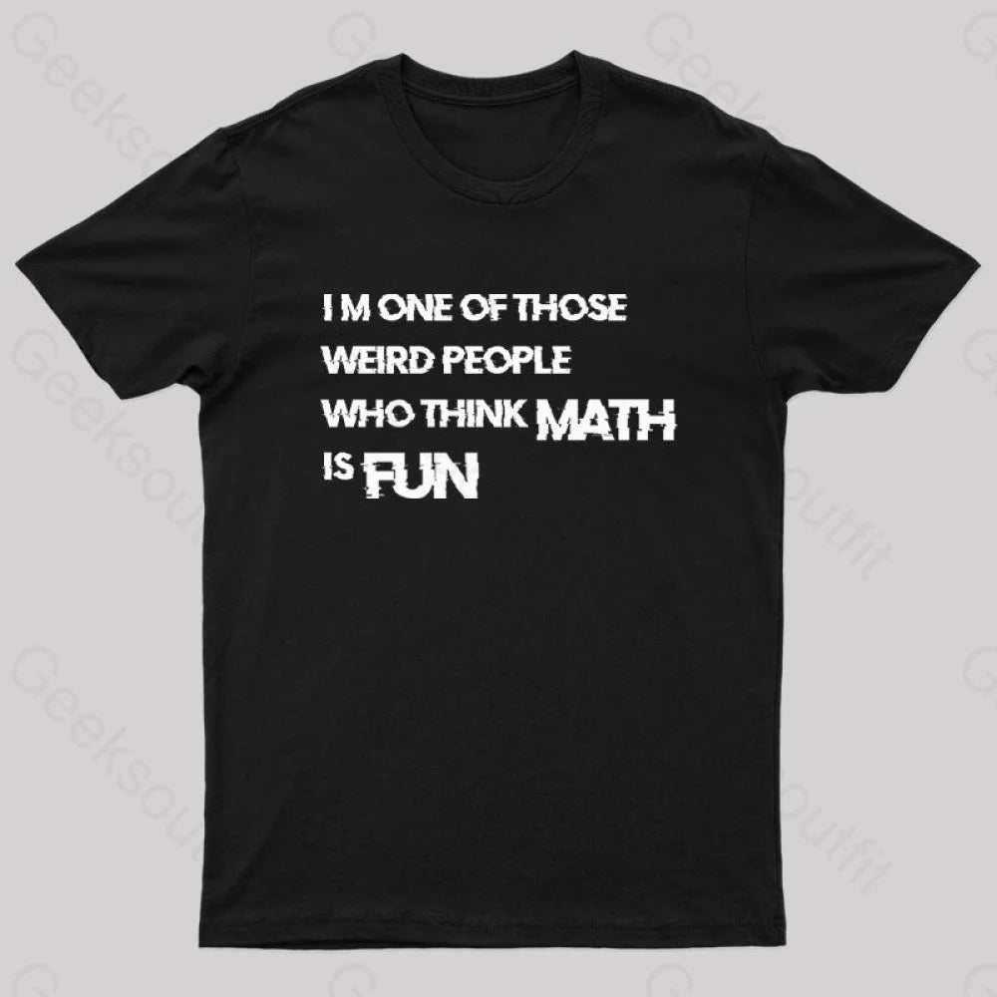](https://www.geeksoutfit.com/products/math-is-fun-nerd-t-shirt?srsltid=AfmBOoqgBx_GXVmQMmBZDggRHDTPi5Jax5NrK8PWwi1lGSLp0HP0RBBq)