**Harold’s History of Mathematics**

**Cheat Sheet**

20 September 2024

**Babylonian and Egyptian Mathematical Developments**

|  |  |  |
| --- | --- | --- |
| **Mathematical Development** | **Babylonian** | **Egyptian** |
| Earliest Evidence of a Number System | 28,000 B.C. | Unknown |
| Earliest Evidence of Mathematics | 4700 B.C. | 4242 B.C. |
| Earliest Advanced Calendar | 4700 B.C. | 4241 B.C. |
| Record Material | Clay Tablets | Stone, Papyrus |
| Number System Base | 60 | 10 |
| Pythagorean Theorem | 1500 B.C. | 3000 B.C. |
| Area of a Rectangle / Square | 1500 B.C. | 2900 B.C. |
| Geometry: Area of a Right Triangle and Circle  Volume of a Cylinder | 1500 B.C. | 1347 B.C. |
| Fractions | 1500 B.C. (1/n) | 1550 B.C. (2/n) |
| Square of Numbers Table | 1500 B.C. | 1550 B.C. (Rhind Papyrus) |
| Arithmetic & Geometric Series | Not Mentioned | 1825 B.C. |
| Linear Equations | Not Mentioned | 1550 B.C. |

**Greek Mathematicians**

|  |  |  |
| --- | --- | --- |
| **Mathematician** | **When they lived** | **Where they lived and their Contributions** |
| **Thales** | 636 – 546 BC | First Greek mathematician, astronomer, and founder of natural philosophy from the Ionian city of Miletus. He predicted a solar eclipse and was considered one of the 7 Ancient Sages. He developed the scientific method and, theories to explain why things change. He introduced geometry to Greece from Egypt. |
| **Pythagoras** | 570 – 495 BC  (480 – 411 BC) | Greek philosopher from the Ionian city of Samos. A student of Thales. Did polymath. Founded a school in Italy. Credited with many mathematical and scientific discoveries, including the Pythagorean theorem, Pythagorean tuning, the five regular solids, the Theory of Proportions, and the sphericity of the Earth. |
| **Socrates** | 469 – 399 BC | Greek philosopher from Athens. He is a central figure in Greek philosophy. Known for the Socratic method (elenchus), Socratic irony, and the pursuit of knowledge. Socrates is famous for saying that he knows nothing. Was sentenced to death and had to drink a cup of hemlock. |
| **Plato** | 427 – 347 BC | Greek philosopher from Athens. A student of Socrates.  He was one of the most famous philosophers of all time. Known as the father of idealism in philosophy. |
| **Aristotle** | 384 – 322 BC | Greek philosopher. One of the most important Western philosophers, a student of Plato, and a teacher of Alexander the Great. Contributions in philosophy, logic, science, metaphysics, ethics, politics, and system of deductive reasoning. |
| **Ptolemy** | 367 – 282 BC | Greek general from Alexandria. He was a historian and successor of Alexander the Great. Founded the Library and the University of Alexandria (Ptolemaic Kingdom centered on Egypt in 300 BC). |
| **Euclid** | 325 – 265 BC | Greek mathematical **teacher** from Alexandria. He is the father of geometry (hence, Euclidean geometry). Created the encyclopedia of Greek mathematics called The Elements about geometry, algebra, and numbers. Wrote 10 other textbooks. |
| **Archimedes** | 287 – 212 BC | Greek mathematician from Syracuse. Was a mathematician, physicist (hydrostatics), engineer, inventor, and astronomer. Determined the exact value of pi. Gold crown “Eureka, eureka!” story. |
| **Eratosthenes** | 276 – 194 BC | Hellenistic astronomer from Cyrene. He was acquainted with Archimedes of Syracuse. Was the second chief librarian at Alexandria. He calculated the circumference of the earth, created latitude and longitude measurements, and made a map of the earth. |
| **Apollonius** | 262 – 200 BC | Greek mathematician and astronomer from Perga but studied in Alexandria. Known for his work on conic sections before the invention of analytic geometry. His definitions of the terms ellipse, parabola, and hyperbola are the ones in use today. Tangents, asymptotes. |
| **Hipparchus** | 190 –  120 BC | Greek mathematician, geographer, and astronomer from Rhodes, Greece. The father of trigonometry. He also solved several problems of spherical trigonometry. He was the first whose quantitative and accurate models for the motion of the Sun and Moon survive. |
| **Heron** | 5 - 65 AD | Greek mathematician from Alexandria. Practical geometry and Heron’s formula to find the area of a triangle. Great experimentalist. He wrote a commentary on Euclid's Elements and a work on applied geometry known as the Metrica. |
| **Menelaus** | 70 – 140 AD | Greek mathematician and astronomer from Alexandria. First to recognize geodesics on a curved surface (spherical geometry) as natural analogs of straight lines. Trigonometry. |
| **Claudius Ptolemy** | 100 – 170 AD | Greek mathematician, astronomer, astrologer, geographer, and music theorist from Alexandria. Wrote the Almagest on astronomy. |
| **Diophantus** | 200 – 284 AD | Greek mathematician from Alexandria. The father of algebra. Was the author of two main works: On Polygonal Numbers and the Arithmetica in thirteen books, made up of arithmetical problems that are solved through algebraic equations. He was the first to recognize positive rational numbers as numbers. |
| **Pappus** | 290 – 350 AD | Greek mathematician **teacher** from Alexandria. He worked as a mathematics teacher to higher-level students. Pappus’ method of analysis represents the recognition that the approach to solving a problem is significant itself. Contributions in geometry, astronomy, and mechanics. |
| **Hypatia** | 350 – 415 AD | Neoplatonist philosopher, astronomer, and mathematician who lived in Alexandria. The first well-documented woman in mathematics. Taught philosophy and astronomy. Was murdered. |

There are many more Greek mathematicians, however, only major ones or my favorites are listed.

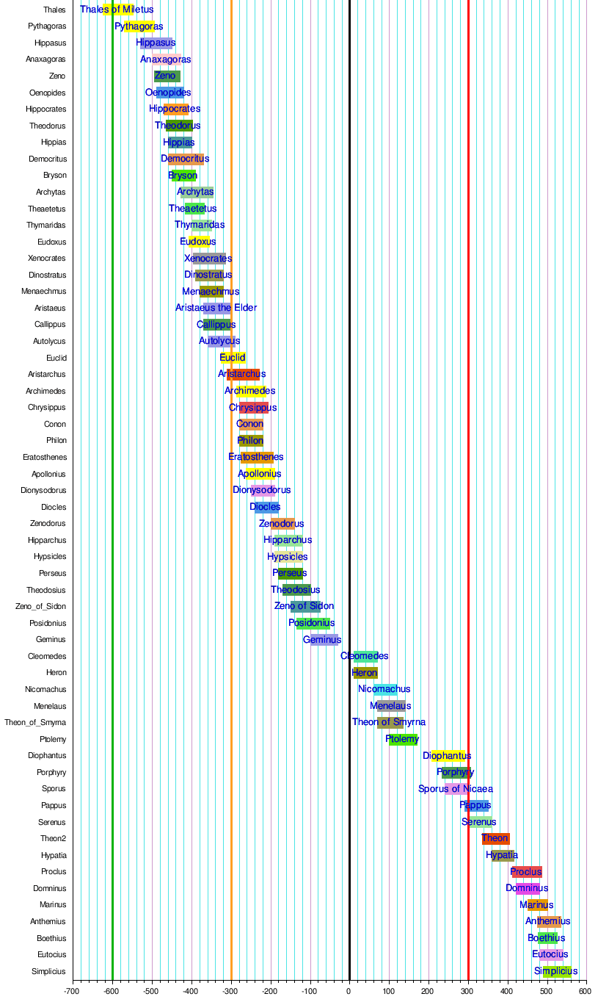

**References**

[MAT-450 History of Math and Math Education](https://www.snhu.edu/admission/academic-catalogs#/courses/V1wUIZLKe?bc=true&bcCurrent=MAT450%20-%20History%20of%20Math%20and%20Math%20Education&bcGroup=Mathematics&bcItemType=courses) (2024). Southern New Hampshire University (SNHU).

Smith, D. E. (1951). II.4 Babylon and II.5 Egypt, History of Mathematics, Volume I, Dover Publication, Inc., p. 35-52.

Berlinghoff, W.P., & Gouvea, F.Q. (2021). Beginnings. *Math Through the Ages - A Gentle History for Teachers and Others*, Second Edition, Colby College, 10-12.

[Most Important Figures in Ancient History (thoughtco.com)](https://www.thoughtco.com/ancient-people-you-should-know-117290)

<https://www.thoughtco.com/ancient-people-you-should-know-117290>

Timeline of ancient Greek mathematicians, Wikipedia, <https://en.wikipedia.org/wiki/Timeline_of_ancient_Greek_mathematicians>.