Harold’s High School Chemistry
1st Semester
Cheat Sheet
5 May 2026
DRAFT

Chapter 1: Measuring Up

Term | Equation | Note
Rulers | When using a ruler that is marked off in 16ths of an inch, report your answers to a hundredth of an inch.
Units | The unit of measurement is just as important as the number.  You must always list the units, followed by the compound!  Example: 6.28 mL H₂O
Significant Figures | - All non-zero figures (1, 2, 3, 4, 5, 6, 7, 8, and 9) are significant.  - A zero (0) is significant if it is between two significant digits.  - A zero (0) is also significant if it’s at the end of the number and to the right of the decimal point.
Using SigFigs | - When adding and subtracting measurements, you must report your answer to the same precision as the least precise number in the problem.  - When multiplying and dividing measurements, you must report your answer with the same number of significant figures as the measurement that has the fewest significant figures.  - There is always some error in the last significant figure of a measurement.
Precision vs. Accuracy | - Precision: The consistency and reproducibility of measurements (e.g., 10 decimal places).  - Accuracy: How close a measurement is to the true or accepted value.
Prefixes
  Prefix | Abbreviation | Meaning | Scientific
  giga | G | 1,000,000,000 | 10⁹
  mega | M | 1,000,000 | 10⁶
  kilo | k | 1,000 | 10³
  hector | H | 100 | 10²
  deca | Da | 10 | 10¹
  centi | c | 0.01 | 10⁻²
  milli | m | 0.001 | 10⁻³
  micro | μ | 0.000001 | 10⁻⁶
  nano | n | 0.000000001 | 10⁻⁹
Scientific Notation | 14,000,000 = 1.4 ⨯ 10⁷ = 1.4E7 | 0.00000014 = 1.4 ⨯ 10⁻⁷ = 1.4E–7
Measuring | Volume ($L$) | 1 cm³ = 1 mL
Measuring | Mass ($g$) | weight = mass ⨯ gravity
Measuring | Density (ρ) | $$density=\frac{mass}{volume} or ρ=\frac{m}{V}$$
Unit Conversion (Train Track Method) | 0.1436 mL = ? m³
  143.6 L | 1000 mL | 1 cm³ | (1 m)³ | 0.1436 m³
   | 1 L | 1 mL | (100 cm)³
Chapter 2: What’s The Matter

Term | Equation | Note

Chapter 3: Making Sense of Atoms and Elements

Term | Equation | Note

Chapter 4: The Modern View of Atoms and Their Chemistry

Term | Equation | Note
Wave
Particle
Orbitals | 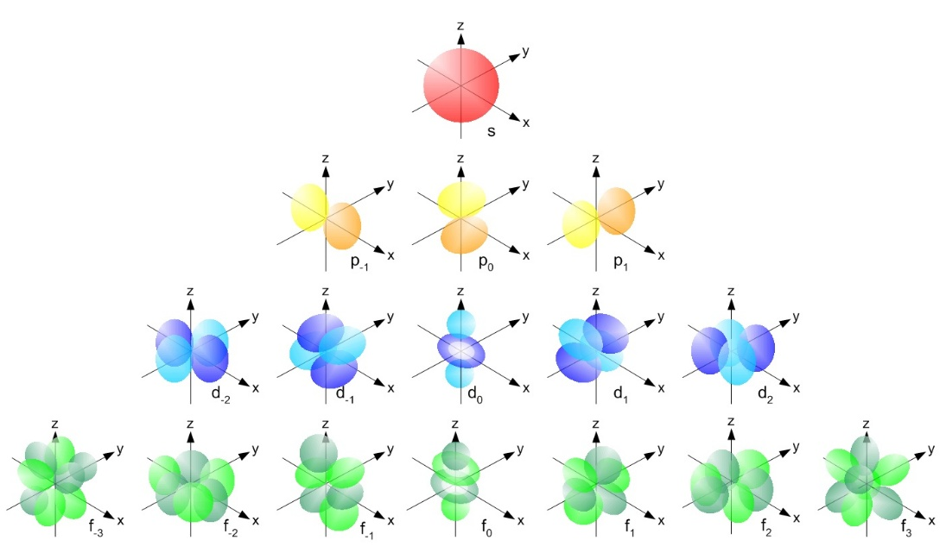

Chapter 5: Covalent Compounds and Their Molecular Geometry

Term | Equation | Note

Chapter 6: Physical and Chemical Changes

Term | Equation | Note

Chapter 7: Stoichiometry

Term | Equation | Note

Chapter 8: Still More on Stoichiometry

Common Polyatomic Ions (Memorize)

# | Name | Ion
1 | Ammonium | $$NH_{4}^{+}$$
2 | Hydronium | $$H_{3}O^{+}$$
3 | Acetate | $$C_{2}H_{3}O_{2}^{-}$$
4 | Cyanide | $$CN^{-}$$
5 | Bicarbonate | $$HCO_{3}^{-}$$
6 | Carbonate | $$CO_{3}^{2-}$$
7 | Hydroxide | $$OH^{-}$$
8 | Nitrite | $$NO_{2}^{-}$$
9 | Nitrate | $$NO_{3}^{-}$$
10 | Sulfite | $$SO_{3}^{2-}$$
11 | Sulfate | $$SO_{4}^{2-}$$
12 | Phosphate | $$PO_{4}^{3-}$$
13 | Chlorite | $$ClO_{2}^{-}$$
14 | Manganate | $$MnO_{4}^{2-}$$

Sources
These chapters and content are from the textbook:
- Dr. Jay L. Wile (2015). Discovering Design with Chemistry, 1st Edition.

