Harold’s Geometry Shape Formulas
Cheat Sheet
25 April 2025

Perimeter, Area, Surface Area, and Volume

2D Shapes | Perimeter  (P, C) | Area  (A) | 3D Shapes | Surface Area  (SA) | Volume  (V)
Units | Units | Units² |  | Units² | Units³
Example | Fence | Pasture |  | Paint It | Fill It
Triangle  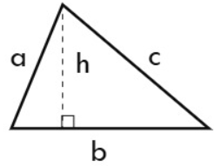 | $$a+b+c$$ | $$\frac{1}{2}bh$$ | Triangular Prism  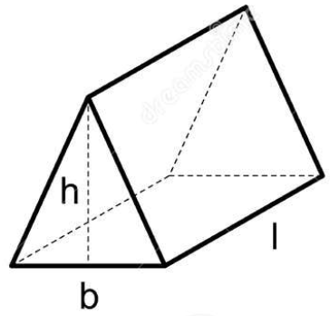 | $$bh+la+lb+lc$$ | $$\frac{1}{2}bhl$$
Square  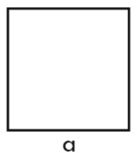 | $$4a$$ | $$a^{2}$$ | Cube  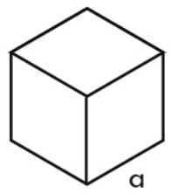 | $$6a^{2}$$ | $$a^{3}$$
Rectangle  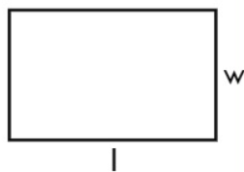 | $$2(l+w)$$ | $$lw$$ | Rectangular Prism  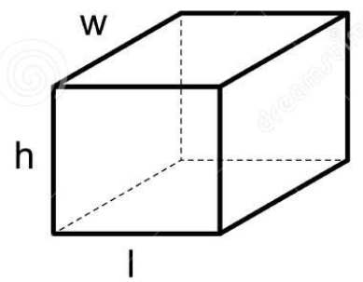 | $$2(lw+lh+wh)$$ | $$lwh$$
Parallelogram  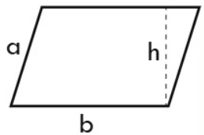 | $$2(a+b)$$ | $$bh$$ | Pyramid  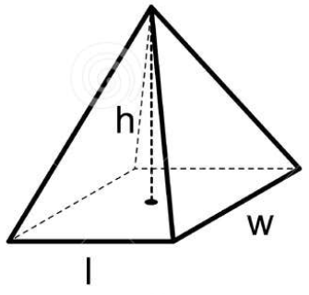 | $$lw+la$$  $la$: lateral area | $$\frac{1}{3}lwh$$
Trapezoid  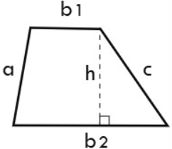 | $$a+b_{1}+b_{2}+c$$ | $$\frac{1}{2}\left(b_{1}+b_{2}\right)h$$ | Cone  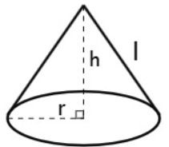 | $$πr^{2}+πrl$$ | $$\frac{1}{3}πr^{2}h$$
Rhombus  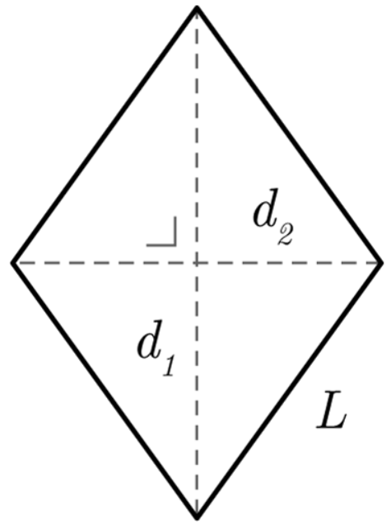 | $$4L$$ | $$\frac{1}{2}d_{1}d_{2}$$ | Cylinder  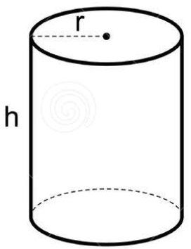 | $$2πrh+2πr^{2}$$ | $$πr^{2}h$$
Regular Polygon  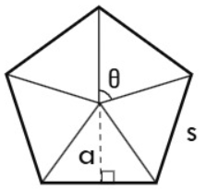 | $$ns$$ | $$n\left(\frac{1}{2}as\right)$$  $a$: apothem  $n$: number of sides | Regular Prism  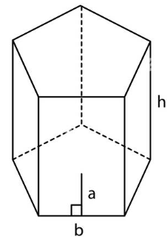 | $$nab+nbh$$ | $$\frac{n}{2}abh$$
Circle  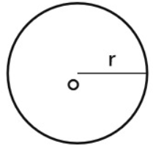 | $$2πr$$  $$=πd$$ | $$πr^{2}$$ | Sphere  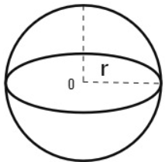 | $$4πr^{2}$$ | $$\frac{4}{3}πr^{3}$$
Circular Sector  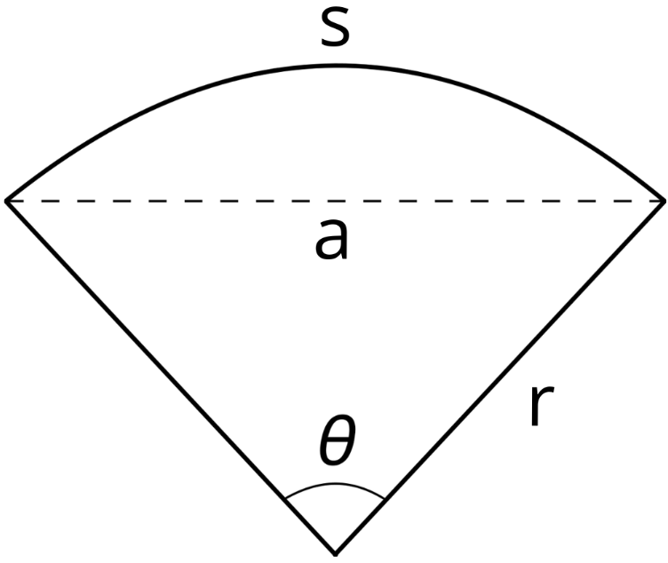 | $$s+2r$$ | $$\frac{θ}{{360}^{∘}}πr^{2}$$ | Spherical Segment  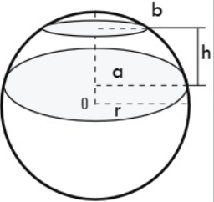 | $$π(a^{2}+b^{2}+2rh)$$  $h$: height of segment | $$\frac{1}{6}πh(3a^{2}+3b^{2}+h^{2})$$
Ellipse  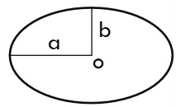 | $$≈π(a+b)$$ | $$πab$$ | Ellipsoid  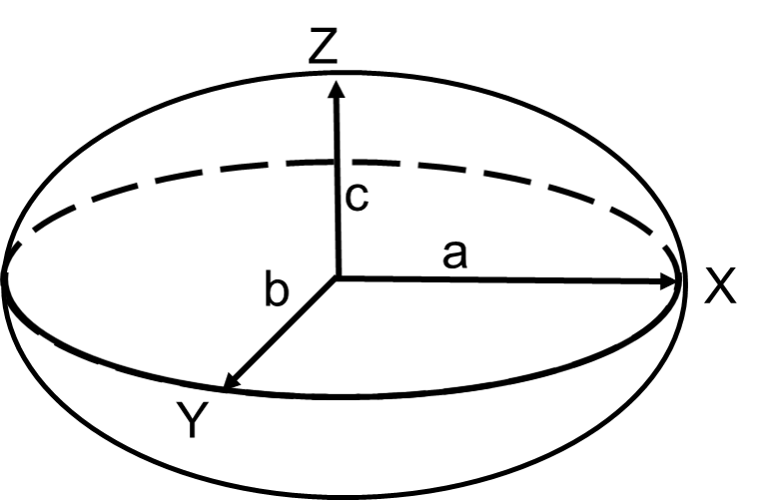 | See Knud Thomsen’s Formula | $$\frac{4}{3}πabc$$

Sources:
- TPT, https://www.teacherspayteachers.com/Product/Perimeter-Area-Surface-Area-Volume-Cheat-Sheet-7377920

