Harold’s Rules of Circle Geometry
Cheat Sheet
21 May 2023

Terminology

Category | Examples
Arcs | 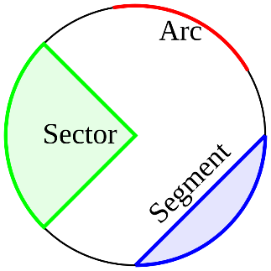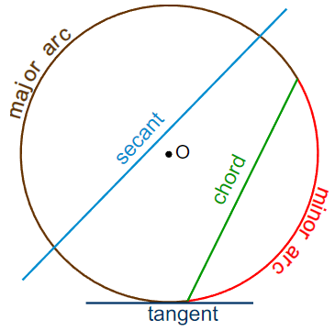
Angles & Sectors | 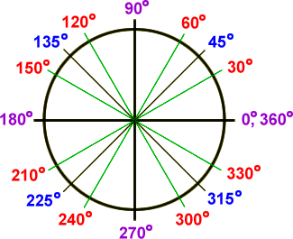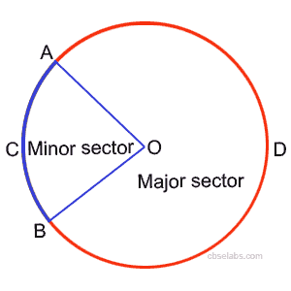
Lines & Chords | 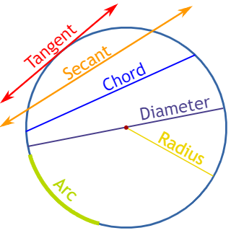
Tangents | 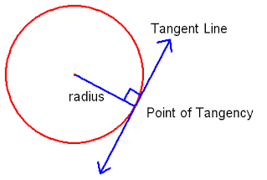
Arcs and Angles in a Circle

Configuration | Rule / Formula | Diagram
Central Angle  (Angle at Center) | Equal to arc  $$θ=x^{°}$$  $$m∠ABC=m\hat{AC}$$ | 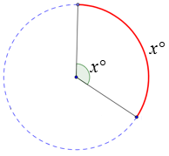
Inscribed Angle  (Angle in Same Segment) | Half the arc  $$θ=\frac{1}{2}x^{°}$$ | 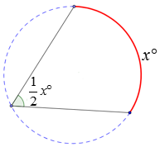
Inscribed Quadrilateral  (Opposite Angles of Cyclic Quadrilateral) | $$m∠A+m∠C={180}^{°}$$  $$m∠B+m∠D={180}^{°}$$  The opposite angles of cyclic quadrilaterals are supplementary (180°). | 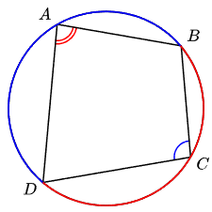
Radius Ʇ Tangent | The angle between the radius and a tangent is 90°. | 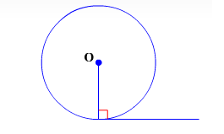
Two Chords  (Internal Angle) | Half the sum  $$θ=\frac{1}{2}\left(x^{°}+y^{°}\right)$$ | 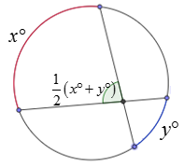
Two Secants  (External Angle) | Half the difference  $$θ=\frac{1}{2}\left(x^{°}-y^{°}\right)$$  $$m∠D=$$  $$\frac{1}{2}\left(m\hat{EF}-m\hat{GH}\right)$$ | 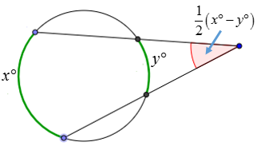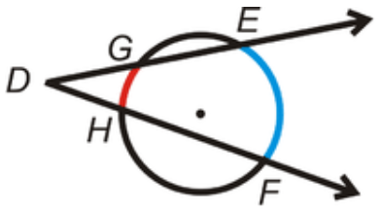
Secant & Tangent  (External Angle) | $$m∠Q=$$  $$\frac{1}{2}\left(m\hat{RS}-m\hat{RT}\right)$$ | 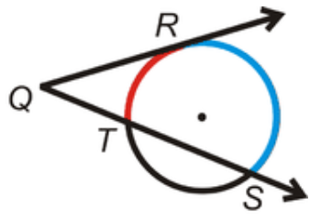
Two Tangents  (External Angle) | $$m∠L=$$  $$\frac{1}{2}\left(m\hat{MPN}-m\hat{MN}\right)$$ | 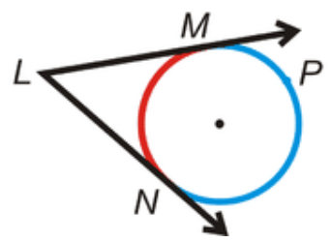
Angle at Center | $${2x}^{°}vs. x^{°}$$  The angle at the center is twice the angle standing on the same chord/arc. | 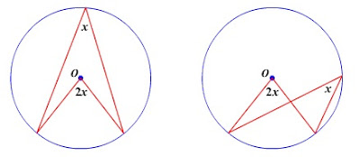
Angles Inscribed in a Semi-Circle | Right Angles  (90°)  Angles on a semi-circle are 90°. | 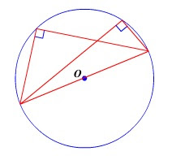
Angles Inscribed in a Circle | Angles from two points on a circle are equal. | 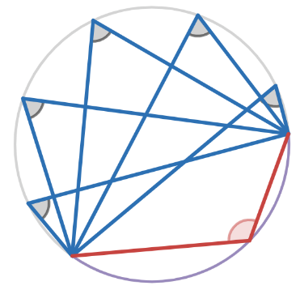
Same Segment Theorem  (Two Inscribed Angles) | $$x^{°}=x^{°}$$  $$y^{°}=y^{°}$$  Angles on the same arc are equal. | 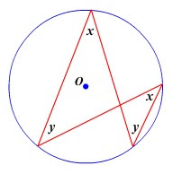
Alternate Segment Theorem | $$x^{°}=x^{°}$$  $$y^{°}=y^{°}$$  The angle between a chord and a tangent is equal to the angle in the alternate segment. | 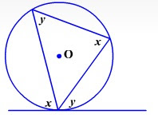
Tangent and Intersected Chord Theorem | $$m∠1=\frac{1}{2}\left(m\hat{AC}\right)$$  $$m∠2=\frac{1}{2}\left(m\hat{ADC}\right)$$  If a tangent and a chord intersect at a point on a circle, then the measure of each angle formed is one-half the measure of its intercepted arc. | 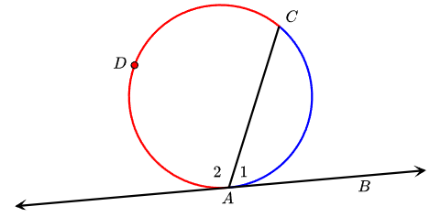
Supplimentary Angles | $$m∠1+m∠2=180°$$ | 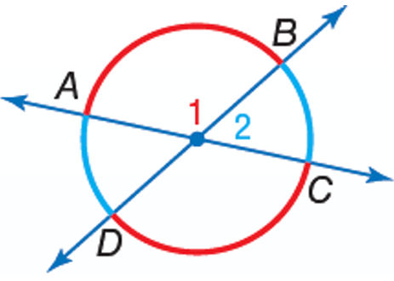
Interior Angles | $$θ=\frac{360°}{n}$$  Sum of interior angles of a circle is always 360°. | 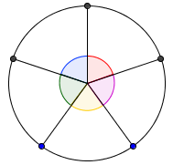

Chords and Secants in a Circle

Configuration | Rule / Formula | Diagram
Perpendicular Bisector of Chord Passes Through Center | The line from the center of a circle to the center of a chord is perpendicular to the chord.  A perpendicular line from the chord to the center bisects the chord. | 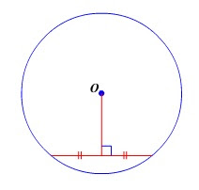
Equal Chords Equidistant from Center | Equal chords are equal distance from the center.  Chords that are equal distance from the center are equal. | 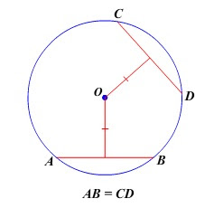
Equal Arcs, Equal Chords | Equal arc/chord subtend equal angles at the center.  Equal angles stand on an equal arc/chord. | 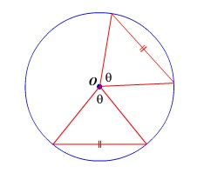
Tangents from External Point | Tangent segments drawn from an external point are equal. | 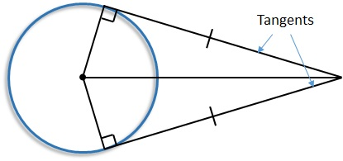
Intersecting Chords Theorem | $$a∙b=c∙d$$ | 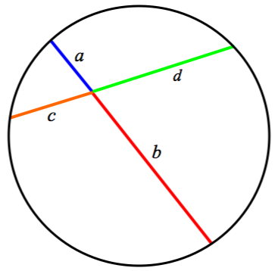
Intersecting Secants Theorem | $$a∙\left(a+b\right)=$$  $$c∙(c+d)$$ | 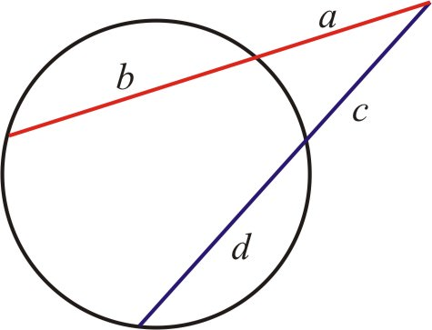
Intersecting Secant-Tangent Theorem | $$a(a+b)=c^{2}$$ | 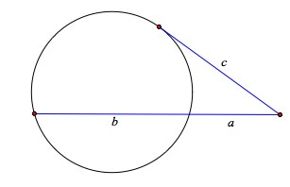

Area and Perimeter

Configuration | Rule / Formula | Diagram
Radius | $$r$$  The distance from the center or origin to a point on the circle. | 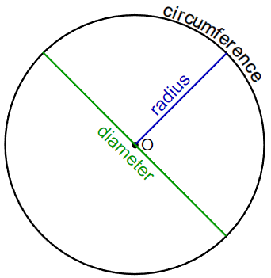
Diameter | $$d=2r$$
Circumference | $$C=2πr$$  $$C=πd$$
Area of Circle | $$A=πr^{2}$$ | 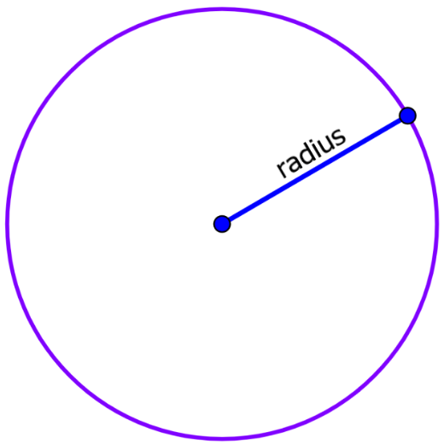
Area of a Sector | $$A=\left(\frac{θ^{°}}{{360}^{°}}\right)∙πr^{2}$$  $$where \left(\frac{θ^{°}}{{360}^{°}}\right)=\frac{area of sector}{area of circle}$$ | 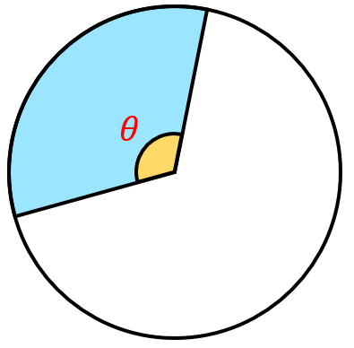
Surface Area of Sphere | $$SA=4πr^{2}$$

Volume of Sphere | $$V=\frac{4}{3}πr^{3}$$ | 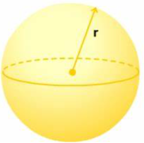

Sources:
Kevin’s Online Maths, Rules of Circle Geometry
http://kelvinsonlinemaths.blogspot.com/2011/03/rules-of-circle-geometry.html

Geometry R, Unit 13 – Circles, Mr. Rosss @ Grady High
https://mrrossatgradyhigh.files.wordpress.com/2022/08/unit-13-notes-circles_2018.pdf

Pinterest, Tangent & Secant Lines, Sandy Lakey
https://www.pinterest.com.mx/pin/817403401103649163/

Online Math Learning.com, Angles and Intercepted Arcs
https://www.onlinemathlearning.com/arc-angles.html
ck-12, 9.7 Segments of Secants and Tangents
https://www.ck12.org/book/ck-12-foundation-and-leadership-public-schools-college-access-reader%3a-geometry/section/9.7/

ck-12, Angles Outside a Circle
https://www.ck12.org/c/geometry/angles-outside-a-circle/lesson/Angles-Outside-a-Circle-BSC-GEOM/

