Harold’s DC Circuits
Cheat Sheet
11 October 2025

Circuit Laws

Circuit Law | Formula
Kirchhoff’s Current Law (KCL) | $$\sum_{i=1}^{n}{I_{i}}=0$$  $$I_{in1}+I_{in2}=I_{out1}+I_{out2}+I_{out3}$$ | 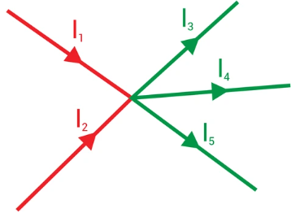
The total current flowing into a node or junction must equal the total current flowing out of the node or junction.
(conservation of charge)
Kirchhoff’s Voltage Law (KVL) | $$\sum_{i=1}^{n}{V_{i}}=0$$  $$V_{1}=V_{2}+V_{3}+V_{4}+V_{5}+V_{6}$$ | 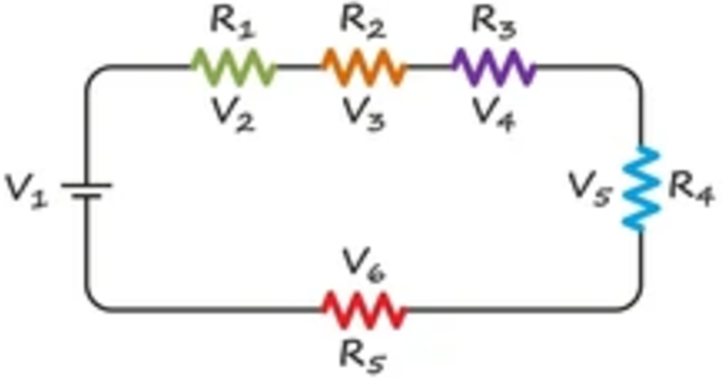
The sum of all voltages around a circuit loop is equal to zero.
(conservation of energy)
Ohm’s Law | $$V=IR$$ | 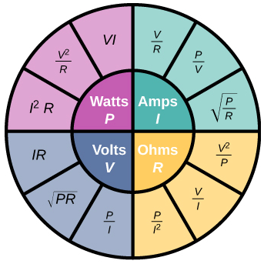
Power | $$P=VI$$  $$P=I^{2}R$$  $$P=\frac{V^{2}}{R}$$  $$P=\frac{W}{t}$$ | An across (V) times a through (I) variable.  $$Watt (W)=\frac{Volt (V)}{Ampere (A)}$$
Electrical Energy | $$E=QV$$  $$E=VIt$$  $$P=I^{2}Rt$$  $$E=Pt$$ | $$Joule \left(J\right)=\frac{Watt \left(W\right)}{second \left(s\right)}$$
Components

Element | Battery | Ground | Current Source
Component | 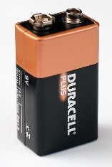 | 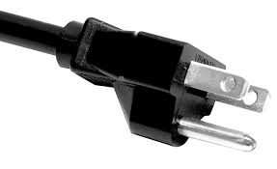 | 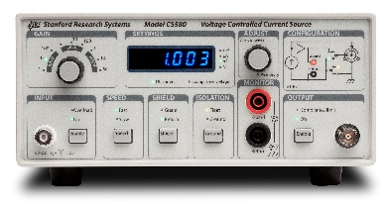
Symbol | 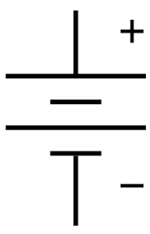 | 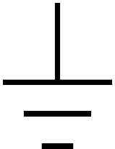 | 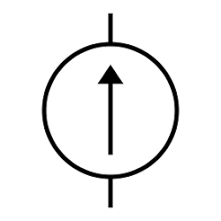
Denoted by | $$V$$ | $$GND$$ | $$I$$
Units | V (Volt) | $$0 V$$ | A (Ampere)
Series | $$V_{EQ}=V_{1}+V_{2}$$ | NA | $$I_{EQ}=I_{1}+I_{2}$$
Parallel | $$V_{1}=V_{2}=V_{3}$$ | NA | $$I_{EQ}=I_{1}+I_{2}$$

Element | Resistor | Capacitor | Inductor
Component | 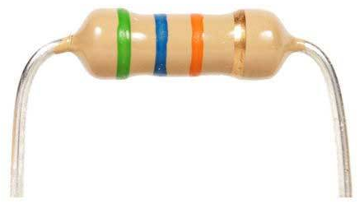 | 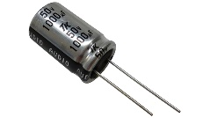 | 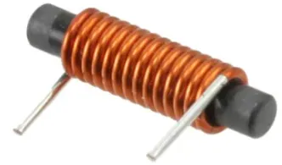
Symbol | 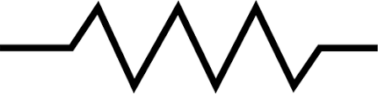 | 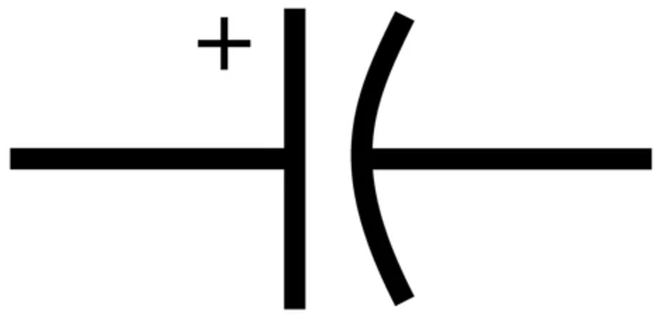 | 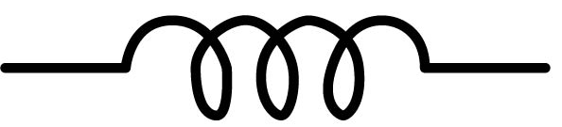
Denoted by | $$R$$ | $$C$$ | $$L$$
Units | Ω (Ohm) | F (Farad) | H (Henry)
Equation | $$R=\frac{V_{R}}{I}$$ | $$C=\frac{Q}{V_{C}}$$ | $$L=\frac{V_{L}}{\left(\frac{di}{dt}\right)}$$
Series | 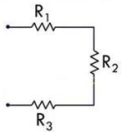 | 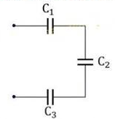 | 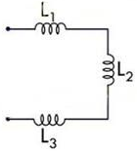
 | $$R_{T}=R_{1}+R_{2}+R_{3}$$ | $$\frac{1}{C_{T}}=\frac{1}{C_{1}}+\frac{1}{C_{2}}+\frac{1}{C_{3}}$$ | $$L_{T}=L_{1}+L_{2}+L_{3}$$
Parallel | 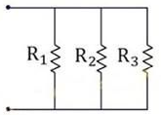 | 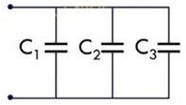 | 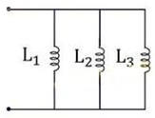
 | $$\frac{1}{R_{T}}=\frac{1}{R_{1}}+\frac{1}{R_{2}}+\frac{1}{R_{3}}$$ | $$C_{T}=C_{1}+C_{2}+C_{3}$$ | $$\frac{1}{L_{T}}=\frac{1}{L_{1}}+\frac{1}{L_{2}}+\frac{1}{L_{3}}$$
Electrical Symbols

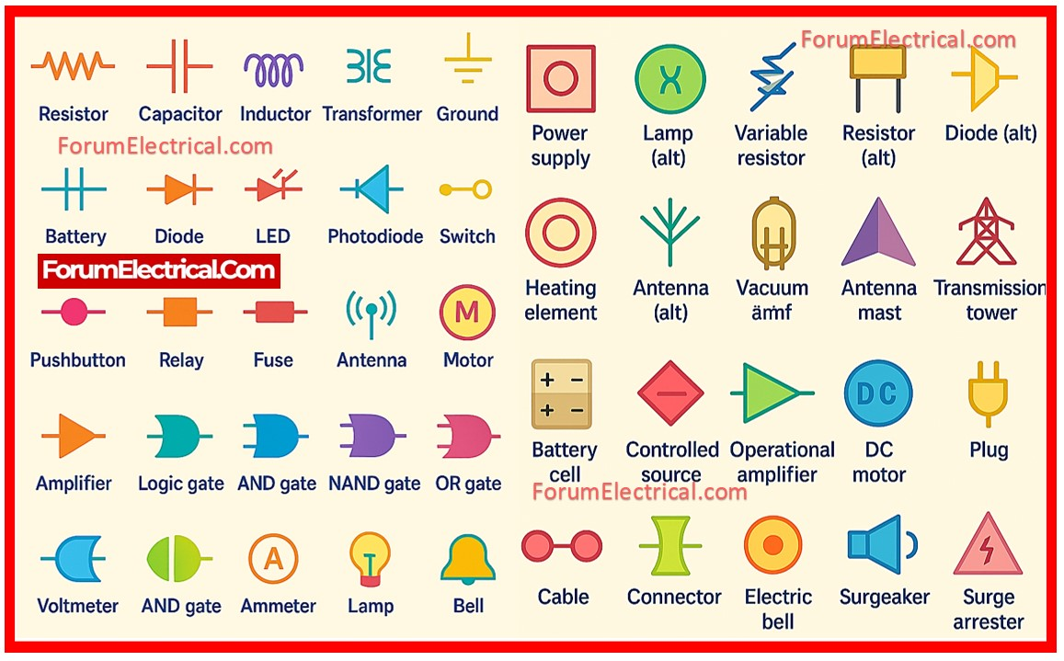

Sources
- Electrical Technology (2020 Oct). Resistance, Capacitance & Inductance in Series-Parallel – Equation & Formulas. https://www.electricaltechnology.org/2020/10/resistance-inductance-capacitance-series-parallel-formulas.html
- ForumElectrical.Com (2025). Electrical Symbols. https://forumelectrical.com/basic-electric-symbols/
- LibreTexts Physics (2024). 9.6: Electrical Energy and Power. https://phys.libretexts.org/Bookshelves/University_Physics/University_Physics_(OpenStax)/University_Physics_II_-_Thermodynamics_Electricity_and_Magnetism_(OpenStax)/09%3A_Current_and_Resistance/9.06%3A_Electrical_Energy_and_Power
- Tech Web (2024). Resonant Circuits: Resonant Frequency and Q Factor. https://techweb.rohm.com/product/power-device/si/18332/

