Harold’s AP Calculus BC
Cheat Sheet
29 November 2022

 | Rectangular | Polar |  | Parametric
Point | $$f\left(x\right)= y$$  $$\left(x, y\right)$$  $$\left(a, b\right)$$  • | $(r , θ)$ or $r ∠ θ$ |  | Point (a,b) in Rectangular:  $$x\left(t\right)=a$$  $$y\left(t\right)=b$$  $$<a,b>$$  $t=3^{rd} variable, usually time$,  with 1 degree of freedom (df)
 |  | Polar Rect.  $$x=r\cos{θ}$$  $$y=r\sin{θ}$$  $$\tan{θ}=\frac{y}{x}$$ | Rect. Polar  $$r^{2}= x^{2}+y^{2}$$  $r= ± \sqrt{x^{2}+ y^{2}}$  $$θ=\tan^{-1}\left(\frac{y}{x}\right)$$
Line | Slope-Intercept Form:  $$y=mx+b$$  Point-Slope Form:  $$y- y_{0}=m (x-x_{0})$$  General Form:  $$Ax+By+C=0$$  Calculus Form:  $$f\left(x\right)=f^{'}\left(a\right) x+f(0)$$ | 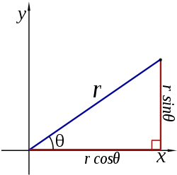 |  | $$<x,y> = <x_{0},y_{0}>+ t<a,b>$$  $$<x,y> = <x_{0}+at,y_{0}+bt>$$  where  $$<a,b> = <x_{2}-x_{1}, { y}_{2}-y_{1}>$$  $$x(t)= x_{0}+ ta$$  $$y(t)= y_{0}+ tb$$  $$m=\frac{∆y}{∆x}=\frac{{ y}_{2}-y_{1}}{x_{2}-x_{1}}=\frac{b}{a}$$
Plane | $$n_{x}\left(x-x_{0}\right)$$  $$+n_{y}\left(y-y_{0}\right)$$  $$+ n_{z}\left(z-z_{0}\right)=0$$ | Vector Form:  $$n ⦁ \left(r- r_{0}\right)=0$$ |  | $$r= r_{0}+ sv+tw$$  where:  - v and w are given vectors defining the plane  - $r_{0}$ is the vector of a fixed point on the plane
Conics | General Equation for All Conics:  $$Ax^{2}+Bxy+Cy^{2}+Dx+Ey+F=0$$  where  $$Line: A=B=C=0$$  $$Circle: A=C and B=0$$  $$Ellipse: AC>0$$  $$or B^{2}-4AC<0$$  $$Parabola: AC=0$$  or $B^{2}-4AC=0$  $$Hyperbola: AC<0$$  $$or B^{2}-4AC>0$$  Note: If $A+C=0$, square hyperbola  Rotation:  If B ≠ 0, then rotate coordinate system:  $$\cot{2θ}=\frac{A-C}{B}$$  $$x=x'\cos{θ-y'\sin{θ}}$$  $$y=y'\cos{θ+x'\sin{θ}}$$  New = (x’, y’), Old = (x, y)  rotates through angle $θ$ from x-axis  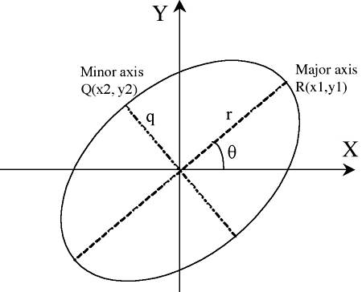 | General Equation for All Conics:  $$r=\frac{p}{1-e\cos{θ}}$$  $$where p=\left\{\begin{aligned} a (1-e^{2}) \\ 2d \\ a (e^{2}-1)\end{aligned}\right.for \left\{\begin{aligned} 0≤e<1 \\ e=1 \\ e>1\end{aligned}\right.$$  p = semi-latus rectum  or the line segment running from the focus to the curve in a direction parallel to the directrix  Eccentricity:  $$\begin{aligned}Circle e=0 \\ Ellipse 0<e<1 \\ Parabola e=1 \\ Hyperbola e>1\end{aligned}$$  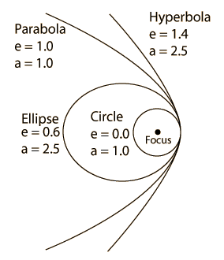 |  | 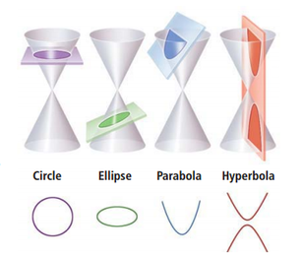  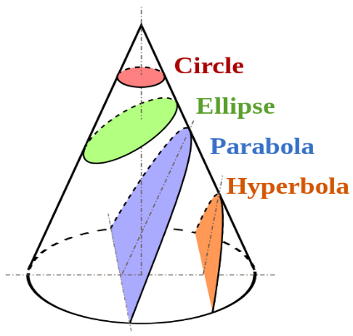
Circle | $${(x-h)}^{2}+{(y-k)}^{2}=r^{2}$$  Center: $\left(h,k\right)$  Vertices: NA  Focus: $\left(h,k\right)$  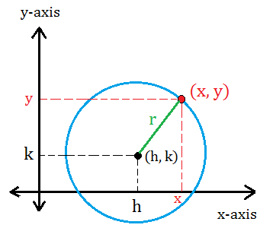 | Centered at Origin:  r = a (constant)  $$θ = θ \left[0, 2π\right] or [0, 360°]$$  Centered at $(r_{0},ϕ)$:  $$r^{2}+r_{0}^{2}-2rr_{0}\cos\left(θ-ϕ\right)=R^{2}$$  Hint: Law of Cosines  or  $$r=r_{0}\cos\left(θ-ϕ\right)+\sqrt{a^{2}-r_{0}^{2} \sin^{2}(θ-ϕ)}$$  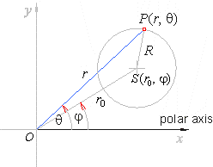 |  | $$x(t)=r\cos{(t)}+h$$  $$y(t)=r\sin{(t)}+k$$  $$\left[t_{min}, { t}_{max}\right]=[0, 2π]$$  Center: $\left(h,k\right)$  Focus: $\left(h,k\right)$
Ellipse | $$\frac{{(x-h)}^{2}}{a^{2}}+\frac{{(y-k)}^{2}}{b^{2}}=1$$  Center: $\left(h,k\right)$  Vertices: $\left(h±a, k\right)$ and $\left(h, k±b\right)$  Foci: $\left(h±c, k\right)$  Focus length, c, from center:  $$c^{2}= a^{2}-b^{2}$$  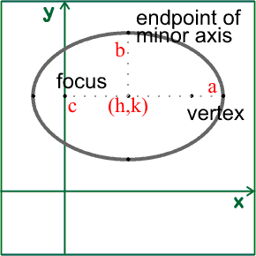 | Ellipse:  $$r=\frac{a (1-e^{2})}{1+e\cos{θ}} for 0<e<1$$  $$where e= \frac{c}{a}= \frac{\sqrt{a^{2}- b^{2}}}{a}$$  relative to center $(h, k)$  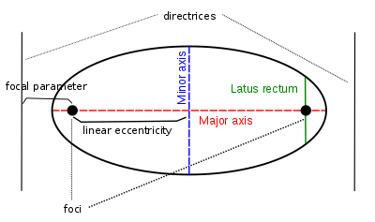  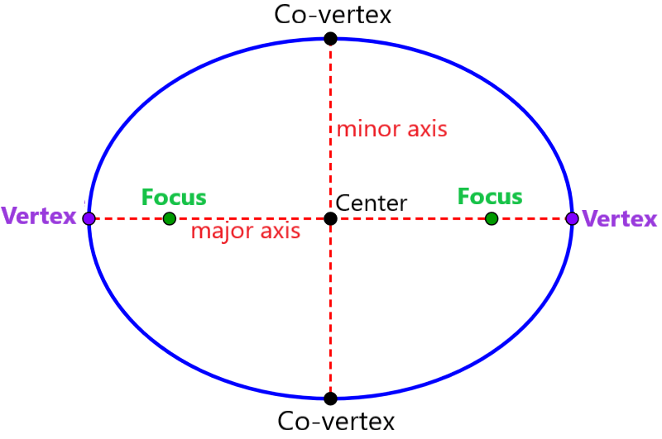  Interesting Note:  The sum of the distances from each focus to a point on the curve is constant.  $$\left|d_{1}+d_{2}\right|=k$$ |  | $$x\left(t\right)=a\cos{(t) }+h$$  $$y(t)=b\sin{(t})+ k$$  $$\left[t_{min}, { t}_{max}\right]=[0, 2π]$$  Center: $\left(h,k\right)$  Rotated Ellipse:  $$x\left(t\right)=a\cos{t\cos{θ-b\sin{t\sin{θ}}}}+h$$  $$y\left(t\right)=a\cos{t\sin{θ+b\sin{t\cos{θ}}}}+k$$  $θ$ = the angle between the x-axis and the major axis of the ellipse
Hyperbola | $$\frac{{\left(x-h\right)}^{2}}{a^{2}}-\frac{{\left(y-k\right)}^{2}}{b^{2}}=1$$  Center: $\left(h,k\right)$  Vertices: $\left(h±a, k\right)$  Foci: $\left(h±c, k\right)$  Focus length, c, from center:  $$c^{2}= a^{2}+b^{2}$$  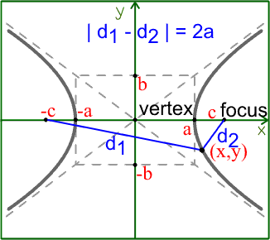 | Vertical Axis of Symmetry:  $$r=\frac{a (e^{2}- 1)}{1+e\cos{θ}} for e>1$$  $$Eccentricity: e>1$$  $$where e= \frac{c}{a}= \frac{\sqrt{a^{2}+ b^{2}}}{a}=\sec{θ>1}$$  relative to center (h, k)  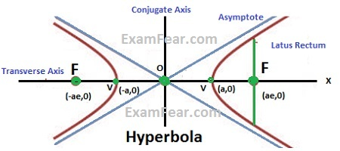  p = semi-latus rectum  or the line segment running from the focus to the curve in the directions $θ=± \frac{π}{2}$  Interesting Note:  The difference between the distances from each focus to a point on the curve is constant.  $$\left|d_{1}-d_{2}\right|=k$$ |  | Left-Right Opening Hyperbola:  $$x(t)=asec({t)}+h$$  $$y(t)=btan({t)}+k$$  $$\left[t_{min}, { t}_{max}\right]=[-c, c]$$  Vertex: (h, k)  Up-Down Opening Hyperbola:  $$x(t)=a\tan{(t)}+h$$  $$y(t)=b\sec{(t)}+k$$  $$\left[t_{min}, { t}_{max}\right]=[-c, c]$$  Vertex: (h, k)  General Form:  $$x(t)=At^{2}+ Bt+C$$  $$y(t)=Dt^{2}+ Et+F$$  where A and D have different signs
Parabola | Vertical Axis of Symmetry:  $$x^{2}=4 py$$  $${\left(x-h\right)}^{2}=4p(y-k)$$  Vertex: $\left(h,k\right)$  Focus: $\left(h,k+p\right)$  Directrix: $y=k-p$  Horizontal Axis of Symmetry:  $$y^{2}=4 px$$  $${\left(y-k\right)}^{2}=4p(x-h)$$  Vertex: $\left(h,k\right)$  Focus: $\left(h+p,k\right)$  Directrix: $x=h-p$  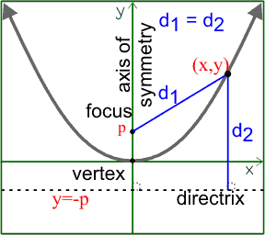 | Vertical Axis of Symmetry:  $$r=\frac{2d}{1+e\cos{θ}}$$  $$Eccentricity: e=1$$  and $d=2p$  Trigonometric Form:  $y=x^{2}$  $$r\sin{θ}=r^{2} \cos^{2}{θ}$$  $$r=\frac{\sin{θ}}{\cos^{2}{θ}}=\tan{θ\sec{θ}}$$  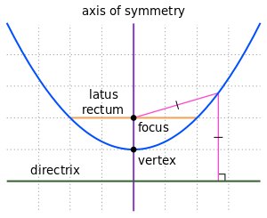  Interesting Note:  The distances from a point on the curve to the focus is the same as to the directrix. |  | Vertical Axis of Symmetry:  $$x\left(t\right)= 2pt+ h$$  $y\left(t\right)=pt^{2}+k$ (opens upwards)  $y\left(t\right)=-pt^{2}-k$ (opens downwards)  $$\left[t_{min}, { t}_{max}\right]=[-c, c]$$  Vertex: $\left(h,k\right)$  Horizontal Axis of Symmetry:  $$y\left(t\right)= 2pt+ k$$  $x\left(t\right)=pt^{2}+h$ (opens to the right)  $x\left(t\right)=-pt^{2}-h$ (opens to the left)  $$\left[t_{min}, { t}_{max}\right]=[-c, c]$$  Vertex: $\left(h,k\right)$  Projectile Motion:  $$x\left(t\right)=x_{0}+v_{x}t+\left(\frac{1}{2}\right)a_{x}t^{2}$$  $y\left(t\right)=y_{0}+v_{y0}t-16t^{2}$ feet  $y\left(t\right)=y_{0}+v_{y0}t-4.9t^{2}$ meters  $$v_{x}=v\cos{θ}$$  $$v_{y}=v\sin{θ}$$  General Form:  $$x=At^{2}+ Bt+C$$  $$y=Dt^{2}+ Et+F$$  where A and D have the same sign

1st Derivative | $$f^{'}\left(x\right)=\lim_{h→0}{\frac{f\left(x+h\right)-f(x)}{h}}$$  $$f^{'}\left(c\right)=\lim_{x→c}{\frac{f\left(x\right)-f(c)}{x-c}}$$  $$f^{'}\left(x\right)=\frac{dy}{dx}=y^{'}=D_{x}$$ | $$\frac{dy}{dx}=\frac{\frac{dy}{dθ}}{\frac{dx}{dθ}}=\frac{\frac{dr}{dθ}\sin{θ}+ r\cos{θ}}{\frac{dr}{dθ}\cos{θ-r\sin{θ}}}$$  Hint: Use Product Rule for  $$y=r\sin{θ}$$  $$x=r cos θ$$ |  | $$\frac{dy}{dx}=\frac{\frac{dy}{dt}}{\frac{dx}{dt}} , provided\frac{dx}{dt}≠0$$
2nd Derivative | $$f^{''}\left(x\right)=\frac{d}{dx}\left(\frac{dy}{dx}\right)= \frac{d^{2}y}{dx^{2}}=y^{''}=D_{xx}$$ | $$\frac{d^{2}y}{dx^{2}}=\frac{d}{dx}\left(\frac{dy}{dx}\right)=\frac{\frac{d}{dθ}\left(\frac{dy}{dx}\right)}{\frac{dx}{dθ}}$$ |  | $$\frac{d^{2}y}{dx^{2}}=\frac{d}{dx}\left(\frac{dy}{dx}\right)=\frac{\frac{d}{dt}\left(\frac{dy}{dx}\right)}{\frac{dx}{dt}}=\frac{\frac{d}{dt}\left(\frac{\frac{dy}{dt}}{\frac{dx}{dt}}\right)}{\frac{dx}{dt}}$$
Integral | Fundamental Theorem of Calculus:  $$F\left(x\right)=\int_{a}^{b}{f\left(x\right) dx} =F\left(b\right)-F(a)$$ | 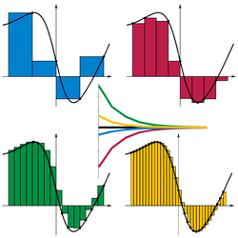 |  | Riemann Sum:  $$S=\sum_{i-1}^{n}{f(y_{i})(x_{i}-x_{i-1})}$$  Left Sum:  $$S= \left(\frac{1}{n}\right)\left[f\left(a\right)+f\left(a+\frac{1}{n}\right)+f\left(a+\frac{2}{n}\right)+…+f(b-\frac{1}{n})\right]$$  Middle Sum:  $$S= \left(\frac{1}{n}\right)\left[f\left(a+\frac{1}{2n}\right)+f\left(a+\frac{3}{2n}\right)+…+f(b-\frac{1}{2n})\right]$$  Right Sum:  $$S= \left(\frac{1}{n}\right)\left[f\left(a+\frac{1}{n}\right)+f\left(a+\frac{2}{n}\right)+…+f(b)\right]$$
Inverse Functions | $$f\left(f^{-1 }(x)\right)=f^{-1 }\left(f(x)\right)=x$$  Inverse Function Theorem:  $$f^{-1}\left(f^{'}\left(a\right)\right)= \frac{1}{f^{'}\left(a\right)}$$ | if $y=sin θ$  if $y=\cos{θ}$  if $y=\tan{θ}$  if $y= csc θ$  if $y=\sec{θ}$  if $y=\cot{θ}$ | $$then θ=\sin^{-1}{y}$$  $$then θ=\cos^{-1}{y}$$  $$then θ=\tan^{-1}{y}$$  $$then θ=\csc^{-1}{y}$$  $$then θ=\sec^{-1}{y}$$  $$then θ=\cot^{-1}{y}$$ | or $θ=\arcsin{y}$  or $θ=\arccos{y}$  or $θ=\arctan{y}$  or $θ=\operatorname{arccsc}{y}$  or $θ=\operatorname{arcsec}{y}$  or $θ=\operatorname{arccot}{y}$
Arc Length | $$L= \int_{a}^{b}{\sqrt{1+{[f^{'}\left(x\right)]}^{2}} dx}$$  Proof:  $$∆s= \sqrt{{\left(x-x_{0}\right)}^{2}+ {\left(y- y_{0}\right)}^{2}}$$  $$∆s = \sqrt{{(∆x)}^{2}+ ({∆y)}^{2}}$$  $$ds= \sqrt{{dx}^{2}+dy^{2}}$$  $$ds= \sqrt{{dx}^{2}+dy^{2}\left(\frac{dx^{2}}{dx^{2}}\right)}$$  $$ds= \sqrt{{dx}^{2}+{\left(\frac{dy}{dx}\right)}^{2}dx^{2}}$$  $$ds= \sqrt{{dx}^{2} \left(1+{\left(\frac{dy}{dx}\right)}^{2}\right)}$$  $$ds= \sqrt{1+{\left(\frac{dy}{dx}\right)}^{2}}dx$$  $$L= \int{ds}$$ | $$L= \int{\sqrt{r^{2}+ {\left(\frac{dr}{dθ}\right)}^{2}} dθ}$$  Circle:  $$L=s=rθ$$  Proof:  $$L=\left(fraction of circumference\right)∙$$  $$π∙(diameter)$$  $$L=\left(\frac{θ}{2π}\right)π (2r)=rθ$$  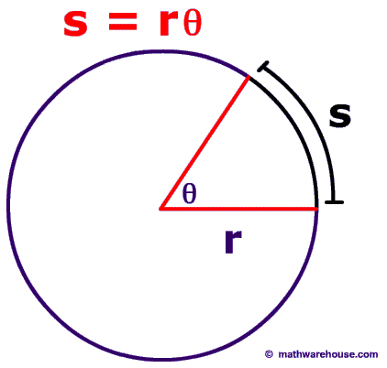 |  | $$L= \int_{α}^{β}{\sqrt{{\left(\frac{dx}{dt}\right)}^{2}+ {\left(\frac{dy}{dt}\right)}^{2}} dt}$$  $$L= \int_{α}^{β}{\sqrt{{\left(\frac{dx}{dt}\right)}^{2}+ {\left(\frac{dy}{dt}\right)}^{2}+ {\left(\frac{dz}{dt}\right)}^{2}} dt}$$  Proof:  $$ds= \sqrt{{dx}^{2}+dy^{2}}$$  $$ds= \sqrt{{dx}^{2}\left(\frac{dt^{2}}{dt^{2}}\right)+dy^{2}\left(\frac{dt^{2}}{dt^{2}}\right)}$$  $$ds= \sqrt{{\left(\frac{dx}{dt}\right)}^{2}+{\left(\frac{dy}{dt}\right)}^{2}dt^{2}}$$  $$ds= \sqrt{{\left(\frac{dx}{dt}\right)}^{2}+{\left(\frac{dy}{dt}\right)}^{2}} dt$$  $$L= \int{ds}$$
Perimeter | Square: P = 4s  Rectangle: P = 2l + 2w  Triangle: P = a + b + c  Circle: C = πd = 2πr  Ellipse: $C≈π(a+b)$ | Ellipse: $C≈2π\sqrt{\frac{a^{2}+b^{2}}{2}}$  $$C≈π \left[3\left(a+b\right)-\sqrt{(3a+b)(a+3b)}\right]$$  $$C≈π \left(a+b\right)\left(1+\frac{3h}{10+\sqrt{4-3h}}\right)$$ |  | Ellipse: $C=4a\int_{0}^{\frac{π}{2}}{\sqrt{1-k^{2}\sin^{2}θ} dθ}$  $$h=\frac{{\left(a-b\right)}^{2}}{{\left(a+b\right)}^{2}} \& k^{2}=\left(1-\frac{b^{2}}{a^{2}}\right)$$
Area | Square: A = s²  Rectangle: A = lw  Rhombus: A = ½ ab  Parallelogram: A = Bh  Trapezoid: $A=\frac{\left(B_{1}+{ B}_{2}\right)}{2} h$  Kite: $A = \frac{d_{1} d_{2}}{2}$  Triangle: A = ½ Bh  Triangle: A = ½ ab sin(C)  Triangle using Heron’s Formula:  $$A= \sqrt{s\left(s-a\right)\left(s-b\right)\left(s-c\right)}$$  $$where s=\frac{a+b+c}{2}$$  Equilateral Triangle: $A = ¼\sqrt{3}s^{2}$  Frustum: $A=\frac{1}{3}\left(\frac{B_{1}+B_{2}}{2}\right)h$  Circle: A = πr²  Circular Sector: A = ½ r²$θ$  Ellipse: A = πab | $$A= \int_{α}^{β}{\frac{1}{2}{[f(θ)]}^{2}dθ}$$  where $r=f(θ)$  Proof:  Area of a sector:  $$A=\int{s dr= }\int{r ∆θ dr=\frac{1}{2}r^{2} ∆θ}$$  where arc length $s=r ∆θ$  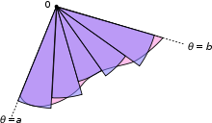 |  | $$A=\int_{α}^{β}{g\left(t\right) f^{'}\left(t\right) dt}$$  where $f\left(t\right)=x$ and $g\left(t\right)=y$  or  x(t) = f(t) and y(t) = g(t)  Simplified:  $$A=\int_{α}^{β}{y\left(t\right) \frac{dx(t)}{dt} dt}$$  Proof:  $$\int_{a}^{b}{f\left(x\right)} dx$$  y = f(x) = g(t)  $$dx =\frac{df\left(t\right)}{dt}dt=f’(t) dt$$
Lateral Surface Area | Cylinder: SA = 2πrh  Cone: SA = πrl  $$SA= 2π\int_{a}^{b}{f\left(x\right) \sqrt{1+{[f^{'}\left(x\right)]}^{2}} dx}$$ | For rotation about the x-axis:  $$SA= \int{2πy} ds$$  For rotation about the y-axis:  $$SA= \int{2πx} ds$$  $$ds= \sqrt{r^{2}+{\left(\frac{dr}{dθ}\right)}^{2}} dθ$$  $$r=f\left(θ\right), α≤ θ≤β$$ |  | For rotation about the x-axis:  $$SA= \int{2πy} ds$$  For rotation about the y-axis:  $$SA= \int{2πx} ds$$  $$ds= \sqrt{{\left(\frac{dx}{dt}\right)}^{2}+{\left(\frac{dy}{dt}\right)}^{2}} dt$$  $$if x=f\left(t\right), y=g\left(t\right), α≤ t≤β$$
Total Surface Area | Cube: SA = 6s²  Rectangular Box: SA = 2lw + 2wh + 2hl  Regular Tetrahedron: SA = 2bh  Cylinder: SA = 2πr (r + h)  Cone: SA = πr² + πrl = πr (r + l)  Sphere: SA = 4πr²  Ellipsoid: SA $≈4π{\left(\frac{a^{p}b^{p}+a^{p}c^{p}+b^{p}c^{p}}{3}\right)}^{1/p}$  Where p $≈1.6075, \left|Relative Error\right|≤1.061\%$  (Knud Thomsen’s Formula)
Surface of Revolution | For revolution about the x-axis:  $$A=2π \int_{a}^{b}{f(x)}\sqrt{1+{\left(\frac{dy}{dx}\right)}^{2}} dx$$  For revolution about the y-axis:  $$A=2π \int_{a}^{b}{x}\sqrt{1+{\left(\frac{dx}{dy}\right)}^{2}} dy$$ | For revolution about the x-axis:  $$A=2πr\int_{α}^{β}{\cos{θ}} \sqrt{r^{2}+ {\left(\frac{dr}{dθ}\right)}^{2}} dθ$$  For revolution about the y-axis:  $$A=2πr\int_{α}^{β}{\sin{θ}}\sqrt{r^{2}+{\left(\frac{dr}{dθ}\right)}^{2}}dθ$$ |  | For revolution about the x-axis:  $$A=2π\int_{a}^{b}{y\left(t\right)} \sqrt{{\left(\frac{dx}{dt}\right)}^{2}+ {\left(\frac{dy}{dt}\right)}^{2}} dt$$  For revolution about the y-axis:  $$A=2π\int_{a}^{b}{x\left(t\right)} \sqrt{{\left(\frac{dx}{dt}\right)}^{2}+ {\left(\frac{dy}{dt}\right)}^{2}} dt$$
Volume | Cube: V = s³  Rectangular Prism: V = lwh  Cylinder: V = πr²h  Triangular Prism: V = Bh  Tetrahedron: V = ⅓ Bh  Pyramid: V = ⅓ Bh = ⅓ lwh  Cone: V = ⅓ Bh = ⅓ πr²h  Sphere: $V=\frac{4}{3}πr^{3}$  Ellipsoid: V = $\frac{4}{3}$πabc
Volume of Revolution | Disk Method  $$V=\int_{a}^{b}{(area of circle) d\left(thickness\right)}$$  Rotation about the x-axis:  $$V= \int_{a}^{b}{π {\left[f\left(x\right)\right]}^{2}dx}$$  Rotation about the y-axis:  $$V= \int_{c}^{d}{πx^{2}dy}$$ | 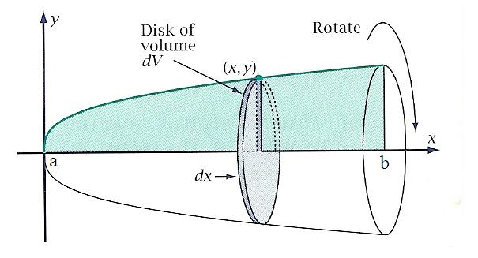
 | Washer Method  Rotation about the x-axis:  $$V= \int_{a}^{b}{π \{}[{f(x)]}^{2}-[g{\left(x\right)]}^{2}\} dx$$ | $$V=V_{Outer Disk}-V_{Inner Disk}$$
 | Shell Method  $$V=\int_{a}^{b}{\left(circumference\right) \left(hight\right) dx}$$  Rotation about the y-axis:  $$V=\int_{a}^{b}{2πx f\left(x\right) dx}$$  Rotation about the x-axis:  $$V=\int_{c}^{d}{2πy g\left(y\right) dy}$$ | 