Harold’s Vectors Cheat Sheet
5 December 2022

Definitions

Term | Formula | Example
Vector Notation | $$A, a$$ | Bold letter
 | $$\vec{a}, \vec{a}$$ | Arrow on top
Component Notation | $$a=\vec{a}=a_{x}\hat{i}+a_{y}\hat{j}+a_{z}\hat{k}$$ | $$a=3\hat{i} +4\hat{j}+5\hat{k}$$
 | $$a=〈a_{x}, a_{y},a_{z}〉$$ | $$a=〈3, 4, 5〉$$
 | $$a=r∠θ$$ | $a=5 ∠ 53.13°$ (2D)
 | 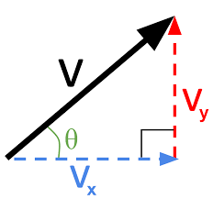  2D | 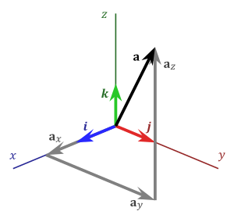  3D
Vectors Used in Examples | $$a=a_{x}\hat{i} +a_{y}\hat{j} +a_{z}\hat{k}$$  $$b=b_{x}\hat{i} +b_{y}\hat{j} +b_{z}\hat{k}$$  2D: set $a_{z}=b_{z}=0$ | $$a=3\hat{i} +4\hat{j}+5\hat{k}$$  $$b=6\hat{i} -7\hat{j}-8\hat{k}$$
Magnitude | $$\left\|a\right\|=\sqrt{a_{x}^{2}+a_{y}^{2}+a_{z}^{2}}$$ | $$\left\|a\right\|=\sqrt{3^{2}+4^{2}+5^{2}}=\sqrt{50}=5\sqrt{2}$$
 | Can also use $\left|a\right|$.  Length of vector, but with no direction (scalar).  Similar to a hypotenuse.  Think multi-dimensional Pythagorean Theorem. | 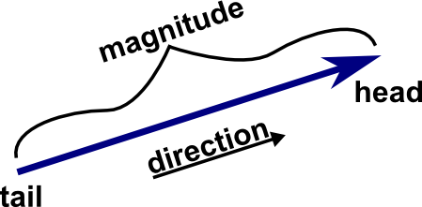
Direction | Divided into dimensional components. | A scalar with a direction is a vector.  Example: speed vs. velocity
 | $$\tan{θ}=\frac{a_{y}}{a_{x}}$$ | $$θ=\tan^{-1}\left(\frac{a_{y}}{a_{x}}\right)=\tan^{-1}\left(\frac{4}{3}\right)≅53.13°$$
Unit Vector  (Basis Vector) | $$\hat{i}=x-axis=〈1, 0, 0〉$$  $$\hat{j}=y-axis=〈0, 1, 0〉$$  $$\hat{k}=z-axis=〈0, 0, 1〉$$ | Circumflex or “hat” on top.  Indicates direction only.  Always has a magnitude of one (1 or unit).
 | $$\vec{u}=\frac{a}{\left\|a\right\|}$$ | $$\vec{u}=\frac{a_{x}\hat{i} +a_{y}\hat{j} +a_{z}\hat{k}}{\sqrt{a_{x}^{2}+a_{y}^{2}+a_{z}^{2}}}$$
Scalar | k, m | A number with no direction or units.
Orthogonal | A change in one dimension does not change in any of the values in the other dimensions. | 2D: right angle  Rectangular Coordinates: The x-axis, y-axis, and z-axis are orthogonal to each other.  Polar Coordinates: The angle is orthogonal to the line segment length
 | if $a•b=0$ | Two vectors are orthogonal if their dot product is zero.
 | 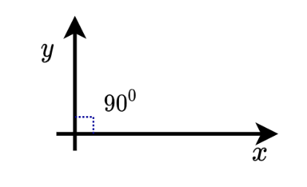 | 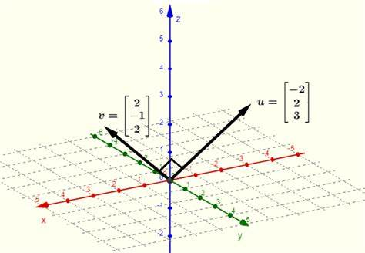
Parallel | If $a=kb$ | Two vectors are parallel if they have the same direction.
 | Collinear of in opposite directions | 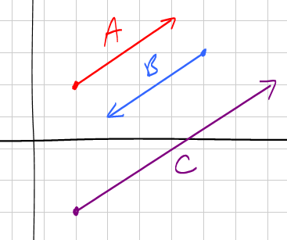
Vector vs. Matrix | vector = $1 x n$ or $n x 1$ matrix | A matrix with only one (1) row or column.
 | 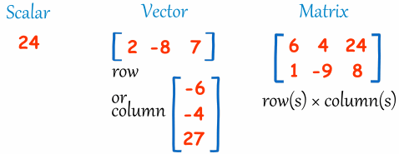

Vector Operations
Operation | Formula | Example
Addition | $$a+b= \left(a_{x}+b_{x}\right)\hat{i}+\left(a_{y}+b_{y}\right)\hat{j}+\left(a_{z}+b_{z}\right)\hat{k}$$ | $$a+b=\left(3+6\right)\hat{i}+\left(4-7\right)\hat{j}+\left(5-8\right)\hat{k}$$  $$=9\hat{i}-3\hat{j}-3\hat{k}$$
 | $$a+b=b+a$$ | Commutative
 | $$\left(a+b\right)+c=a+\left(b+c\right)$$ | Associative
 | $$(k+m)a=ka+ma$$ | Distributive
 | $$k\left(a+b\right)=ka+kb$$
 | 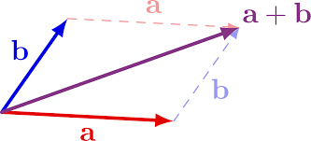 | 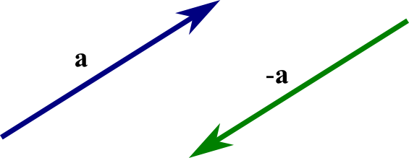
Subtraction | $$a-b=a+\left(-b\right)$$ | Change the direction of $\vec{b}$ then add.
 | 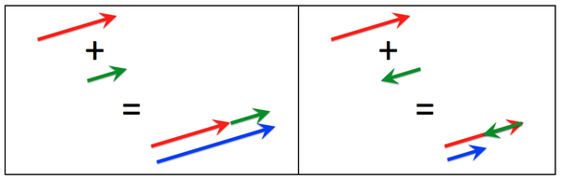
Scalar Multiplication | $$ka=ka_{x}\hat{i} +ka_{y}\hat{j} +ka_{z}\hat{k}$$ | $$3∙a=3∙3\hat{i} +3∙4\hat{j} +3∙5\hat{k}$$  $$=9\hat{i} +12\hat{j} +15\hat{k}$$
 | Changes the magnitude only.
 | $$k\left(a+b\right)=ka+kb$$ | 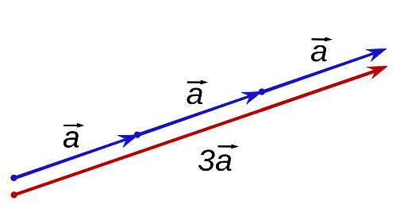
Dot Product  (Scalar Product) | $$a•b= a_{x}b_{x}+a_{y}b_{y}+a_{z}b_{z}$$ | $$a•b= (3)(6)+(4)(-7)+(5)(-8)=-50$$
 | $$a•b=\left\|a\right\| \left\|b\right\|\cos{θ}$$ | $$\cos{θ}=\frac{a•b}{\left\|a\right\| \left\|b\right\|}$$
 | $$a•b=b•a$$ | Commutative
 | $$a•\left(b+c\right)=a•b+a•c$$ | Distributive
 | $$k(a•b)=ka•b=a•kb$$ | Scalar Multiplication
 | $$0•u=0$$ | Zero Vector Dot Product
 | $$u•u={\left\|u\right\|}^{2}$$ | Dot Product and Vector Magnitude Relationship
 | Is always a scalar.
 |  | 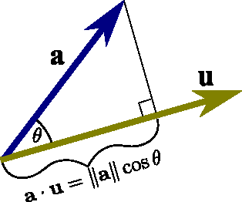
Cross Product  (Vector Product) | $$a⨯b=\left|\begin{matrix}i & j & k \\ a_{x} & a_{y} & a_{z} \\ b_{x} & b_{y} & b_{z}\end{matrix}\right|=\left|\begin{matrix}a_{y} & a_{z} \\ b_{y} & b_{z}\end{matrix}\right|i-\left|\begin{matrix}a_{x} & a_{z} \\ b_{x} & b_{z}\end{matrix}\right|j+\left|\begin{matrix}a_{x} & a_{y} \\ b_{x} & b_{y}\end{matrix}\right|k$$  $$=\left(a_{y}b_{z}-b_{y}a_{z}\right) i-\left(a_{x}b_{z}-b_{x}a_{z}\right) j+\left(a_{x}b_{y}-b_{x}a_{y}\right) k$$
 | $$\left\|a⨯b\right\|=\left\|a\right\| \left\|b\right\|\sin{θ}$$ | $$\sin{θ}=\frac{\left\|a⨯b\right\|}{\left\|a\right\| \left\|b\right\|}$$
 | $$a⨯b=-b⨯a$$ | Anti-Commutative
 | $$\left(a⨯b\right)⨯c≠a⨯\left(b⨯c\right)$$ | Not Commutative
 | $$\left(a⨯b\right)⨯c=(a•c)b-(a•b) c$$
 | $$a⨯(b⨯c)≠(a⨯b)⨯c$$ | Not Associative
 | $$a•(b⨯c)=(a⨯b)•c$$
 | $$a⨯\left(b+c\right)=a⨯b+a⨯c$$ | Distributive
 | $$\left(a+b\right)⨯c=a⨯c+b⨯c$$
 | $$k(a⨯b)=ka⨯b=a⨯kb$$ | Scalar Multiplication
 | $$\left(ka\right)⨯b=k\left(a⨯b\right)=a⨯\left(kb\right)$$
 | Is always a vector orthogonal to the other two vectors.
 | 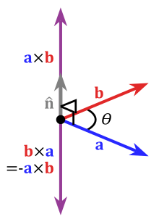 | 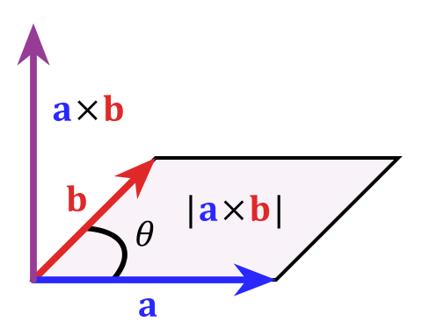
Scalar Triple Product | $$\left(a⨯b\right)•c=a•\left(b⨯c\right)=b•\left(c⨯a\right)=c•\left(a⨯b\right)=\left|\begin{matrix}a_{x} & a_{y} & a_{z} \\ b_{x} & b_{y} & b_{z} \\ c_{x} & c_{y} & c_{z}\end{matrix}\right|$$
Vector Triple Product | $$a⨯\left(b⨯c\right)=\left(a•c\right) b-\left(a•b\right) c$$
Vector Applications

Application | Formula | Example
Projection | $${proj}_{a}b=\left(\frac{a∙b}{a∙a}\right)a$$ | 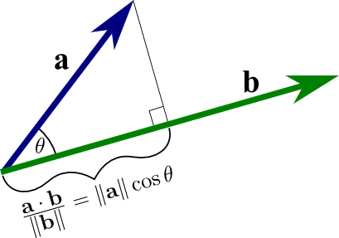
Right Hand Rule | The cross product produces a vector orthogonal to the other two vectors. | Use the right hand rule to determine direction of the cross product vector.
 | 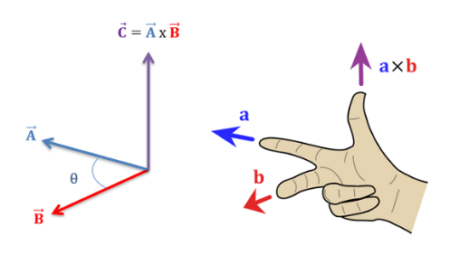
Area  (Parallelagram) | $$A=\left\|a⨯b\right\|$$ | 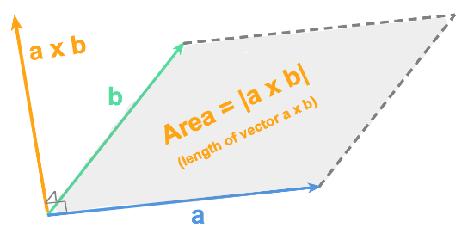
Volume  (Parallelepiped) | $$V=\left\|\left(a⨯b\right)•c\right\|$$ | 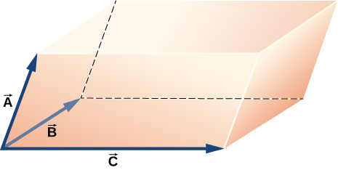
Torque | $$τ=r⨯F$$ | $$\left\|τ\right\|=r F\sin{θ}$$
Coplanar | Three vectors are coplanar if  $$\left(a⨯b\right)•c=\left|\begin{matrix}a_{x} & a_{y} & a_{z} \\ b_{x} & b_{y} & b_{z} \\ c_{x} & c_{y} & c_{z}\end{matrix}\right|=0$$ | All three vectors are in the same plane.

