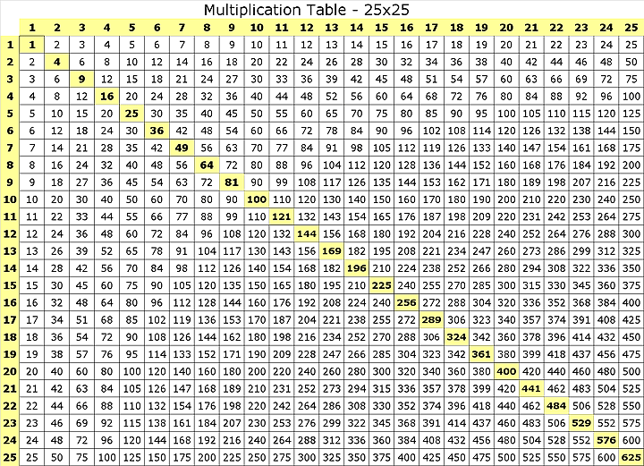
Multiplication Table – 25 x 25
 | 1 | 2 | 3 | 4 | 5 | 6 | 7 | 8 | 9 | 10 | 11 | 12 | 13 | 14 | 15 | 16 | 17 | 18 | 19 | 20 | 21 | 22 | 23 | 24 | 25
1
2
3
4
5
6
7
8
9
10
11
12
13
14
15
16
17
18
19
20
21
22
23
24
25

Harold’s Times Tables
“Cheat Sheet”
10 April 2020

For: Digit · n | Fill-In Tips | How to Spot | Prime Factoring Tips
Digit
1 | Copy n | Same as n | See prime numbers (2,3,5,7,11,13,17,19,23, …)
2 | Double n | If the last digit is even $\left\{0, 2, 4, 6, 8\right\}$ | Cut in half. Keep if the result is an integer.  Factors: $\left\{2, …, m\right\}$
3 | Triple n | See 9’s Rule below | Divide by ‘3’. Keep if the result is an integer.  Factors: $\left\{3, …, m\right\}$
4 | Double n twice | If the last digit is even, then candidate | Cut in half twice. Keep if the result is an integer.  Factors: $\left\{4, …, m\right\}→\left\{2, 2, …, m\right\}$
5 | Add a trailing ‘0’ to n, then cut in half | If the last digit is a ‘0’ or ‘5’ | See 10’s Rule below if trailing ‘0’.  Divide by ‘5’ if trailing ‘5’.  Factors: $\left\{5, …, m\right\}$
6 | Triple n, then Double | 6, 12, 18, 24, 30, 36, 42, 48, 54, 60, … | Cut in half, then divide by ‘3’.  Keep if the result is an integer.  Factors: $\left\{6, …, m\right\}→\left\{2, 3, …, m\right\}$
7 | Memorize | Hardest | Divide by ‘7’ after trying all other factoring tips.  Factors: $\left\{7, …, m\right\}$
8 | Double n 3 times | If the last digit is even, then candidate | Cut in half three times.  Keep if the result is an integer.  Factors: $\left\{8, …, m\right\}→\left\{2, 2, 2, …, m\right\}$
9 | If n ≤ 10, then  _(n-1)__(9-(n-1))_ | Digits add up to ‘9’ or multiples of ‘9’ (9m) | Add up all digits, then divide by ‘9’.  If the result is an integer, then ‘9’ is a factor.  Factors: $\left\{9, …, m\right\}→\left\{3, 3, …, m\right\}$
10 | Add a trailing ‘0’ to n | If the last digit is a ‘0’ | Drop trailing zero to get the factors $\left\{2, 5\right\}$.  Factors: $\left\{10, …, m\right\}→\left\{2, 5, …, m\right\}$
11 | If n ≤ 9, then  _n_n_ | You see double digits | Divide by ‘11’. Keep if the result is an integer.  Factors: $\left\{11, …, m\right\}$
12 | 12 · 12 = 144 | Is even and large | Cut in half twice, then divide by ‘3’.  Keep if the result is an integer.  Factors: $\left\{12, …, m\right\}→\left\{2, 2, 3, …, m\right\}$

