Harold’s Precalculus
Cheat Sheet
29 November 2022

 | Rectangular | Polar |  |  | Parametric
Point | $$f\left(x\right)= y$$  $$\left(x, y\right)$$  $$\left(a, b\right)$$  • | $(r , θ)$ or $r ∠ θ$ |  |  | Point (a,b) in Rectangular:  $$x\left(t\right)=a$$  $$y\left(t\right)=b$$  $$<a,b>$$  $t=3^{rd} variable, usually time$,  with 1 degree of freedom (df)
 |  | Polar Rect.  $$x=r\cos{θ}$$  $$y=r\sin{θ}$$  $$\tan{θ}=\frac{y}{x}$$ |  | Rect. Polar  $$r^{2}= x^{2}+y^{2}$$  $r= ± \sqrt{x^{2}+ y^{2}}$  $$θ=\tan^{-1}\left(\frac{y}{x}\right)$$
Line | Slope-Intercept Form:  $$y=mx+b$$  Point-Slope Form:  $$y- y_{0}=m (x-x_{0})$$  General Form:  $$Ax+By+C=0$$  Calculus Form:  $$f\left(x\right)=f^{'}\left(a\right) x+f(0)$$ | 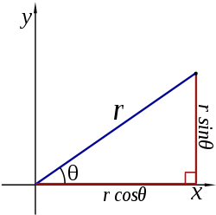 |  |  | $$<x,y> = <x_{0},y_{0}>+ t<a,b>$$  $$<x,y> = <x_{0}+at,y_{0}+bt>$$  where  $$<a,b> = <x_{2}-x_{1}, { y}_{2}-y_{1}>$$  $$x(t)= x_{0}+ ta$$  $$y(t)= y_{0}+ tb$$  $$m=\frac{∆y}{∆x}=\frac{{ y}_{2}-y_{1}}{x_{2}-x_{1}}=\frac{b}{a}$$
Plane | $$n_{x}\left(x-x_{0}\right)$$  $$+n_{y}\left(y-y_{0}\right)$$  $$+ n_{z}\left(z-z_{0}\right)=0$$ | Vector Form:  $$n ⦁ \left(r- r_{0}\right)=0$$ |  |  | $$r= r_{0}+ sv+tw$$
Conics | General Equation for All Conics:  $$Ax^{2}+Bxy+Cy^{2}+Dx+Ey+F=0$$  where  $$Line: A=B=C=0$$  $$Circle: A=C and B=0$$  $$Ellipse: AC>0$$  $$or B^{2}-4AC<0$$  $$Parabola: AC=0$$  or $B^{2}-4AC=0$  $$Hyperbola: AC<0$$  $$or B^{2}-4AC>0$$  Note: If $A+C=0$, square hyperbola  Rotation:  If B ≠ 0, then rotate coordinate system:  $$\cot{2θ}=\frac{A-C}{B}$$  $$x=x'\cos{θ-y'\sin{θ}}$$  $$y=y'\cos{θ+x'\sin{θ}}$$  New = (x’, y’), Old = (x, y)  rotates through angle $θ$ from x-axis  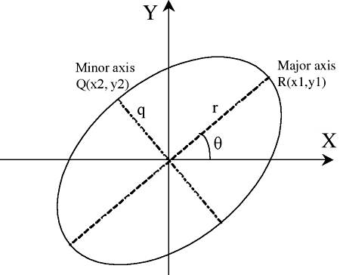 | 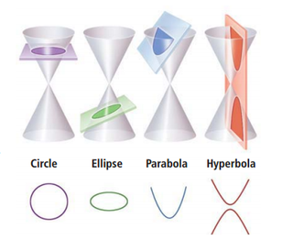  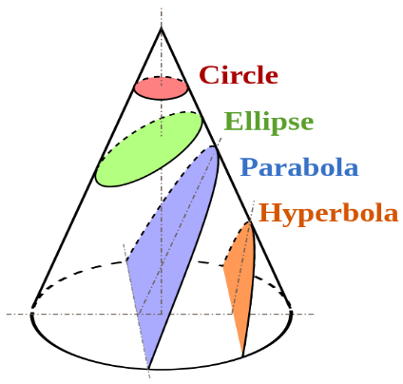
Circle | $${(x-h)}^{2}+{(y-k)}^{2}=r^{2}$$  Center: $\left(h,k\right)$  Vertices: NA  Focus: $\left(h,k\right)$  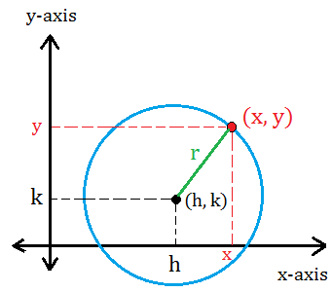 | Centered at Origin:  r = a (constant)  $$θ = θ \left[0, 2π\right] or [0, 360°]$$ |  |  | $$x(t)=r\cos{(t)}+h$$  $$y(t)=r\sin{(t)}+k$$  $$\left[t_{min}, { t}_{max}\right]=[0, 2π)$$  $$\left(h, k\right)=center of circle$$
Ellipse | $$\frac{{(x-h)}^{2}}{a^{2}}+\frac{{(y-k)}^{2}}{b^{2}}=1$$  Center: $\left(h,k\right)$  Vertices: $\left(h±a, k\right)$  Co-Vertices: $\left(h, k±b\right)$  Foci: $\left(h±c, k\right)$  Focus length, c, from center:  $$c^{2}= a^{2}-b^{2}$$  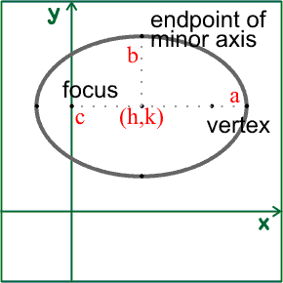 | 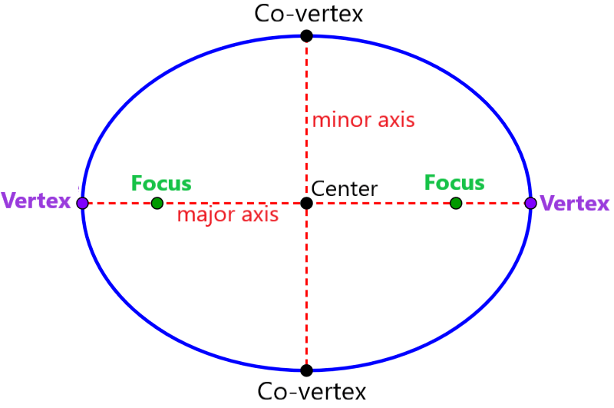  Interesting Note:  The sum of the distances from each focus to a point on the curve is constant.  $$\left|d_{1}+d_{2}\right|=k$$ |  |  | $$x\left(t\right)=a\cos{(t) }+h$$  $$y(t)=b\sin{(t})+ k$$  $$\left[t_{min}, { t}_{max}\right]=[0, 2π]$$  $$\left(h, k\right)=center of ellipse$$  Rotated Ellipse:  $$x\left(t\right)=a\cos{t\cos{θ-b\sin{t\sin{θ}}}}+h$$  $$y\left(t\right)=a\cos{t\sin{θ+b\sin{t\cos{θ}}}}+k$$  $θ$ = the angle between the x-axis and the major axis of the ellipse
Hyperbola | $$\frac{{\left(x-h\right)}^{2}}{a^{2}}-\frac{{\left(y-k\right)}^{2}}{b^{2}}=1$$  Center: $\left(h,k\right)$  Vertices: $\left(h±a, k\right)$  Foci: $\left(h±c, k\right)$  Focus length, c, from center:  $$c^{2}= a^{2}+b^{2}$$  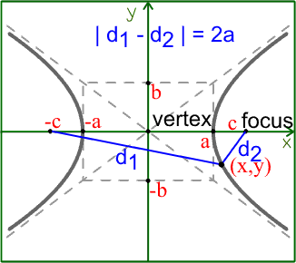 | 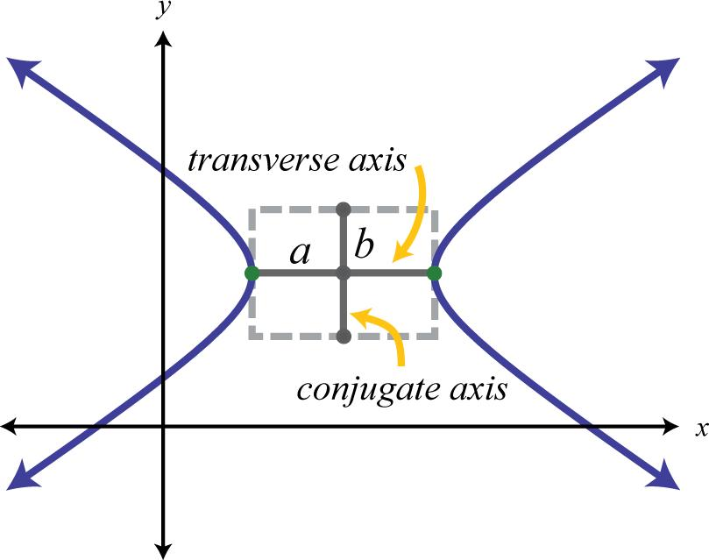  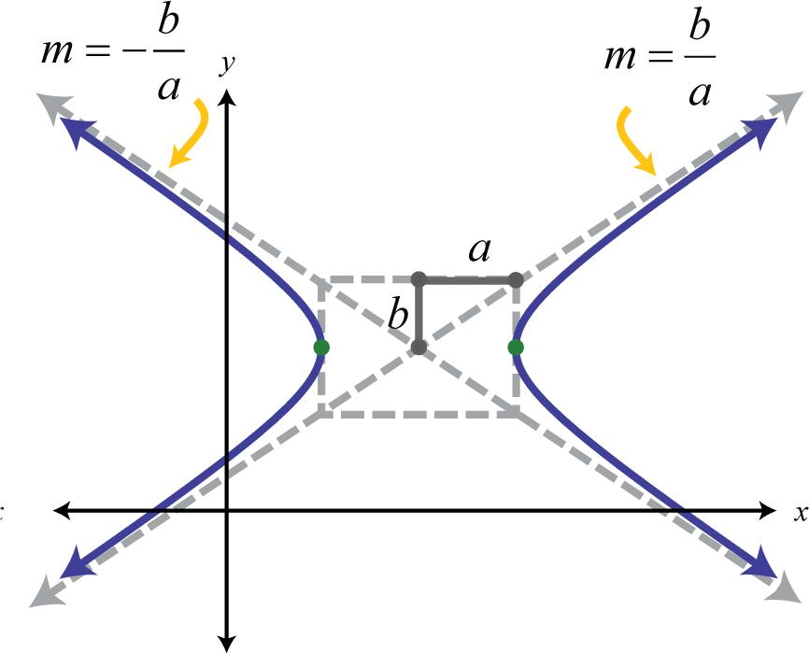  Interesting Note:  The difference between the distances from each focus to a point on the curve is constant.  $$\left|d_{1}-d_{2}\right|=k$$ |  |  | Left-Right Opening Hyperbola:  $$x(t)=asec({t)}+h$$  $$y(t)=btan({t)}+k$$  $$\left[t_{min}, { t}_{max}\right]=[-c, c]$$  (h, k) = vertex of hyperbola  Up-Down Opening Hyperbola:  $$x(t)=a\tan{(t)}+h$$  $$y(t)=b\sec{(t)}+k$$  $$\left[t_{min}, { t}_{max}\right]=[-c, c]$$  (h, k) = vertex of hyperbola  General Form:  $$x(t)=At^{2}+ Bt+C$$  $$y(t)=Dt^{2}+ Et+F$$  where A and D have different signs
Parabola | Vertical Axis of Symmetry:  $$x^{2}=4 py$$  $${\left(x-h\right)}^{2}=4p(y-k)$$  Vertex: $\left(h,k\right)$  Focus: $\left(h,k+p\right)$  Directrix: $y=k-p$  Horizontal Axis of Symmetry:  $$y^{2}=4 px$$  $${\left(y-k\right)}^{2}=4p(x-h)$$  Vertex: $\left(h,k\right)$  Focus: $\left(h+p,k\right)$  Directrix: $x=h-p$  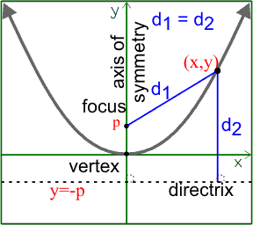 | 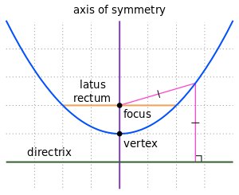  Vertical Axis of Symmetry:  $$x\left(t\right)= 2pty=Dt^{2}+ Et+F$$  where A and D have the same sign  Interesting Note:  The distances from a point on the curve to the focus is the same as to the directrix. |  |  | Vertical Axis of Symmetry:  $$x\left(t\right)= 2pt+h$$  $y\left(t\right)=pt^{2}+k$ (opens upwards) or  $y\left(t\right)=-pt^{2}-k$ (opens downwards)  $$\left[t_{min}, { t}_{max}\right]=[-c, c]$$  Vertex: $\left(h,k\right)$  Horizontal Axis of Symmetry:  $$y\left(t\right)= 2pt+k$$  $x\left(t\right)=pt^{2}+h$ (opens to the right) or  $x\left(t\right)=-pt^{2}-h$ (opens to the left)  $$\left[t_{min}, { t}_{max}\right]=[-c, c]$$  Vertex: $\left(h,k\right)$  Projectile Motion:  $$x\left(t\right)=x_{0}+v_{x}t$$  $y\left(t\right)=y_{0}+v_{y}t-16t^{2}$ feet  $y\left(t\right)=y_{0}+v_{y}t-4.9t^{2}$ meters  $$v_{x}=v\cos{θ}$$  $$v_{y}=v\sin{θ}$$  General Form:  $$x=At^{2}+ Bt+C$$  $$y=Dt^{2}+ Et+F$$  where A and D have the same sign
Inverse Functions | $$f\left(f^{-1 }(x)\right)=f^{-1 }\left(f(x)\right)=x$$  Inverse Function Theorem:  $$f^{-1}\left(b\right)= \frac{1}{f^{'}\left(a\right)}$$  where ${b= f}^{'}\left(a\right)$ | if $y=sin θ$  if $y=\cos{θ}$  if $y=\tan{θ}$  if $y= csc θ$  if $y=\sec{θ}$  if $y=\cot{θ}$ | $$then θ=\sin^{-1}{y}$$  $$then θ=\cos^{-1}{y}$$  $$then θ=\tan^{-1}{y}$$  $$then θ=\csc^{-1}{y}$$  $$then θ=\sec^{-1}{y}$$  $$then θ=\cot^{-1}{y}$$ |  | or $θ=\arcsin{y}$  or $θ=\arccos{y}$  or $θ=\arctan{y}$  or $θ=\operatorname{arccsc}{y}$  or $θ=\operatorname{arcsec}{y}$  or $θ=\operatorname{arccot}{y}$
Arc Length | 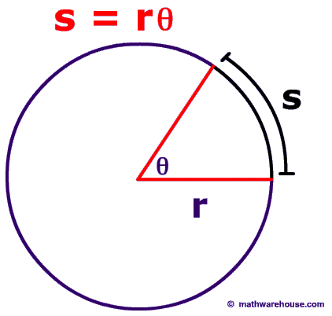 | Circle:  $$L=s=rθ$$  Proof:  $$L=\left(fraction of circumference\right)∙$$  $$π∙(diameter)$$  $$L=\left(\frac{θ}{2π}\right)π (2r)=rθ$$
Perimeter | Square: P = 4s  Rectangle: P = 2l + 2w  Triangle: P = a + b + c | Circle: C = πd = 2πr  Ellipse: $C≈π(a+b)$
Area | Square: A = s²  Rectangle: A = lw  Rhombus: A = ½ ab  Parallelogram: A = Bh  Trapezoid: $A=\frac{\left(B_{1}+B_{2}\right)}{2} h$  Kite: $A = \frac{d_{1} d_{2}}{2}$ | Triangle: A = ½ Bh  Triangle: A = ½ ab sin(C)  Triangle using Heron’s Formula:  $$A=\sqrt{s\left(s-a\right)\left(s-b\right)\left(s-c\right)}$$  $$where s=\frac{a+b+c}{2}$$  Equilateral Triangle: $A= \frac{\sqrt{3}}{4}s^{2}$ |  |  | Frustum: $A=\frac{1}{3}\left(\frac{B_{1}+B_{2}}{2}\right)h$  Circle: A = πr²  Circular Sector: A = ½ r²$θ$  Ellipse: A = πab
Lateral Surface Area | Cylinder: SA = 2πrh  Cone: SA = πrl
Total Surface Area | Cube: SA = 6s²  Rectangular Box: SA = 2lw + 2wh + 2hl  Regular Tetrahedron: SA = 2bh  Cylinder: SA = 2πr (r + h) | Cone: SA = πr² + πrl = πr (r + l)  Sphere: SA = 4πr²  Ellipsoid: SA = (too complex)
Volume | Cube: V = s³  Rectangular Prism: V = lwh  Cylinder: V = πr²h  Triangular Prism: V= Bh  Tetrahedron: V= ⅓ Bh | Pyramid: V = ⅓ Bh  Cone: V = ⅓ bh = ⅓ πr²h  Sphere: $V=\frac{4}{3}πr^{3}$  Ellipsoid: V = $\frac{4}{3}$πabc

