Harold’s Kinematic Graphs
“Cheat Sheet”
26 November 2017

Distance, Velocity, Acceleration, Jerk
 | Area | Slope |  | Equations | Time Graphs
Distance | ↑ | ↓ |  | $$x$$ | 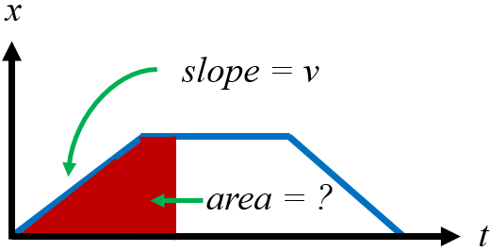
Velocity | ↑ | ↓ |  | $$v=\frac{x}{t}$$ | 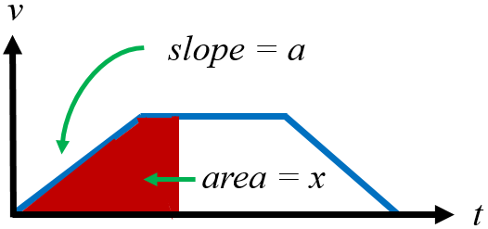
Acceleration | ↑ | ↓ |  | $$a=\frac{v}{t}=\frac{x}{t^{2}}$$ | 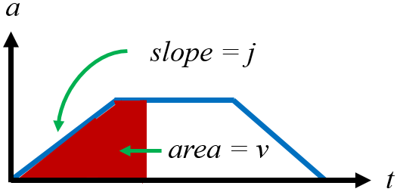
Jerk | ↑ | ↓ |  | $$j=\frac{a}{t}=\frac{v}{t^{2}}=\frac{x}{t^{3}}$$ | 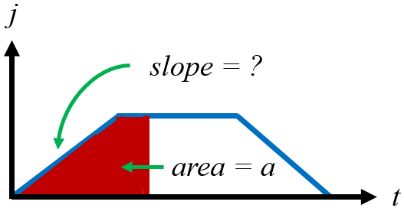
Polynomials | Constant  Linear  Quadratic  Cubic  Quartic |  | $$x^{0}=1 →c$$  $$x^{1}=x →mx+b$$  $$x^{2}=x^{2}→ax^{2}+bx+c$$  $$x^{3}=x^{3}→ax^{3}+bx^{2}+cx+d$$  $$x^{4}=x^{4}→ax^{4}+bx^{3}+…$$ |  | 