Harold’s Exponential Growth and Decay
Cheat Sheet
16 May 2016

Discrete | Continuous
$$A=P{\left(1+\frac{r}{n}\right)}^{nt}$$ | $$A=Pe^{rt}$$
Simple Interest:  $$A=P+I=P+Prt=P(1+rt)$$  A = Amount after time t  P = Original amount, such as principle  e = The natural number (~2.718)  r = Rate of growth/loss, e.g. interest rate (15% = 0.15)  t = Elapsed time  n = Divides time into periods per time unit | e ≈ 2.71828 18284 59045 23536 …  $e= \lim_{n→∞}{{\left(1+\frac{1}{n}\right)}^{n}}$  $A= \lim_{n→∞}{P{\left(1+\frac{r}{n}\right)}^{nt}}=Pe^{rt}$  e = $\sum_{i=0}^{∞}{\frac{x^{n}}{n !}}$ = $1+\frac{1}{1!}+\frac{1}{2!}+\frac{1}{3!}+\frac{1}{4!}+\frac{1}{5!}+…$
Savings Account Example:  P = $100  r = 8% = 0.08  t = 1 year  n = 4 (quarterly)  $A=\$100{\left(1+\frac{0.08}{4}\right)}^{4(1)}$= $108.24 | Savings Account Example:  $A=\$100 e^{0.08(1)}$ = $108.33  If n = 1, A = $108.00 (+0$¢)$ Annually  If n = 4, A = $108.24 (+24$¢)$ Quarterly  If n = 12, A = $108.29 (+5$¢)$ Monthly  If n = 365, A = $108.33 (+4$¢)$ Daily  If n = ∞, A = $108.33 (+0$¢)$ Continuously
Compounded interest after 3 years:  $$A(3)=P \left(1+8\%\right) \left(1+8\%\right) \left(1+8\%\right)$$  $A(3)=P{\left(1+0.08\right)}^{3}$ = 1.26 * P | (See calculus derivation on page 2)
$$A=P{\left(1+\frac{r}{n}\right)}^{nt}$$  $$P= \frac{A}{{\left(1+\frac{r}{n}\right)}^{nt}}$$  $$r=n \left[{\left(\frac{A}{P}\right)}^{1/{nt}}-1\right]$$  $$t= \frac{1}{n} \frac{\ln{(\frac{A}{P})}}{\ln\left(1+\frac{r}{n}\right)}$$  n = ? | $$A=Pe^{rt}$$  $$P= \frac{A}{e^{rt}}$$  $$r=\frac{1}{t}\ln\left(\frac{A}{P}\right)$$  $$t=\frac{1}{r}\ln\left(\frac{A}{P}\right)$$  n = ∞

Calculus Derivation | Graphs
Assume the rate of growth or decay is proportional to the amount of substance (P).  $$\frac{dP}{dt} ∝P$$  $$\frac{dP}{dt}=k P$$  Separate variables and integrate:  $$\frac{dP}{P}=k dt$$  $$\int{\frac{dP}{P}} =\int{k dt}$$  $$\ln\left|P\right|=kt+c$$  Solve for P(t):  $$e^{\ln\left|P\right|}= e^{kt+c}$$  $$\left|P\right|= e^{c} e^{kt}=Ce^{kt}$$  At t=0 (initial condition):  $$P\left(0\right)= Ce^{k*0}=C*1= P_{0}$$  Therefore,  $$P(t)=P_{0} e^{kt}$$  or  $$A=Pe^{rt}$$ | 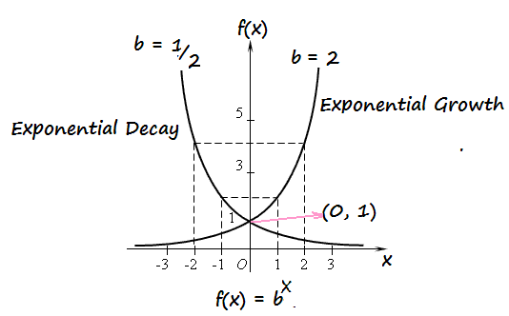  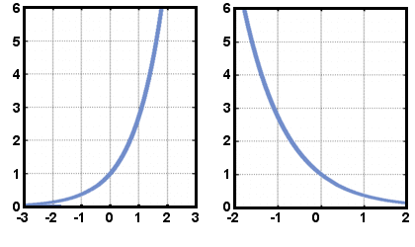  Left: Exponential Growth (k or r positive)  Right: Exponential Decay (k or r negative)
Chemistry | Half-Life
$$A = Amount remaining after time t$$  $$A_{0}=Amount starting with at time t=0$$  $$T = Half Life (time units)$$  $$t = time (time units)$$ | $$A=A_{0}{\left(\frac{1}{2}\right)}^{\frac{t}{T}}$$

