Harold’s Boolean Algebra
Cheat Sheet
12 September 2021

Boolean Algebra

Boolean Expression | Law or Rule | Equivalent Circuit | Description
$$A+1=1$$ | Annulment  (OR) | 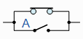 | A in parallel with closed = “CLOSED”
$$A•0=0$$ | Annulment  (AND) | 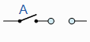 | A in series with open = “OPEN”
$$A+0=A$$ | Identity  (OR) | 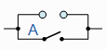 | A in parallel with open = “A”
$$A•1=A$$ | Identity  (AND) | 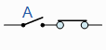 | A in series with closed = “A”
$$A+A=A$$ | Idempotent  (OR) | 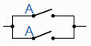 | A in parallel with A = “A”
$$AA=A$$ | Idempotent  (AND) | 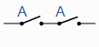 | A in series with A = “A”
$$\overline{\left( \overline{A } \right)}=A$$ | Double Negation | 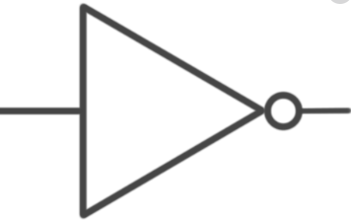 | NOT NOT A (double negative) = “A”
$$A+\overline{A}=1$$ | Complement  (OR) | 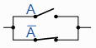 | A in parallel with NOT A = “CLOSED”
$$A\overline{A}=0$$ | Complement  (AND) | 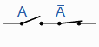 | A in series with NOT A = “OPEN”
$$A+B=B+A$$ | Commutative  (OR) | 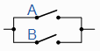 | A in parallel with B = B in parallel with A
$$AB=BA$$ | Commutative  (AND) | 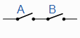 | A in series with B = B in series with A
$$A\left(B+C\right)$$  $$=AB+AC$$ | Distributative  (OR) |  | Permits the multiplying or factoring out of an expression
$$A+BC=$$  $$(A+B)(A+C)$$ | Distributative  (AND)
$$A+\left(B+C\right)$$  $$=\left(A+B\right)+C=A+B+C$$ | Associative  (OR) |  | Allows the removal of brackets from an expression and regrouping of the variables
$$A\left(BC\right)$$  $$=\left(AB\right)C$$  $$=ABC$$ | Associative  (AND)
$$A+\left(AB\right)=A$$ | Absorptive  (OR) |  | Enables a reduction in a complicated expression to a simpler one by absorbing like terms
$$A\left(A+B\right)=A$$ | Absorptive  (AND)
$$A+\overline{A}B=A+B$$ | Absorptive  (Derived) |  | Reduces a complicated expression to a simpler one by absorbing compliment term
$$\overline{\left(A+B\right)}=\overline{A}•\overline{B}$$ | De Morgan’s Theorem  (NOR) |  | Invert and replace OR with AND
$$\overline{AB}=\overline{A}+\overline{B}$$ | De Morgan’s Theorem  (NAND) |  | Invert and replace AND with OR

Source: https://www.electronics-tutorials.ws/boolean/bool_6.html

Boolean Logic Gates

Boolean Logic | Notation | Gate | Description
IDENTITY | 1  T  True | 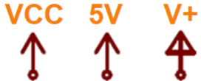 | On, Tautology, High voltage (typically +5V)
NULL | 0  F  ⊥  False | GND  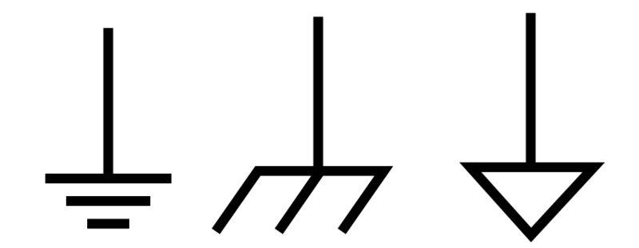 | Off, Contradiction, Low voltage (typically 0V)
Input | A, B, C, D |  | Line, Wire, Connects to
Output | W, X, Y, Z |  | Line, Wire, Connects from
AND | $$A⋅B$$  $$AB$$  $$A.B$$  A ∧ B  A ∩ B | 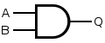 | AND, BUT, Multiply, Conjunction, Intersection
OR | $$A+B$$  A ∨ B  A ∪ B  A | B | 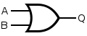 | Inclusive-OR, Add, Disjunction, Union
NOT | $$\overline{A}$$  $$A^$$  $$A'$$  $$¬A$$  $$\sim A$$  $$!A$$ | 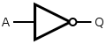 | NOT, Invert, Negation, Change, Difference
NAND | $$\overline{AB}$$  A ⊼ B  A | B* | 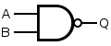 | Not AND
NOR | $$\overline{A+B}$$  A ⊽ B  A ↓ B | 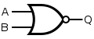 | Not OR
XOR | A ⊕ B  A ⊻ B  $$A\overline{B}+\overline{A}B$$ | 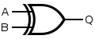 | Exclusive-OR, Both A and B are different
XNOR | A ⊙ B  $$\overline{A⊕B}$$  $$AB+\overline{A}\overline{B}$$ | 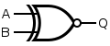 | Exclusive-NOR, Both A and B are the same

Boolean Logic Truth Tables

Inputs |  | Outputs
A | B | AND  $$⋅$$ | NAND | OR  + | NOR | XOR  ⊕ | XNOR  ⊙ | NOT  $$\overline{A}$$ | VCC  1 | GND  0
0 | 0 | 0 | 1 | 0 | 1 | 0 | 1 | A=1 | 1 | 0
0 | 1 | 0 | 1 | 1 | 0 | 1 | 0 | A=1 | 1 | 0
1 | 0 | 0 | 1 | 1 | 0 | 1 | 0 | A=0 | 1 | 0
1 | 1 | 1 | 0 | 1 | 0 | 0 | 1 | A=0 | 1 | 0

Blank Truth Tables

Inputs |  | Output
A | B | X
0 | 0
0 | 1
1 | 0
1 | 1

Inputs |  |  | Output
A | B | C | X | Y
0 | 0 | 0
0 | 0 | 1
0 | 1 | 0
0 | 1 | 1
1 | 0 | 0
1 | 0 | 1
1 | 1 | 0
1 | 1 | 1

Inputs |  |  |  | Output
A | B | C | D | X | Y | Z
0 | 0 | 0 | 0
0 | 0 | 0 | 1
0 | 0 | 1 | 0
0 | 0 | 1 | 1
0 | 1 | 0 | 0
0 | 1 | 0 | 1
0 | 1 | 1 | 0
0 | 1 | 1 | 1
1 | 0 | 0 | 0
1 | 0 | 0 | 1
1 | 0 | 1 | 0
1 | 0 | 1 | 1
1 | 1 | 0 | 0
1 | 1 | 0 | 1
1 | 1 | 1 | 0
1 | 1 | 1 | 1

Karnaugh Mapping (K-Map)

2-Bit  K-Map |  | A
 |  | 0 | 1
B | 0
 | 1

3-Bit  K-Map |  | AB
 |  | 00 | 01 | 11 | 10
C | 0
 | 1

4-Bit  K-Map |  | AB
 |  | 00 | 01 | 11 | 10
CD | 00
 | 01
 | 11
 | 10

2x2 Group
1x4 Group

K-Map Rules

1) Circle only 1s (ones) and don’t cares for Sum of Products (SOP), $e.g. \overline{A} \overline{B} \overline{C}+\overline{A}BC+AB\overline{C}$.
a. Circle only 0s (zeros) and don’t cares for Product of Sums (POS), $e.g. (A+\overline{B})(\overline{A}+B)$.
b. Don’t cares may be used or ignored.
2) No diagonals, only horizontal or vertical connections.
3) Group only adjacent cells in groups with powers of 2 (1x1, 1x2, 2x1, 2x2, 2x4, 4x2, 1x4, 4x1).
4) Make groups as large as possible.
5) Must group all 1s (ones) for SOP or all 0s (zeros) for POS.
6) Overlapping is allowed.
7) Wrapping around all edges allowed, both top-bottom edges and left-right edges.
8) Fewest groups possible (OPTIMAL).
9) For each circle, determine which inputs do not contribute to the logic (is both 0 and 1).
10) Write down equation as a SOP, $e.g. \overline{A} \overline{B} \overline{C}+\overline{A}BC+AB\overline{C}$

